Oregon State University

State and County Delivered Bridge Replacement Project Analysis
Phase I and Phase II
Summary of Project Results
Submitted by
Toni L. Doolen, PhD
Behrouz Behmardi

02/02/2010

I. Executive Summary 3
II. Introduction 10
III. Background 11
IV. Analysis Phase I 13
A. Project cost vs. delivery type 13
B. Project cost vs. project duration 14
C. Project cost vs. bridge length and delivery method 16
D. Project cost vs. project duration, bridge length and delivery method 17
E. Project duration vs. delivery type 18
F. Bridge length vs. delivery method 19
G. Project cost vs. project duration, bridge length, delivery method, and closure type 20
H. Project cost vs. bridge length after removing upper and lower tails 21
I. Project cost vs. engineering project duration 23
V. Analysis Phase II 25
A. Project cost vs. clearance type 26
B. Construction cost vs. bridge closure 26
C. Construction cost vs. number of bids 28
D. Project duration vs. region 29
VI. Conclusions 32
VII. Appendix A: Bridges included in analysis 33
VIII. Appendix B: Bridges excluded from analysis 38

- Executive Summary
This report summarizes the results of Phase I and Phase II of the “State vs. County Delivery Bridge Replacement Analysis” project. The data set used in the project included 190 bridge replacement projects. Key attributes of the projects are summarized in Table 1.

Table 1: Bridge Project Characteristics
Total number of bridges | 190
# of state-delivered projects | 50
# of county-delivered projects | 140
Costs ($) | $60,500 – 6,388,217
Bridge Length (ft) | 23-680
Duration (days) | 106-2,494
Average # of bids | 4
% of Projects by Closure Type | 21% built in stages  52% offsite detour  27% onsite detour
% of Projects by Clearance Type | 92% over water  1% over railroad  7% over canal/irrigation
% of Projects by Region | Region 1 17%  Region 2 25%  Region 3 26%  Region 4 9%  Region 5 23%

To enable a valid analysis of the data, the following assumptions and mathematical operations were performed:
- Costs, duration, length, and width data were transformed using natural logs for all analyses. Testing was completed on the transformed data to verify that the transformed data were robust and satisfied the requirements of normally-distributed errors and equal variances.
- As design and construction projects spanned multiple years, present values were used for all cost data to enable comparison of bridge costs.
- Engineering costs were distributed equally from the engineering design start date to the start of construction date.
- Construction costs were distributed equally across years between the start of construction date and the substantial construction completion date.
- Right of way costs were not included when calculating total costs.
- Total duration included both engineering design duration and construction duration.

In the first phase of the project, the focus was determining whether or not the project delivery type (state or county) could be a significant predictor of project cost or project duration. The variables (and associated measurement units) included in Phase I analysis:
- Project delivery type (state and county)
- Engineering and construction costs ($’s). Right-of-way costs were not included.
- Engineering design and construction durations (days)
- Bridge length (ft)
- Bridge closure during construction (yes or no)

The significant findings resulting from Phase I are summarized next.

Phase I, Finding 1:
- 79% of the variability observed in the cost of bridge replacement projects, included in the study, can be explained by project duration and bridge length.
- Approximately 7% of this variation is due to project duration, but the largest portion of cost variation (72%) can be explained by bridge length.
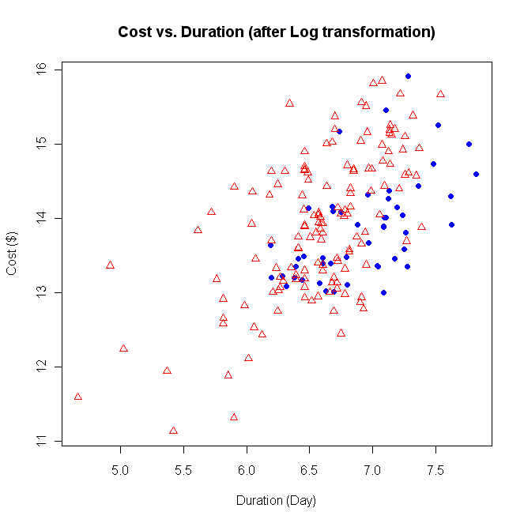
Total Project Cost ($)
1800
1000
670
400
245
150
Total Duration (Days)
County delivery
State delivery
9,000,000
3,300,000
1,200,000
450,000
160,000
60,000

Figure 1: Overall summary of cost vs. duration

(Note: there were no state-delivered projects with total costs < $450,000)

Phase I, Finding 2:
- The average duration of the engineering design portion of state-delivered projects was greater than the average duration of the engineering design portion of county-delivered projects. The difference was statistically significant. The average duration for the engineering design portion of county-delivered projects was 449 days. The average duration for the engineering design portion of state-delivered projects was 774 days. See Figure 2 for a graphical summary of total project duration by delivery type.
Duration (Days)
County delivered
State delivered
Delivery Method
3000
1800
1000
670
400
245
150

Figure 2: Duration vs. delivery method

Phase I, Finding 3:
- Closing (or not) of the bridge during construction did not provide any additional explanation for variation observed in total bridge replacement costs, for the set of bridges studied. As can be seen in Figure 3, bridge closures are distributed across the entire range of project costs.
665
400
250
150
90
55
33
Total Project Cost ($)
Bridge Length (ft)
Bridge not closed
Bridge closed
9,000,000

3,300,000

1,200,000

450,000

160,000

60,000

Figure 3: Project cost vs. length with bridge closure type specified
In Phase II, the focus was on completing additional analysis was to see if it was possible to create a predictive model for project costs and project duration. Based on the results of Phase I, four additional variables were identified for inclusion in the study. The first two additional variables stratified the bridges based on closure type (on-site detour, off-site detour, and staged build) and clearance type (over water, over railroad, over canal/irrigation). The third variable was the number of bids received for a project. Three levels were defined for the analysis (projects with two or few bids, projects with three to five bids, and projects with six or more bids). The fourth variable was the project location. For purposes of this study, five regions were defined based on the geographical location of the project and population density. The significant findings resulting from the Phase II analysis are summarized next.

Phase II, Finding 1:
- The map used to define the Region associated with each project in included in Figure 4. Projects in Region 1 were found to take longer to complete than projects in Region 5.
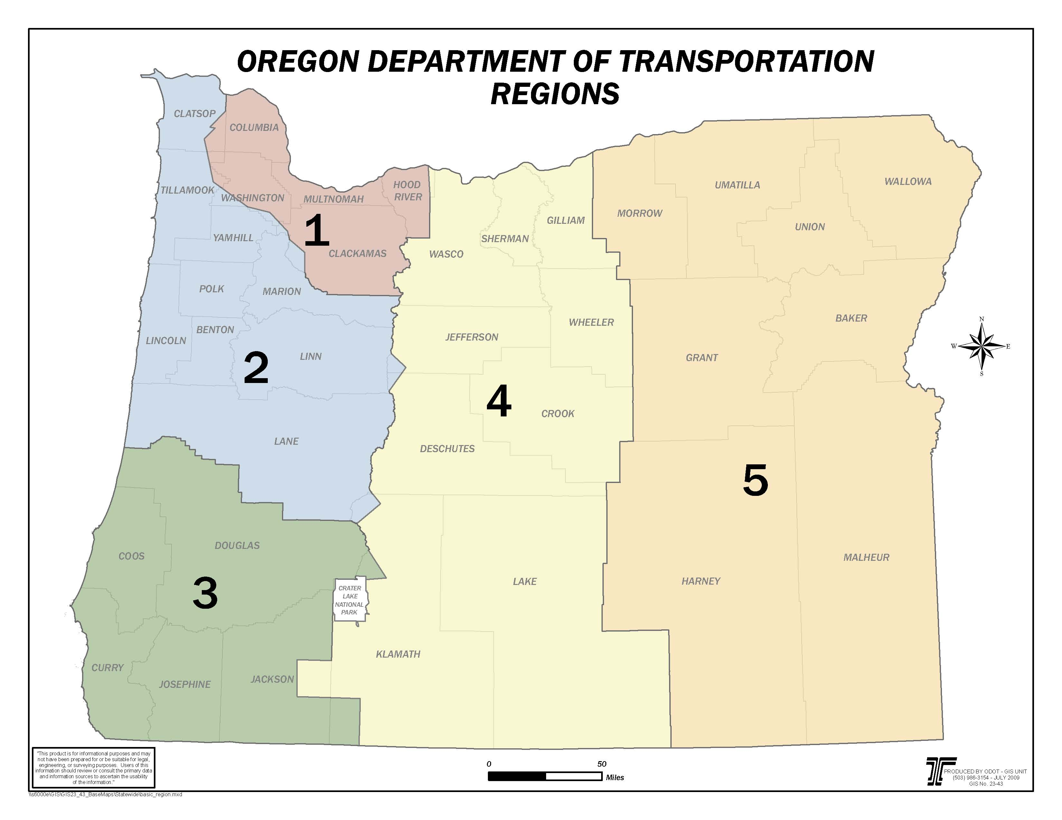

Figure 4: Regions 1 – 5 and associated counties.

Phase II, Finding 2:
- The number of bids was treated as a categorical variable with three levels (two or fewer bids, three to five bids, or more than six bids). The number of bids was not found to be a significant predictor of total project costs.

Phase II, Finding 3:
- Clearance type was found to impact project construction costs. Projects extending over railroads had higher construction costs than projects over water. Projects extending over irrigation or canals had the lowest construction costs. See Figure 5. Clearance type, however, was not found to be a significant predictor of overall project costs. Clearance type was found to be correlated with bridge length, which was identified in Phase I as a significant predictor of costs.
Construction Cost ($)
Clearance Type
Water Rail Irrigation/Canal
3,300,000
1,200,000
450,000
165,000
60,000

Figure 5: Construction Costs vs. Clearance Type

Phase II, Finding 4:
- The type of closure/detour used for the projects in this study was found to have a significant impact on project construction costs. Projects that were built in stages had higher construction costs than projects using onsite or offsite detours. There was no difference in project construction costs between projects using onsite and offsite detours. See Figure 6.
Construction Cost ($)
3,300,000
1,200,000
450,000
160,000
60,000

Closure Type
Onsite Detour Offsite Detour Built in Stages

Figure 6: Construction Costs vs. Closure Type

Phase I and Phase II Overall Findings
A mathematical model was developed based on 190 bridge replacement projects. Approximately 86% of the observed variation in total project costs can be accounted for in a model that includes bridge length, project duration, and bridge width. Only 14% of the variation in project costs remains unexplained. The five variables identified as having significant prediction power on project costs and/or project duration include bridge length, bridge width, clearance type, and delivery method. These variables should be considered in estimating project costs for future replacement projects. It is likely that it would take significant amount of time to identify additional variables to explain the remaining variation and to collect the data. It is also likely that the unaccounted for variation (14%) cannot be explained by a single variable. It is likely a result of a large number of variables. The overall relationships between project cost and the significant relationships identified are summarized in Figure 7.
- The length of the bridge was found to be the most significant predictor of construction costs. Bridge length can explain approximately 72% of the variation observed in project costs for the 190 bridge replacement projects included in this study. The type of clearance can explain a small proportion of the variation observed in bridge length. 5% of the variation observed in the projects studied can be explained by the type of clearance for the project.
- Project duration and bridge width explain an additional 14% of the variation observed in construction costs for the projects studied.
- The project delivery type (county vs. state) was found to explain approximately 10% of the variation observed in project duration, which accounts for approximately 1% of the variation observed in total project cost.
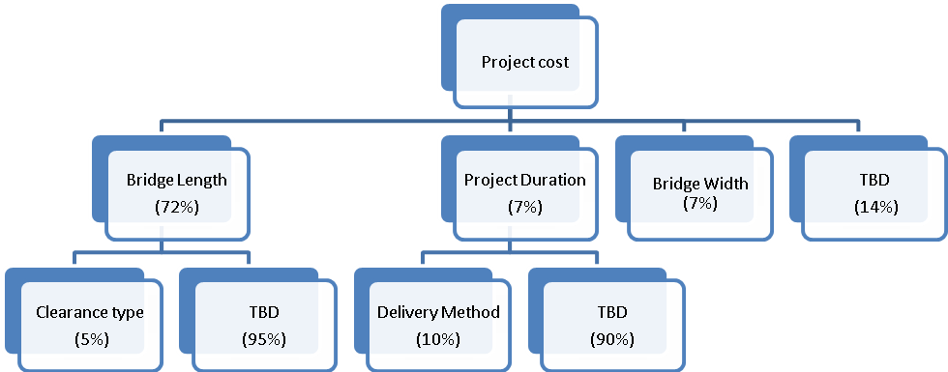
Figure 7: Relationships between project cost and significant predictors, including bridge length, project duration, bridge width, clearance type, and delivery method
- Introduction
The remaining sections of this report summarize the detailed results of the first and second phase of the “State vs. County Delivery Bridge Replacement Analysis” study. Data for this study were received from Jon Oshel (County Road Program Manager) and Holly Winston (Senior Local Bridge Standards Engineer). Initially, data from 226 bridge replacement projects occurring between 1994 and 2008 were collected. Some of the bridge replacement projects were eliminated from the study as the projects did not represent a typical project, e.g. projects having a significant rehabilitation component or because at the time of data collection, the project was not completed. The final data set that was analyzed included 190 bridge replacement projects. Appendix A contains a list of all bridge replacement project included in the study. Appendix B contains a list of the 36 bridge replacement projects excluded from the study, along with the reason for exclusion. Summary information for the 190 bridges included in the analysis is provided is shown in Table 1. Additional data on the “extreme” bridge replacement projects are summarized in Table 2. The data provided for each project included total project cost, which included both engineering and construction costs, project duration (the total duration of each project was calculated by measuring the elapsed time between the engineering design begin date and substantial construction completion date), bridge length (feet), delivery type (state or county), closure type, bridge clearance type, number of bids received for the project, and project location. The purpose of Phase I of the study was to determine whether or not project delivery type could explain observed variations in project costs and project durations. Phase II was completed to identify the significance of other key variables on project costs and durations.

Table 2: Extreme Bridge Replacement Project Details
 | County | Bridge name | Funding source | Begin date | Completion date | Total Cost  ($) | Total Duration  (days) | Length  (ft)
Most expensive | Coos County | Stringtown Overflow | OTIA III | 07/08/2004 | 10/01/2002 | 6,428,672 | 1180 | 610
Least expensive | Benton county | Bottger Creek | Local | 02/17/2007 | 10/01/2007 | 60,500 | 226 | 28
Longest length | Washington County | Tualatin River | OTIA II | 09/23/1999 | 11/15/2004 | 4,432,497 | 1880 | 680
Shortest length | Jackson county | Cottonwood Creek | Local | 06/01/2005 | 10/01/2007 | 212,900 | 852 | 23
Longest duration | Clackamas County | Abernethy Creek | HBP | 07/20/1994 | 05/18/2001 | 1,185,472 | 2494 | 105
Shortest duration | Lake county | Dick's Creek | Local | 07/01/2003 | 10/15/2003 | 76,067 | 106 | 46

Delivery type was defined based on the source of funding for the replacement project, i.e. state or FHWA. Projects funded by the Federal Highway Bridge Program (HBP) were identified as state-delivered projects; whereas projects funded by the Oregon Transportation Investment Act (OTIA I, OTIA II, or OTIA III), Oregon Watershed Enhancement Board (OWEB), or Local sources were identified as county-delivered projects. In this analysis, project cost and duration were the dependent variables under consideration.

Project costs were adjusted to enable comparison of projects that were completed in different years. Standard engineering economic principles were applied to adjust costs for inflationary effects. Project costs were divided into two different categories, design engineering costs and construction costs. Design engineering costs were distributed equally on an annual basis between the project start date and the project construction award date. Construction costs were distributed equally on an annual basis between the construction award date and construction substantial completion date.

Two types of independent variables were included in the analysis -- indicator variables and quantitative variables. Indicator variables are variables that take the value of 0 or 1 to indicate the absence or presence of a factor. Delivery type, closure type, clearance type, number of bids, and region were the five independent, indicator variables included in the study. Project duration, bridge length, and bridge width were the independent, quantitative variables included in the analysis.

The remainder of this report summarizes the results of the various statistical and graphical analyses completed to determine which factors, including delivery type, are most significant in explaining bridge replacement project costs and project durations.

- Background
This section provides some background information on the type of analyses that were performed in this study. Linear regression models and Analysis of Variance (ANOVA) were used to analyze the data. A simple linear regression model is a straight line function that relates the mean of a dependent variable to independent variables. The dependent variable is an output of interest, e.g. project costs. Independent variables are those variables that are believed to drive a dependent variable. A linear regression analysis is used to determine whether or not a linear function can be used to predict the value of the mean of a dependent variable when two quantitative variables are analyzed. ANOVA is used when one of the variables in an indicator variable. In both Phase I and Phase II, the two primary dependent variables of interest were project costs and project duration. The symbol “y” is used to represent dependent variables. In Phase I, bridge length, delivery type and bridge closure were the independent variables studied. In Phase II bridge width, bridge closure type, bridge clearance type, number of bids, and region were added as independent variables to the analysis. The symbols, x₁, x₂, …, x_{n}, are used to represent independent variables in a mathematical model. A simple linear regression model is represented in the following general formula:
y = B₀+ B₁×x₁+ B₂×x₂+ …+B_{n}×x_{n.}

In this format, B₀, B₁, …, B_{n} are the model parameters that have to be estimated. These parameters were estimated using the mean square error method. After estimating the model parameters, the result can be summarized in a table as illustrated in Table 3.

Table 3: General table of results from a linear regression analysis
 | Estimate | Pr(>|t|)
B₀ | … | …
B₁ | … | …
…
B_{n} | … | …
Adjusted R-squared: …

The first column includes the names of the parameters. The second column includes the estimated values for each parameter. The third column is the p-value for each parameter. The p-value is a probability value that specifies the significance of the estimate. When the p-value is less than 0.05 it is said that there is sufficient evidence that the parameter estimate is correct. The last row of the table includes the adjusted value of R-squared. R-squared identifies how much variability in the dependent variable can be explained by the independent variables included in the model.

In completing a linear regression analysis, there are four assumptions that must be met. Constant variance is one assumption for a linear regression model to be valid. This assumption can be validated with a fitted value vs. residual plot. A fitted value is the dependent variable value based on the estimated parameters. A residual value is the difference between the true value and estimated value of the dependent variable. To meet the assumption of constant variance, the plot between the fitted and residual values must be dispersed randomly around a value of zero. A second assumption is that the error terms are normally distributed. Normal probability plots of the residuals were reviewed to verify that this assumption was met for each variable included in the analysis. The third assumption is that the data being analyzed vary in a linear fashion. Linearity was verified by plotting each independent variable against each dependent variable. It was found that for each of the quantitative variables included in the study (cost, duration, length, and width), the assumption of linearity was not met unless the data were transformed. A natural log transformation was applied and shown to produce well-behaved data. For the remainder of this report the term “log” will be used when referring to any data where a natural log transformation was applied. The fourth assumption is of independence. There was no evidence of serial or time-based correlation observed in the data used for this study.

- Analysis Phase I
- Project cost vs. delivery type
Project costs were analyzed as a function of delivery type using a linear regression model. The results are summarized in Table 4. The assumption of constant variance of the errors appears to be a valid as the fitted values for cost (when the natural log transformation was applied) are randomly dispersed around the value of 0. Since the p-value for B₁ (0.304) is greater than 0.05, there is no evidence that the delivery method can be used to explain the observed variation in costs. These results indicate that the parameter, B₁, can be set to zero with high confidence. This model indicates that the average cost for a bridge replacement project is approximately $1.65 million, irrespective of whether the project was delivered by a county or by the state. Based on this analysis, the average cost for a bridge replacement project is not directly dependent on delivery type.

In summary, differences observed in project costs cannot be directly attributed to the type of project delivery used (state or county).

Table 4: Project cost vs. delivery type
Model variables | Model  Tested:  Cost = B₀ + B₁ × Fund  Valid:  Cost=1,640,995
  Type | Name | Description
  Indicator | Fund | $$\begin{aligned}\left\{1 \text{State}−\text{delivery} | \right.\end{aligned}$$
  Dependent | L-cost | Log(cost)
Assumption validation  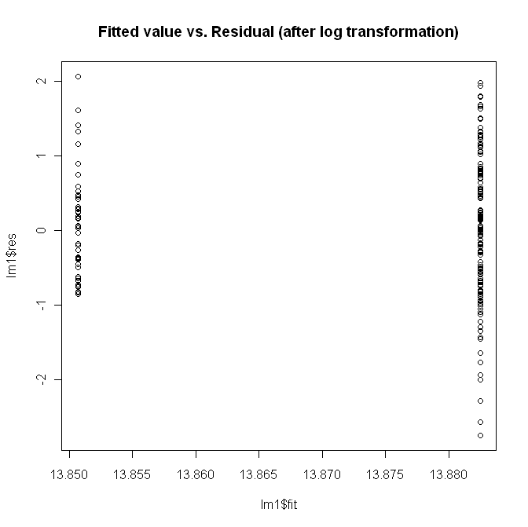  Residuals  Fitted Values ($) | Linear regression results
   | Estimate Std. | Pr(>|t|)
  B₀ | 1640995 | <<0.001
  B₁ | -259305 | 0.304
  Adjusted R-squared: 0.006

- Project cost vs. project duration
A plot of project costs against project duration (for the entire set of projects analyzed) is shown in Figure 8. While there appears to be a linear relationship between these data, log transformations were applied to both costs and duration to produce a better behaved distribution for analyses. The plot of the transformed data is shown in Figure 9.
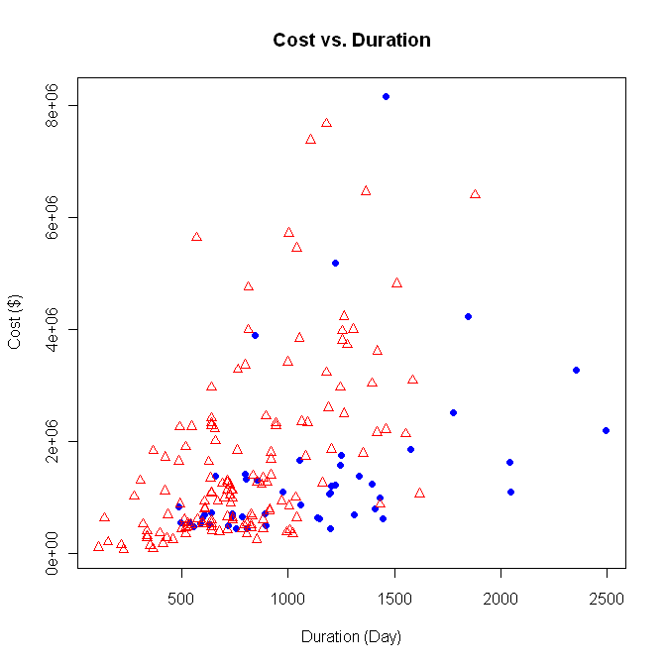
County delivery
State delivery

Figure 8: Scatter graph of project costs vs. project duration for untransformed data

1800

1000

670

400

245

150

Total Cost ($)
County delivery
State delivery
Total Duration (Days)
9,000,000
3,300,000
1,200,000
450,000
160,000
60,000

Figure 9: Scatter graph of project cost vs. project duration after log transformation

The relationship between the log of project cost and the log of project duration was analyzed next using linear regression. An indicator variable defining the delivery type used for the project was included in the analysis. The results are summarized in Table 5. The assumption of constant variance of the errors appears to be a valid for this data set when transformed values for project cost and duration are used. Since the p-values for B₂ (0.363) and B₃ (0.252) are greater than 0.05 there is no evidence that either project delivery type or the interaction between project delivery type and project duration can be used to explain the observed variation in costs. This model does support a significant relationship between project duration and project cost, with project duration explaining approximately 38% of the observed variation in project costs as measured by the adjusted R-squared value of 0.38.

In summary, the average cost for a bridge replacement project was found to be correlated with project duration. Duration can explain roughly 38% of the variation observed in project costs for the 190 bridge replacement projects included in the study. Differences observed in project costs were again found to not be attributable to the type of project delivery used (state or county).

Table 5: Project cost vs. project duration
Model variables | Model  Tested:  L-cost = B₀ + B₁×L-duration+B₂× Fund + B₃× L-duration:Fund  Valid:  L-cost = 5.77 + 1.23 × L-duration
  Type | Name | Description
  Indicator | Fund | $$\begin{aligned}\left\{1 \text{State}−\text{delivery} | \right.\end{aligned}$$
  Independent | L-duration | Log(duration)
  Dependent | L-cost | Log(cost)
Assumption validation  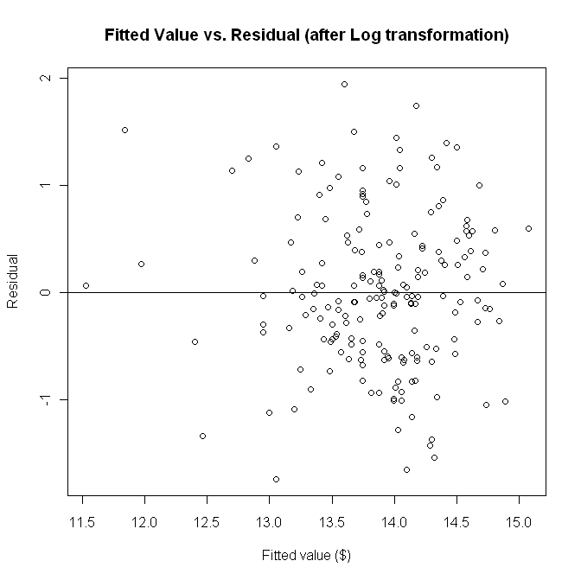 | Linear regression results
   | Estimate | Pr(>|t|)
  B₀ | 5.77 | <<0.001
  B₁ | 1.23 | <<0.001
  B₂ | 1.74 | 0.363
  B₃ | 0.32 | 0.252
  Adjusted R-squared: 0.38
- Project cost vs. bridge length and delivery method
In the next step of the analysis, project costs were analyzed with both bridge length and delivery type included in the model. A scatter graph of project costs against bridge length (for the entire set of projects analyzed) is shown in Figure 10. Similar to project cost and duration, it was necessary to use a natural log transformation to obtain a distribution of data appropriate for linear regression analysis.
665
400
250
150
90
55
33
Total Cost ($)
Length (ft) (Ft)
9,000,000
3,300,000
1,200,000
450,000
160,000
60,000
County delivery
State delivery

Figure 10: Scatter graph of project cost vs. bridge length

The relationship between the log of project cost and the log of length was analyzed using linear regression. An indicator variable defining the delivery type used for the project was included in the analysis. The results are summarized in Table 6. The assumption of constant variance of the errors appears to be a valid for this data set when transformed values for project cost and length are used. Since the p-values for B₂ (0.38) and B₃ (0.47) are greater than 0.05 there is no evidence that either project delivery type or the interaction between project delivery type and bridge length can be used to explain the observed variation in costs. This model does support a significant relationship between bridge length and project costs, with bridge length explaining a very significant portion (72%) of the observed variation in project costs as measured by the adjusted R-squared value of 0.72.

In summary, the average cost for a bridge replacement project was found to be significantly correlated with bridge length. Length can explain roughly 72% of the variation observed in project costs for the 190 bridge replacement projects included in the study. Differences observed in project costs were again found to not be attributable to the type of project delivery used (state or county).

Table 6: Project cost vs. bridge length and delivery method
Model variables | Model  Tested:  L-cost = B₀ + B₁×L-length+B₂× Fund + B₃× L-length:Fund  Valid:  L-cost = 8.93 + 1.09 × L-length
  Type | Name | Description
  Indicator | Fund | $$\begin{aligned}\left\{1 \text{State}−\text{delivery} | \right.\end{aligned}$$
  Independent | L-length | Log(length)
  Dependent | L-cost | Log(cost)
Assumption validation | Linear regression result
   | Estimate | Pr(>|t|)
  B₀ | 8.93 | <<0.001
  B₁ | 1.09 | <<0.001
  B₂ | 0.54 | 0.38
  B₃ | -0.098 | 0.47
  Adjusted R-squared: 0.72

- Project cost vs. project duration, bridge length and delivery method
A model including three independent variables (delivery type, project duration, and length) and interaction effects between the three variables was built next. The results are summarized in Table 7. The assumption of constant variance of the errors appears to be a valid for this data set when transformed values for project cost, project duration and length are used. Since the p-values for B₃, B₅, B₆, and B₇ are greater than 0.05 there is no evidence that project delivery type or the interaction between project delivery type and project duration or bridge length can be used to explain the observed variation in costs. This model does support a significant relationship between project duration, bridge length and project costs, with duration, length, and the interaction between duration and length explaining a very significant portion (72%) of the observed variation in project costs as measured by the adjusted R-squared value of 0.72. Bridge length and project duration were both found to be significant predictors of project cost. A significant interaction effect between duration and length was also identified.
In summary, a model including project duration, bridge length, and the interaction between duration and length can explain approximately 79% of the variation observed in project costs. Differences observed in project costs were again found to not be attributable to the type of project delivery used (state or county), nor were significant interactions between delivery, duration, and/or length found.

Table 7: Project cost vs. project duration, bridge length and delivery method
Model variables | Model  Tested:  L-cost = B₀ + B₁×L-duration + B₂×L-length + B₃×Fund.ind + B₄×L-duration:L-length +  B₅×L-length:Fund + B₆×L-duration:Fund+ B₇×L-duration:L-length:Fund  Valid:  L-cost = 1.57×L-duration + 2.51×L-length -0.24×L-duration:L-length
  Type | Name | Description
  Indicator | Fund | $$\begin{aligned}\left\{1 \text{State}−\text{delivery} | \right.\end{aligned}$$
  Independent | L-duration | Log(duration)
  Independent | L-length | Log(length)
  Dependent | L-cost | Log(cost)
Assumption validation  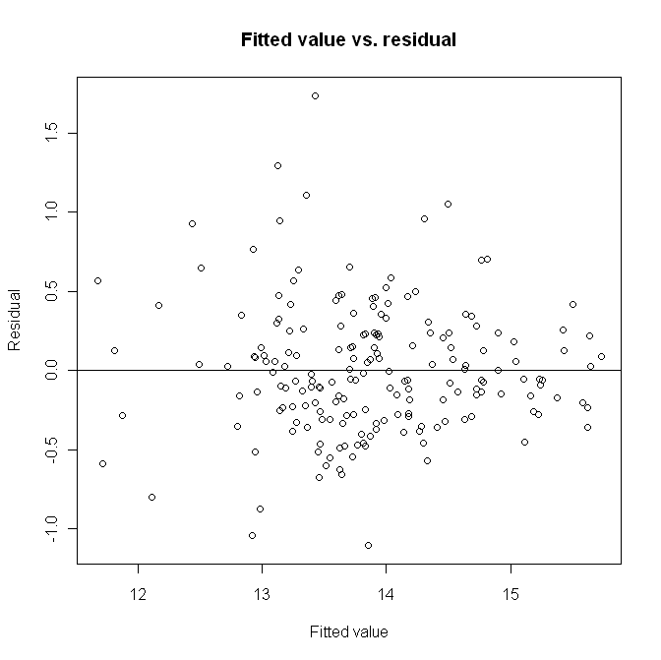 | Linear regression results
   | Estimate | Pr(>|t|)
  B₀ | -0.78 | 0.7837
  B₁ | 1.57 | 0.0002
  B₂ | 2.51 | 0.0002
  B₃ | 11.71 | 0.230
  B₄ | -0.24 | 0.016
  B₅ | -2.51 | 0.256
  B₆ | -1.70 | 0.223
  B₇ | 0.36 | 0.234
  Adjusted R-squared: 0.79

- Project duration vs. delivery type
The impact of project delivery type (state or county) on bridge engineering design project duration was investigated next. Results are summarized Table 8. Since the p-value for B₀ and B₁ are << 0.001, there is evidence for project delivery being a significant variable in explaining the observed variation in project duration. The total project duration for county delivered projects was 714 days; whereas the total project duration for state delivered projects was 1022 days. A significant difference was also found when only the engineering design portion of projects was compared. While only a small portion of the variation in project duration (slightly less than 10%) can be explained by delivery type, the relationship is statistically significant.

In summary, project delivery type is a significant predictor of project duration. However, project delivery type explains only a very small percentage of the observed variation in project duration.

Table 8: Project duration and delivery method
Model variables | Model  Tested:  L-duration = B₀ + B₁×Fund  Valid:  L-duration = 6.57 + 0.36×Fund
  Type | Name | Description
  Indicator | Fund | $$\begin{aligned}\left\{1 \text{State}−\text{delivery} | \right.\end{aligned}$$
  Dependent | L-duration | Log (duration)
County Delivery  State Delivery  Total Duration (days)  3000  1800  1000  670  400  245  150  Delivery Method | ANOVA results
   | Estimate | Pr(>|t|)
  B₀ | 6.57 | < <0.001
  B₁ | 0.36 | <<0.001
  Adjusted R-squared: 0.096

- Bridge length vs. delivery method
The relationships between project delivery type and bridge length was investigated next. This analysis was needed to determine if the two delivery methods could be distinguished based on bridge length, e.g. if only shorter bridges were built using county delivery and/or if longer bridges were only built using state delivery. The results of this analysis are summarized in Table 9. Since the p-values for B₁ (0.30) is greater than 0.05 there is no evidence that project delivery type is related to bridge length.

In summary, no significant relationship was found, for the bridge replacement projects included in this study, between bridge length and project delivery type.
Table 9: Bridge length vs. delivery method
Model variables | Model  Tested:  L-length = B₀ + B₁×Fund  Valid: NA
  Type | Name | Description
  Indicator | Fund | $$\begin{aligned}\left\{1 \text{State}−\text{delivery} | \right.\end{aligned}$$
  Dependent | L-length | Log(length)
County Delivered Project  State Delivered Project  Length (ft)  Delivery Method  665  400  250  150  90  55  33 | ANOVA results
   | Estimate | Pr(>|t|)
  B₀ | 4.56 | < <0.001
  B₁ | -0.12 | 0.30
  Adjusted R-squared: -0.004

- Project cost vs. project duration, bridge length, delivery method, and closure type
In the next analysis, a fourth variable, closure type, was included in the model. In the Phase I analysis, bridge closure was defined with an indicator variable, and projects were identified as having required bridge closure or not having required bridge closure. Project costs are plotted against project duration and bridge length for projects requiring closure and projects not requiring closure in Figure 11. It was necessary to use log transformations of cost, duration, and length to obtain a distribution of data appropriate for linear regression analysis.

In summary, the type of bridge closure was not found to have a significant relationship with either project duration or bridge length, with the initial categorization of bridges remaining open or bridges closed during the replacement project.

Total Cost ($)
665
400
250
150
90
55
33
Bridge not closed
Bridge closed
9,000,000
3,300,000
1,200,000
450,000
160,000
60,000
Length (Ft)

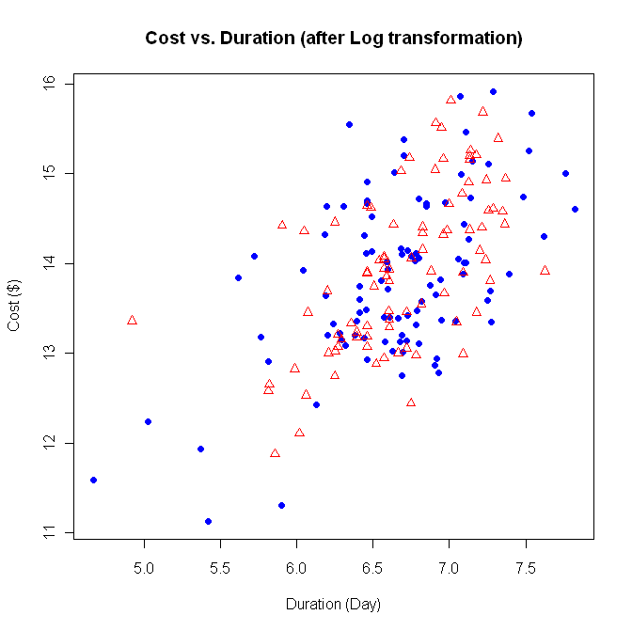
1800
1000
670
400
245
150
Total Cost ($)
Bridge not closed
Bridge closed
Duration (Days)
9,000,000
3,300,000
1,200,000
450,000
160,000
60,000

Figure 11: Scatter graph of project cost vs. project duration and vs. bridge length

- Project cost vs. bridge length after removing upper and lower tails
Because the data set contained only a small number of state-delivered projects for shorter bridges and a small number of county-delivered projects for longer bridges, the upper and lower tails of the data set were removed to determine if a better model could be identified. The bridge projects that were removed from the data set are identified with a number in Figure 12. The results from this analysis are summarized in Table 10. The assumption of constant variance of the errors appears to be a valid assumption for this data set when transformed values for cost and length are used. Since the p-values for B₂ (0.90) and B₃ (0.94) are greater than 0.05 there is no evidence that project delivery type is related to project cost even when extreme points are removed from the data set.
In summary, even with higher and lower cost projects removed from the dataset, there was no indication that project costs could be predicted based on the type of delivery. Thus, data from all 190 bridge replacement projects are used for all remaining Phase I and Phase II analyses.

665
400
250
150
90
55
33
Cost ($)
Length (ft)
Bridge not closed
Bridge closed
9,000,000
3,300,000
1,200,000
450,000
160,000
60,000
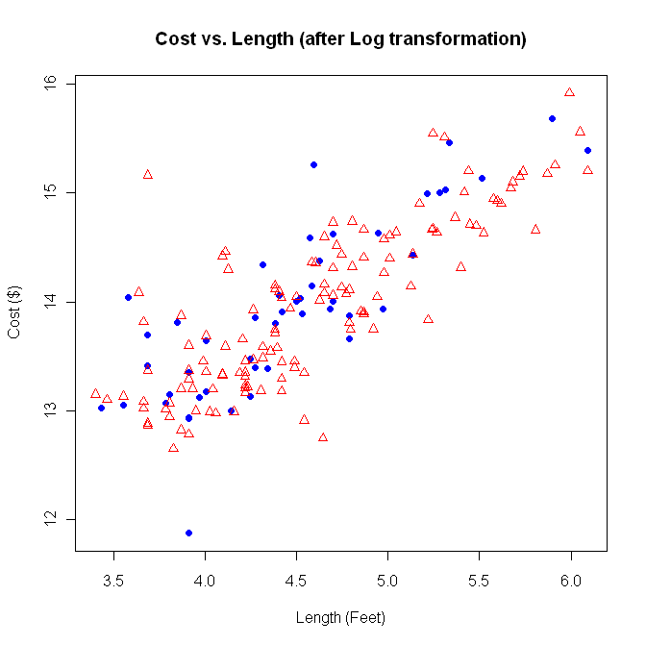
400
250
150
90
55
33
Cost ($)
Length (ft)
9,000,000
3,300,000
1,200,000
450,000
160,000
Bridge not closed
Bridge closed

Figure 12: Scatter graphs of project cost vs. length with extreme points identified and after removing the upper and lower tails

Table 10: Project cost vs. bridge length after removing upper and lower tail data
Model variables | Model  Tested:  L-cost = B₀ + B₁×L-length+B₂× Fund + B₃× L-length:Fund  Valid:  L-cost = 9.39 + 0.99 × L-length
  Type | Name | Description
  Indicator | Fund | $$\begin{aligned}\left\{1 \text{State}−\text{delivery} | \right.\end{aligned}$$
  Independent | L-length | Log(length)
  Dependent | L-cost | Log(cost)
Assumption validation  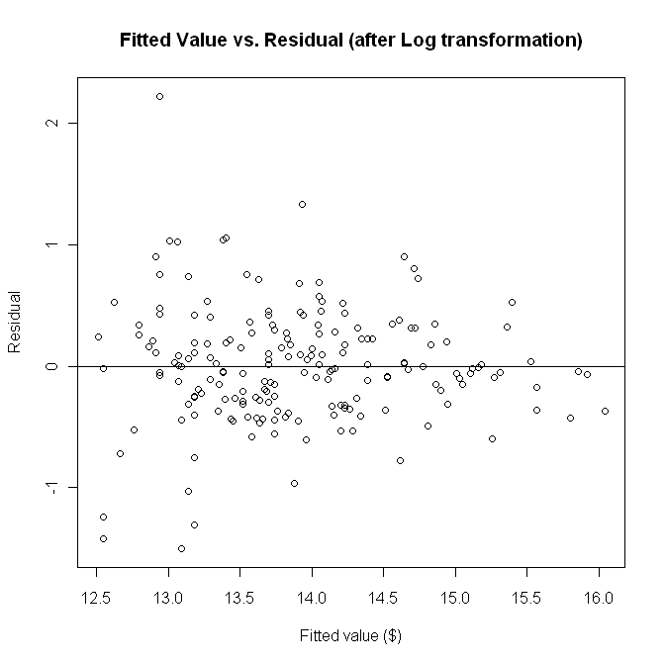 | Linear regression result
   | Estimate | Pr(>|t|)
  B₀ | 9.39 | <<0.001
  B₁ | 0.99 | <<0.001
  B₂ | 0.072 | 0.90
  B₃ | -0.0095 | 0.94
  Adjusted R-squared: 0.62

- Project cost vs. engineering project duration
Project costs were also analyzed looking at only the engineering design portion of the project duration (eduration). As can be seen in Figure 13, log transformation of both engineering design costs and engineering design duration are necessary. After transforming the engineering cost and engineering design duration data, a regression model was tested. Results are summarized in Table 11. The assumption of constant variance of the errors appears to be a valid assumption for this data set when transformed values for cost and engineering design duration are used. Since the p-values for B₂ (0.53) and B₃ (0.50) are greater than 0.05 there is no evidence that either project delivery type or the interaction between project delivery type and the engineering design project duration can be used to explain the observed variation in costs. This model does support a significant relationship between project duration and project costs, with project duration explaining approximately 14% of the observed variation in project costs as measured by the adjusted R-squared value of 0.14. Differences observed in the project costs cannot be attributed to the type of project delivery used (state or county).

In summary, consistent with the total cost analysis, engineering design duration does account for some (approximately 14%) of the observed variation in engineering design costs.
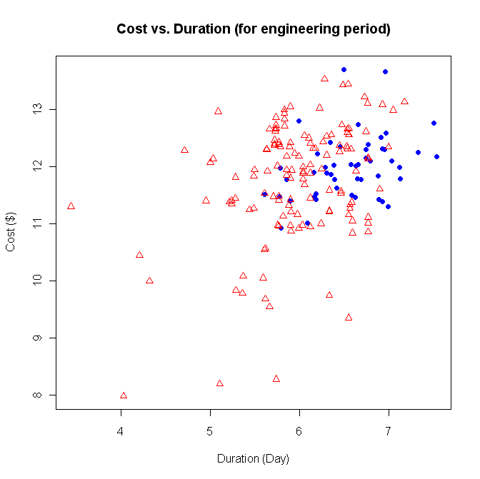
Engineering Design Cost ($)
1,100
400
150
55
450,000
160,000
60,000
20,000
8,000
3,000
County delivery
State delivery
Engineering Design Duration (Days)

Figure 13: Scatter graph of the engineering design cost vs. engineering design duration

Table 11: Project cost vs. project duration during the engineering phase of the project
Model variables | Model  Tested:  L-cost = B₀ + B₁×L-eduration+B₂× Fund + B₃× L-eduration:Fund  Valid:  L-cost = 7.99 + 0.63 × L-eduration
  Type | Name | Description
  Indicator | Fund | $$\begin{aligned}\left\{1 \text{State}−\text{delivery} | \right.\end{aligned}$$
  Independent | L-eduration | Log(duration)
  Dependent | L-cost | Log(cost)
Assumption Validation | Linear regression result
   | Estimate | Pr(>|t|)
  B₀ | 7.99 | <<0.001
  B₁ | 0.63 | <<0.001
  B₂ | 1.25 | 0.53
  B₃ | -0.21 | 0.50
  Adjusted R-squared: 0.1436
- Analysis Phase II
This section summarizes the findings resulting from the Phase II analyses. In this phase, four new variables (bridge width, clearance type, number of bids, and project location) were added to the study and one variable (bridge closure type) was refined. All of these new variables, except bridge width were indicator variables. The goal of Phase II was to investigate whether or not these additional variables could be used to explain variation in costs for the 190 bridge replacement projects included in this study. For Phase II analyses, costs and durations were analyzed more closely depending on the variables included in a particular model. Engineering costs, construction costs, or total costs were used as appropriate to the particular analysis being performed. Similarly, engineering design, construction, or total durations were used depending on the variables being studied.

Three clearance types were defined for the study. The projects were divided depending on whether the bridge spanned over water, over a railroad, or over irrigation / canals. The number of bids received for each project was used to create three categories of bridge projects (projects with two or few bids, projects with three to five bids, and projects with six or more bids). Project location was categorized based on the geographical location of the project. Each project was located in one of the five defined regions. A refined bridge closure factor was defined based on whether a project used building stages, onsite detours, or offsite detours. The bridge closure variable used in Phase I categorized bridge projects based on whether or not bridge closure was required during construction. This previous definition led to some ambiguity, thus additional data were obtained to more clearly specify what method was used during construction. The notation used for Phase II variables is summarized in Table 12.

Table 12: Notation for Phase II variables
Item | Definition | Item | Definition
TCOST | Total Cost | L_TCOST | Log transformation of total cost
PCOST* | Preliminary engineering cost | L_PCOST | Log transformation of preliminary engineering cost
CCOST* | Construction cost | L_CCOST | Log transformation of construction cost
TDUR | Total Duration | L_TDUR | Log transformation of total duration
PDUR** | Engineering design duration | L_PDUR | Log transformation of engineering duration
CDUR** | Construction duration | L_CDUR | Log transformation of construction duration
LENGTH | Bridge length | L_LENGTH | Log transformation of length
WIDTH | Bridge width | L_WIDTH | Log transformation of width
REG.FACT | Region factor (1, 2, 3, 4, 5) | BC.FACT | Bridge closure factor (Built in stages, On-site detour, Off-site detour)
CT.FACT | Clearance type factor (Over water, over railroad, over irrigation/canal)
*: TCOST=PCOST+CCOST **: TDUR=PDUR+CDUR
- Project cost vs. clearance type
Project costs were analyzed as a function of clearance type. Analysis of variance was completed to determine if clearance type was a significant predictor. Based on the results from the analysis of variance, clearance type was found to be a significant predictor for project costs. Residuals were plotted against fitted values to confirm constant variance. Linear regression models were then built for each category of clearance. The results of these analyses are summarized in Table 13. Since the p-values for the analysis of variance is less than 0.05 there is evidence that clearance type can be used to explain the observed variation in project costs. Since the p-values for B₀ and B₂ are less than 0.05, three different cost equations can be created, one for each type of clearance. This model, however, explains only a very small percentage (3%) of the observed variation (adjusted R-squared = 0.03). The average project cost for bridges built over railroad are higher than projects replacing bridges built over water or irrigation/canals. The least expensive bridge replacement projects are those where the bridge is built over irrigation/canals.

In summary, although the cost models for the clearance type do differ, clearance type explains only a very small portion (3%) of the observed variation in project costs. The same analyses were also completed, using only construction costs as the dependent variable. Parallel results were found.
Table 13: Project cost vs. clearance type
Model variables | Model  Tested:  L_TCOST = B₀ + B₁ × CT_OR + B₂ × CT_OI  Valid:  L_TCOST1=13.43 (Avg. cost over water)  L_TCOST2=13.74 (Avg. cost over railroad)  L_TCOST3=12.95 (Avg. cost over irrigation/canal)
  Type | Name | Description
  Indicator | CT_OR | $$\begin{aligned}\left\{1 \text{over}−\text{railroad} | \right.\end{aligned}$$
  Indicator | CT_OI | $$\begin{aligned}\left\{1 \text{over} −{\text{irr}}/{\text{canal}} | \right.\end{aligned}$$
  Dependent | L_TCOST | Log(TCOST)
Analysis of Variance results | Linear regression results
   | Df | Pr(>F)
  CT.FACT | 2 | 0.01420
  Residuals | 0.92
   | Estimate | Pr(>|t|)
  B₀ | 13.43 | <<0.001
  B₁ | 0.32 | 0.589
  B₂ | -0.79 | <<0.001
  Adjusted R-squared: 0.03427

- Construction cost vs. bridge closure
Construction costs were analyzed next as a function of bridge closure type. The results for construction cost are summarized in Table 14. Residuals were plotted against fitted values to confirm constant variance. Analysis of variance was completed to determine if bridge closure type was a significant predictor of construction costs. The p-value was slightly larger than 0.05. Linear regression models were then built for each category of closure (on-site detour, off-site detour, and staged build). Since the p-values for B₀ and B₂ are less than 0.05, two different cost equations can be created, one for on-site or off-site detours and one for projects where staged builds were used. The average project cost for bridges in which a staged build was used are higher than projects using either on or off-site detours. This model, however, explains only a very small percentage (< 2%) of the observed variation (adjusted R-squared = 0.02).

In summary, although the cost models for the closure type do indicate that projects using a staged build have higher construction costs, the observed impact on construction costs was minimal.

Table 14: Construction cost vs. bridge closure type
Model variables | Model  Tested:  L_CCOST = B₀ + B₁ × BC_OF + B₂ × BC_BS  Valid:  L_CCOST1=13.28 (Avg. cost on-site detour or off-site detour)  L_CCOST2=13.72 (Avg. cost built in stages)
  Type | Name | Description
  Indicator | BC_OF | $$\begin{aligned}\left\{1 \text{offsite} | \right.\end{aligned}$$
  Indicator | BC_BS | $$\begin{aligned}\left\{1 \text{built} \text{in} \text{stage} | \right.\end{aligned}$$
  Dependent | L_CCOST | Log(CCOST)
ANOVA | Linear regression results
   | Df | Pr(>F)
  BC.FACT | 2 | 0.05843
  Residuals | 0.93
   | Estimate | Pr(>|t|)
  B₀ | 13.28 | <<0.001
  B₁ | 0.02288 | 0.8904
  B₂ | 0.42719 | 0.0369
  Adjusted R-squared: 0.01954
Results and assumption validation
Construction Cost ($)
3,300,000
1,200,000
450,000
160,000
60,000
Closure Type
Onsite Detour Offsite Detour Built in Stages

- Construction cost vs. number of bids
The next variable that was analyzed was the number of bids received for a bridge replacement project. Construction costs were analyzed vs. number of bids using a linear regression model. The results are summarized in Table 15. Residuals were plotted against fitted values to confirm constant variance. Linear regression models were then built for each of three categories of bids received (two or fewer bids, three to five bids, and six or more bids). Since the p-values for B₀, B₀, and B₂ are less than 0.05, three different construction cost equations can be created, one for category of bids. This model explains approximately 10% of the variation observed in construction costs (adjusted R-squared = 0.10). However, this variable does not explain a significant portion of total project costs.

In summary, the number of bids received for a bridge replacement project is related to the construction costs of the completed project, but is not a significant predictor of total project costs.

Table 15: Construction costs vs. number of bids
Model variables | Model  Tested:  L_CCOST = B₀ + B₁ × Bids1 + B₂ × Bids2  Valid:  Valid model 1:  L_CCOST= 13.04 (Two or fewer bids)  Valid model 2:  L_CCOST=13.63 (Three to five bids)  Valid model 3:  L_CCOST=14.31(Six or more bids)
  Type | Name | Description
  Indicator | Bids1 | $$\begin{aligned}\left\{1 {\text{three}}_{{\text{to}}_{\text{five}}} | \right.\end{aligned}$$
  Indicator | Bids2 | $$\begin{aligned}\left\{1 {\text{six}}_{{\text{or}}_{\text{more}}} | \right.\end{aligned}$$
  Dependent | L_CCOST | Log(CCOST)
Assumption Validation  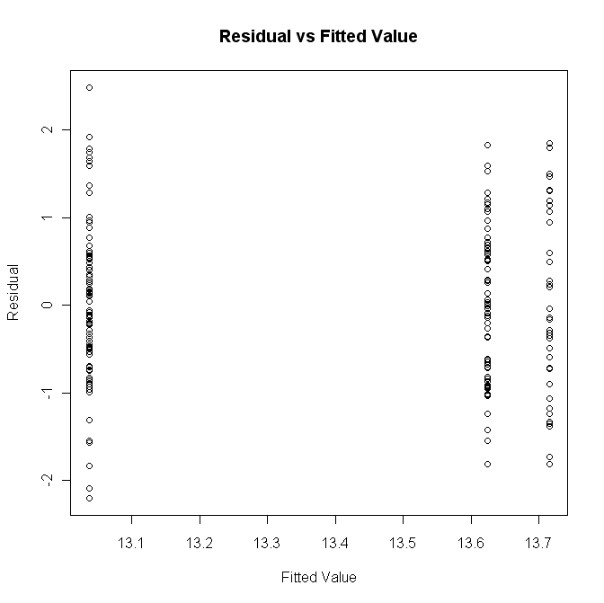 | Linear regression results
   | Estimate | Pr(>|t|)
  B₀ | 13.04 | 0.000
  B₁ | 0.59 | 0.000
  B₂ | 0.68 | 0.000
  Adjusted R-squared: 0.101
- Project duration vs. region
Project duration was analyzed vs. regions using linear regression models. Three different durations were analyzed – the design duration, the construction duration, and the total project duration. The results are summarized in Tables 16, 17, and 18, respectively. Residuals were plotted against fitted values to confirm constant variance for all three models. In the first linear regression model analyzing the relationship between design duration and region, the p-values for the parameters were significant for the parameters for four of the five regions. Regions 4 and 5 had the lowest engineering design durations (averaging approximately 345 days). Regions 1 and 2 had the highest average engineering durations (averaging 626 days). The average design duration for region 3 was 459 days. Approximately 10% (adjusted R-squared = 0.10) of the variation in design duration can be explained by differences due to the location of the bridge replacement project.

Table 16: Design duration vs. region
Model variables | Model  Tested:  L_PDUR = B₀ + B₁ × Reg2 + B₂ × Reg3 + B₃ × Reg4 + B₄ × Reg5  Valid model 1:  L_PDUR= 6.44 (regions 1 and 2)  Valid model 2:  L_PDUR=6.13 (region 3)  Valid model 3:  L_PDUR= 5.85 (region 4)  Valid model 4:  L_PDUR= 5.84 (region 5)
  Type | Name | Description
  Indicator | Reg2 | $$\begin{aligned}\left\{1 {\text{region}}_{2} | \right.\end{aligned}$$
  Indicator | Reg3 | $$\begin{aligned}\left\{1 {\text{region}}_{3} | \right.\end{aligned}$$
  Indicator | Reg4 | $$\begin{aligned}\left\{1 {\text{region}}_{4} | \right.\end{aligned}$$
  Indicator | Reg5 | $$\begin{aligned}\left\{1 {\text{region}}_{5} | \right.\end{aligned}$$
  Dependent | L_PDUR | Log(PDUR)
Assumption Validation | Linear regression results
   | Estimate | Pr(>|t|)
  B₀ | 6.44 | 0.000
  B₁ | -0.28 | 0.051
  B₂ | -0.31 | 0.031
  B₃ | -0.59 | 0.001
  B₄ | -0.60 | 0.000
  Adjusted R-squared: 0.101

In the second linear regression model analyzing the relationship between construction duration and region, the p-values for the parameters were significant for only region 4. Regions 1, 2, 3, and 5 had average construction durations of 305 days; whereas the average construction duration for region 4 was 194 days. Approximately 10% (adjusted R-squared = 0.10) of the variation in construction duration can be explained by differences due to the location of the bridge replacement project.

Table 17: Construction duration vs. region
Model variables | Model  Tested:  L_CDUR = B₀ + B₁ × Reg2 + B₂ × Reg3 + B₃ × Reg4 + B₄ × Reg5  Valid model 1:  model 1:  L_CDUR= 5.72 (regions 1, 2, 3, and 5)  model 2:  L_CDUR=5.27 (region 4)
  Type | Name | Description
  Indicator | Reg2 | $$\begin{aligned}\left\{1 {\text{region}}_{2} | \right.\end{aligned}$$
  Indicator | Reg3 | $$\begin{aligned}\left\{1 {\text{region}}_{3} | \right.\end{aligned}$$
  Indicator | Reg4 | $$\begin{aligned}\left\{1 {\text{region}}_{4} | \right.\end{aligned}$$
  Indicator | Reg5 | $$\begin{aligned}\left\{1 {\text{region}}_{5} | \right.\end{aligned}$$
  Dependent | L_CDUR | Log(CDUR)
Assumption Validation  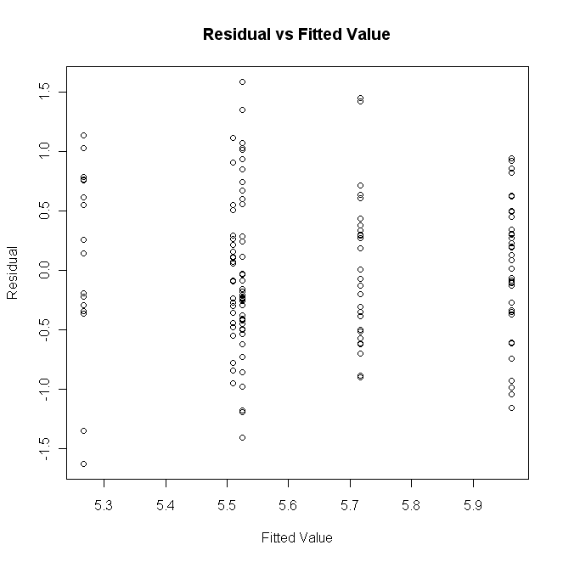 | Linear regression results
   | Estimate | Pr(>|t|)
  B₀ | 5.72 | 0.000
  B₁ | -0.19 | 0.170
  B₂ | 0.25 | 0.083
  B₃ | -0.45 | 0.017
  B₄ | -0.21 | 0.156
  Adjusted R-squared: 0.101

In the third linear regression model analyzing the relationship between the total project duration and region, the p-values for the parameters were significant for only regions 4 and 5. Regions 1, 2, and 3 had average project durations of 972 days; whereas the average project duration for region 4 was 584 days and was 633 days for region 5. Approximately 10% (adjusted R-squared = 0.10) of the variation in project duration can be explained by differences due to the location of the bridge replacement project.

In summary, projects take longer in the regions 1, 2, and 3 than in regions 4 and 5.

Table 18: Total project duration vs. region
Model variables | Model  Tested:  L_TDUR = B₀ + B₁ × Reg2 + B₂ × Reg3 + B₃ × Reg4 + B₄ × Reg5  Valid:  model 1:  L_TDUR= 6.88 (regions 1, 2, and 3)  model 2:  L_TDUR=6.37 (region 4)  model 3:  L_DUR= 6.45 (region 5)
  Type | Name | Description
  Indicator | Reg2 | $$\begin{aligned}\left\{1 {\text{region}}_{2} | \right.\end{aligned}$$
  Indicator | Reg3 | $$\begin{aligned}\left\{1 {\text{region}}_{3} | \right.\end{aligned}$$
  Indicator | Reg4 | $$\begin{aligned}\left\{1 {\text{region}}_{4} | \right.\end{aligned}$$
  Indicator | Reg5 | $$\begin{aligned}\left\{1 {\text{region}}_{5} | \right.\end{aligned}$$
  Dependent | L_TDUR | Log(TDUR)
Assumption Validation  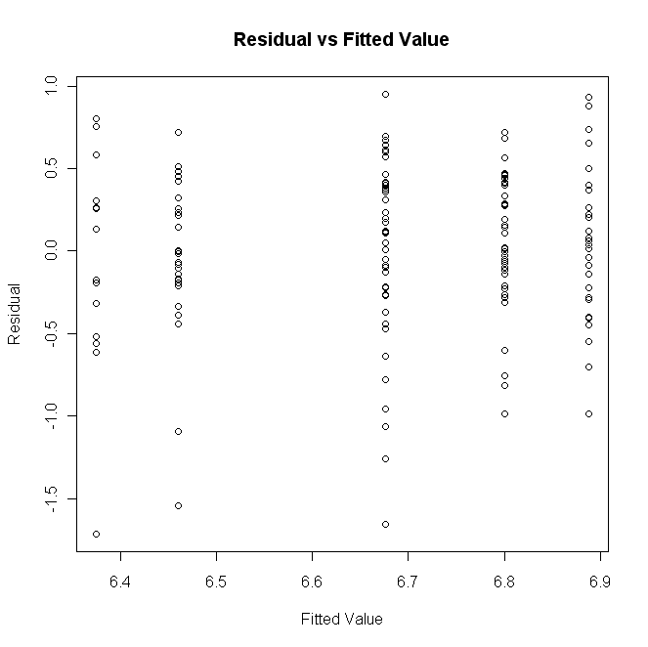 | Linear regression results
   | Estimate | Pr(>|t|)
  B₀ | 6.88 | 0.000
  B₁ | -0.21 | 0.052
  B₂ | -0.09 | 0.414
  B₃ | -0.51 | 0.000
  B₄ | -0.43 | 0.000
  Adjusted R-squared: 0.102

- Conclusions
This study was focused on determining whether or not the source of funding was a significant factor in determining bridge replacement project costs. A secondary purpose of the study was to identify key variables that could be used to explain observed variations in project costs. Data from 190 bridge replacement projects was used in the analyses described in this report. Based on the analyses complete, variation in total project costs can be explained primarily by the length of the bridge being replaced, the width of the bridge being replaced, and the overall duration of the project. A small amount of the variation observed in project length (approximately 5%) can be attributed to the clearance type (over water, over railroad, or over irrigation/canal). Similarly a small amount (10%) of the variation observed in project duration can be attributed to the type of delivery. Analyses were also completed using cost/square foot and cost/linear foot as the dependent variable.

Overall, it was shown that for the 190 bridges included in this study, the type of delivery (state or county) does not impact project costs directly. There was also no evidence that bridge closure type when treated as a binary (closed or not closed) or indicator variable (built in stages, off-site detour, or on-site detour) can explain the observed variations in project costs.

The number of bids and the location of the bridge replacement project were both found to have a small impact on construction costs but did not explain a significant portion of the observed variation in total project costs.

The best model found, as a result of the analysis, is the model that includes project duration, bridge length, and bridge width (p-value <<< 0.001, adjusted R-square= 0.86). In this model, project delivery type was found to impact project duration, which in turn impacted project costs. The majority of variation in project costs can be explained by bridge length (adjusted R-square = 0.72). The general relationship between cost and the other independent variables found to be significant is summarized in Figure 7.
- Appendix A: Bridges included in analysis
County | Original NBIS # | New NBIS # | Bridge Name | Road Name | Funding Source
Baker County | 01C408 | 20259 | Burnt R Clarks Creek Rd. | County Rd. 1121 | OTIA III
Baker County | 01C227 | 20258 | Cracker Crk/Cracker Cr. R. | C-553 NON-FA | OTIA III
Baker County | 01C522 | 19803 | Dixie Creek | Rye Valley Road | OTIA I
Baker County | 00741 | 19280 | Pritchard Cr (Old US 30) | County Rd 539 | HBP
Benton County | 14103 | N/A | Bottger Creek | Hoskins Road | Local
Benton County | 14185 | 19616 | Flat Creek | Old River Road | OTIA I
Benton County | 03C10 | 19216 | Muddy Creek | Airport Road | HBP
Benton County | 14401 | 19862 | Muddy Creek |  | OTIA I
  Llewellyn Road
Benton County | 14402 | 18865 | Muddy Crk Overflow Channel | Llewellyn Road | HBP
Benton County | 14195 | 19215 | Newton Creek | Chapel Drive | HBP
Benton County | 14122 | 20130 | Oliver Creek | Bellfountain Rd. | OTIA III
Benton County | 14523A | N/A | Stewart Slough | Seavy Ave | Local
Benton County | 14528 | 20731 | West Fork Mary's River | Long Road | HBP
Clackamas County | 06223 | 18285 | Abernethy Creek | Anchor Way | HBP
Clackamas County | 05C09 | 19119 | Abernethy Creek | Washington Street | HBP
Clackamas County | N/A | 20793 | Bear Creek | Lolo Pass Road | Local
Clackamas County | N/A | 20779 | Buckner Creek | Beavercreek Road | Local
Clackamas County | 06607 | 18853 | Eagle Creek | Rainbow Road | HBP
Clackamas County | 06541 | 20149 | Milk Creek | Dhooge Road | OTIA III
Clackamas County | 06511 | 20147 | Milk Creek | Mulino Road | OTIA III
Clackamas County | 06562 | 19749 | Mill Creek | Graves Road | OTIA I
Clackamas County | 00605 | 20148 | Molalla River | Fryrer Park Road | OTIA III
Clackamas County | 06429 | 18095 | Oswego Canal | Childs Road | HBP
Clackamas County | 06605 | 19593 | Salmon River | East Bridge Road | HBP
Clackamas County | 06401 | 19951 | Zigzag River | Lolo Pass Road | HBP
Clatsop County | 11158A | 18842 | Lower Walluski Road | Labiske Road | HBP
Clatsop County | 11159A | 18843 | Upper Walluski Road | Labiske Road | HBP
Columbia County | 13378 | 19118 | Beaver Creek | Heath Road | HBP
Columbia County | 00157 | 20059 | Beaver Creek | Old Hwy 30 @ MP 4.60 | HBP
Columbia County | 00155 | 20058 | Beaver Creek | Old Hwy 30 @ MP 5.49 | HBP
Columbia County | 13771A | 20653 | East Fork Nehalem River | Scappoose-Vernonia Hwy. | OTIA III
Columbia County | 13746A | 20655 | Lizzie Creek | Chapman Road | OTIA III
Columbia County | 13791A | 20658 | Lost Creek | Lost Creek Road | OTIA III
Columbia County | 09C22 | 20654 | North Fork Scappoose Creek | Chapman Grange Road | OTIA III
Columbia County | 13764A | 20652 | North Fork Scappoose Creek | Scappoose-Vernonia Hwy. | OTIA III
Columbia County | 9C158 | N/A | South Beaver Creek | Old Hwy 30 | OTIA III
Columbia County | 13626A | 20656 | Tide Creek | Anliker Road | OTIA III
Coos County | 08927 | 20126 | Beaver Slough | Leneve Bridge | OTIA III
Coos County | 11C22 | 19665 | Cunningham Creek | Cunningham Road | HBP
Coos County | 11C108 | 18850 | Drain Ditch | Benson Creek Road | HBP
Coos County | 11C113 | 20356 | Kentuck Slough | County Rd. 45 | OTIA III
Coos County | C1101 | 18821 | Larson Creek | County Road 7A | HBP
Coos County | 11C53 | 20102 | Noble Creek | County Rd. 186 | OTIA III
Coos County | 01314A | 20127 | North Fork Coquille River | Cooper | OTIA III
Coos County | 08464 | 20128 | North Fork Coquille River | Gravelford Road | OTIA III
Coos County | 11C90X | 18854 | Saunders Lake | County Road 220A | HBP
Coos County | 08859 | 20129 | Stringtown Overflow | County Rd. 5A | OTIA III
Coos County | 11C78 | 20205 | Upper Rock Creek | County Rd. 21C | OTIA III
Crook County | 16636 | 19913 | Crooked River | Conant Basin Road | HBP
Crook County | 13C12 | 19026 | Crooked River | Elliot Lane | HBP
Crook County | 13C28 | 20027 | Crooked River | Newsom Road | OTIA III
Crook County | 371-1 | N/A | Irrigation Ditch | Riggs Road East | OTIA III
Crook County | 13C36A | 18955 | Ochocco Creek | Willowdale Road | HBP
Deschutes County | 09C35 | 19610 | Johnson Market Bridge | Johnson Market Road | OTIA I
Douglas County | 19C067 | 18903 | Bachelor Creek | County Road 50 | HBP
Douglas County | 19C486 | 20369 | Calapooya Creek | County Rd. 9 | OTIA III
Douglas County | 19C495 | 20531 | Cow Creek | County Rd. 21 | OTIA III
Douglas County | 19C472 | 20317 | Days Creek | Tiller-Trail Hwy. | OTIA III
Douglas County | 19C023 | 20154 | Deadman Creek | South Umpqua River Road | OTIA III
Douglas County | 19C481 | 20502 | Diamond Creek | Tiller-Trail Hwy. | OTIA III
Douglas County | 19C431 | 20411 | Emile Creek | Little River Road | OTIA III
Harney County | 25E32 | N/A | Crane Creek | Crane - Venator | Local
Harney County | 25D01 | 20453 | Dry Creek | Catlow Valley Road | OTIA III
Harney County | 25C02 | N/A | Dunder Und Blitzen | Narrrows - Princeton | Local
Harney County | 25A82 | 20455 | Ninemile Slough | IRR C106 | OTIA III
Harney County | 25E10 | 20279 | North Drewsey Slough | Drewsey Road | OTIA III
Harney County | 25E24 | 19624 | Pine Creek | Pine Creek Road | HBP
Harney County | 25A16 | 20454 | Silver Creek Slough | Silver Creek Road | OTIA III
Harney County | 25A22 | N/A | Silvies River - West Loop | West Loop | OTIA II
Harney County | 25E11 | 20280 | South Drewsey Slough | Drewsey Road | OTIA III
Harney County | 25A43 | 19922 | West Fork Silvies River | Greenhouse Lane | OTIA II
Jackson County | 29C195 | 20177 | Antelope Creek | E. Antelope Road | Local
Jackson County | 29C34 | 20178 | Antelope Creek | Meridan Road | OTIA I
Jackson County | 07811 | 20121 | Applegate River | Applegate Road | OTIA III
Jackson County | 08038 | 20122 | Applegate River | Applegate Road | OTIA III
Jackson County | 07503 | 20087 | Bear Creek | County Road No. 960 | OTIA III
Jackson County | 06947 | 19630 | Bear Creek | East Pine Street | HBP
Jackson County | 07703 | 18869 | BEAR CREEK | Kirtland Road | HBP
Jackson County | 07990 | 20086 | Bear Creek | West Valley View Road | OTIA III
Jackson County | 07905 | 20067 | Beaver Creek | Applegate Road | OTIA III
Jackson County | 29C224 | 20187 | Big Butte Creek | Netherlands Road | OTIA I
Jackson County | N/A | N/A | Cottonwood Creek | Colestin Road | Local
Jackson County | 08707 | 20083 | Emigrant Creek | Dead Indian Road | OTIA III
Jackson County | 08914 | 20055 | Evans Creek | Evans Creek Road | OTIA III
Jackson County | 07229 | 20056 | Evans Creek | Evans Creek Road | OTIA III
Jackson County | 29C218 | 19614 | Foots Creek | Right Fork Foots Creed Road | OTIA I
Jackson County | 29C185 | N/A | Galls Creek | Galls Creek Road | Local
Jackson County | 07988 | 20220 | Little Applegate River | Applegate Road | HBP
Jackson County | 29C198 | 20105 | Pleasant Creek | Pleasant Creek Road | OTIA I
Jackson County | 07819 | 20071 | Red Blanket Creek | Butte Falls-Prospect Hwy. | OTIA III
Jackson County | 29C220 | 19615 | Right Fork Foots Creek | Foots Creek Road | OTIA I
Jackson County | 07708 | 20072 | Snider Creek | Table Rock Road | OTIA III
Jackson County | 07989 | 20068 | Star Gulch Creek | Applegate Road | OTIA III
Jackson County | 07687 | 20478 | Thompson Creek | Thompson Creek Road | OTIA III
Jackson County | 07688 | 20479 | Thompson Creek | Thompson Creek Road | OTIA III
Jackson County | 07689 | 20481 | Thompson Creek | Thompson Creek Road | OTIA III
Jackson County | 29C79 | 19780 | Wagner Creek | Wagner Creek Road | Local
Jackson County | 29C80 | 20458 | Wagner Creek | Wagner Creek Road | Local
Jefferson County | 31C50A | 20042 | Irrigation Canal | Park Lane | OTIA III
Jefferson County | 31C071 | 19779 | Trout Creek | Gosner Road | OTIA II
Josephine County | 122005 | 20350 | Coyote Creek | Bloom Road | OTIA III
Josephine County | 144005 | 19680 | Grave Creek | Beecher Road | HBP
Josephine County | 250005 | 20723 | Jones Creek | Foothill Blvd. | OTIA III
Josephine County | 33C13 | 20508 | Sucker Creek | Holland Loop Road | OTIA III
Josephine County | 420005 | 18908 | West Fork Williams Creek | East Fork Road | HBP
Klamath County | 08103 | 19068 | "A" Canal | Homedale Road | HBP
Klamath County | 18C025 | 20363 | Lost River | Crystal Springs Road | Local
Klamath County | 06745 | 20380 | Sprague River | Sprague River Road | OTIA III
Klamath County | 06835B | 20382 | Sprague River | Sprague River Road | OTIA III
Lake County | 37C041 | 20076 | Deep Creek | 3-14 | OTIA III
Lake County | 37C043 | 19841 | Dick's Creek | Crooked Creek | Local
Lake County | N/A | 20445 | Lower Crane Creek | Crane Creek 1-15 | OWEB
Lake County | N/A | 20446 | Upper Crane Creek | Crane Creek 1-15 | OWEB
Lane County | 14875A | N/A | Big River | London Road | OTIA III
Lane County | 39C224 | 20354 | Row River | Row River Road | OTIA III
Linn County | N/A | 19730 | Calapooia River | Driver Raod | HBP
Linn County | 12240 | 20257 | Calapooia River | Tangent Drive | OTIA III
Linn County | 12764 | 20331 | Calapooia River | Wirth Road | OTIA III
Linn County | 11965 | 18963 | Hamilton Creek | Plagman Drive | HBP
Linn County | 02623 | 20565 | Thomas Creek | Scio-Main Street | OTIA III
Malheur County | 45C135 | 18946 | Alkali Creek | Woodbridge Road | HBP
Malheur County | 45C121 | 19697 | Bull Creek Canal | Bully Creek Road | OTIA I
Malheur County | 15521A | 20281 | Drain Ditch | Harper-Westfall Road | OTIA III
Malheur County | 45R10 | 19921 | Low Lift Canal | Fir Road | OTIA I
Malheur County | 45C220 | 19920 | Owyhee Canal | Clark Boulevard | OTIA I
Malheur County | 45C119 | 19676 | Vale Main Canal | Reservoir Road | Local
Marion County | 47C53 | 20330 | Abiqua Creek | South Abiqua Road | HBP
Marion County | 1501 | 20620 | Mill Creek | Marion Road SE | Local
Marion County | 47C22 | 20091 | Pudding River | Mt. Angel-Gervais Road | OTIA III
Marion County | 47C21 | 20217 | Pudding River (Overflow) | Mt. Angel-Gervais Road | OTIA III
Marion County | 01106 | 20150 | Rail Road | Jeffrson-Marion Hwy. | OTIA III
Morrow County | 49C23 | 20073 | Rhea Creek | Brenner Canyon Road | OTIA I
Multnomah County | 04522 | N/A | Beaver Creek Bridge | Beaver Creek Bridge | OTIA I
Polk County | 53B04 | 19969 | Little Luckiamute River | Bridge Street | OTIA III
Polk County | 53C112 | 18939 | Little Luckiamute River | Socialist Valley Road | HBP
Polk County | 53C017 | 19978 | Luckiamute River | Airlie Road | OTIA III
Polk County | 10307A | 19970 | Luckiamute River | Buena Vista Road | OTIA III
Polk County | 53C013 | 19976 | Luckiamute River | Corvallis Road | OTIA III
Polk County | 53C083 | 19974 | Rickreal Creek | Rickreall Road | OTIA III
Polk County | 53C029 | 19975 | Rickreall Creek | Greenwood Road | OTIA III
Polk County | 53C077 | 19973 | Rock Creek | Fire Hall Road | OTIA III
Polk County | 53C110) | 20299 | Teal Creek | Frost Road | HBP
Polk County | 53C113 | 19972 | Willamette River Overflow | Wigrich Road | OTIA III
Tillamook County | 57C28 | 20629 | Bewley Creek | Bewley Creek Road | OTIA III
Tillamook County | 57C26 | 19625 | Blaser Bridge | Tillamook River Road | OTIA I
Tillamook County | 06550 | N/A | Earl Bridge | Long Prairie Road | OTIA II
Tillamook County | 57C45 | 20106 | East Creek | Moon Creek Road | OTIA III
Tillamook County | 57C29 | 20630 | Killam Creek | South Prairie Road | OTIA III
Tillamook County | 57C73 | 18984 | Neskowin Creek | Cascade Trace Road | HBP
Tillamook County | 11380A | 20276 | Nestucca River | Blaine Road | OTIA III
Tillamook County | 57C35 | 20625 | Wilson River | Kansas Creek Road | OTIA III
Umatilla County | 59C636 | 20284 | Despain Gulch | Despain Gulch Road | OTIA III
Umatilla County | 59C535 | 18942 | Dry Creek | Harris Rd | HBP
Umatilla County | 59C422 | 20256 | Dry Creek | Steen Road | OTIA II
Umatilla County | 59C714 | 20285 | Greasewood Creek | Columbia Street | OTIA III
Umatilla County | 59C680 | 20368 | Stage Gulch Ditch | Cooper Road | HBP
Umatilla County | 59C212 | 18954 | US Feed Canal | Cooper Road | HBP
Umatilla County | 59C205 | 19987 | US Feed Canal | Stage Gulch Road | HBP
Umatilla County | 59C627 | 20283 | Vansycle Canyon | Butler Grade Road | OTIA III
Umatilla County | 59C358 | 18938 | Wildhorse Creek | McCormach Road | HBP
Union County | 61C21 | 20174 | Catherine Creek | Badger Flat Lane | OTIA I
Union County | 61C19 | 20176 | Grande Ronde River | McKennon Lane | OTIA II
Union County | 61C30 | 20175 | Little Creek #5 | High Valley Road | OTIA I
Wallowa County | 63C13 | 20588 | Bear Creek | Bear Creek Road | OTIA III
Wallowa County | 63C01 | 20587 | Bear Creek | Frontage Road | OTIA III
Wallowa County | 63C81 | 20388 | Imnaha River | Lower Imnaha Road | HBP
Wallowa County | 63C80 | 20447 | Imnaha River | Upper Imnaha Road | OTIA III
Wallowa County | 63C79 | 20448 | Imnaha River | Upper Imnaha Road | OTIA III
Wallowa County | 063C17 | 20287 | Trout Creek | Golf Course Road | OTIA III
Wallowa County | 63C137 | 19939 | Wallowa River | Baily Lane | HBP
Wallowa County | 63C35 | 20288 | Wallowa River | Ed Long | OTIA I
Wallowa County | 63C36 | 20289 | Wallowa River | Orval Makin | OTIA II
Wallowa County | 63C019 | 18802 | Wallowa River | Wade Gulch Road | HBP
Wasco County | 00106 | 18774 | Eightmile River | Lower Eightmile Road | HBP
Washington County | 671664 | N/A | Beaver Creek | Timber Road | OTIA III
Washington County | 671367 | 20437 | East Fork Dairy Creek | Greener Road | OTIA III
Washington County | 671276 | 18951 | Galls Creek | Clapshaw Hill Road | HBP
Washington County | 671389 | 20297 | Nehalem River | Timber Road | OTIA III
Washington County | 671391 | 20296 | Nehalem River | Vernonia Road | OTIA III
Washington County | 01767 | 20069 | Tualatin River | OR 10 (Hwy 142) | HBP
Washington County | 671235 | 19619 | Tualatin River | Rood Bridge Road | OTIA II
Washington County | 671418 | 20295 | Tualatin River | SW Scholls Ferry Road | OTIA III
Washington County | 671234 | 19193 | Tualatin River Overflow | Minter Bridge Road | OTIA I
Yamhill County | 11540A | 20065 | Baker Creek | Baker Creek Road | OTIA III
Yamhill County | 11566 | 20066 | North Yamhill River | Meadow Lake Road | OTIA III
Yamhill County | 11605 | 19880 | Panther Creek | Rex Brown Road | OTIA I
Yamhill County | 11774C | 19161 | Willamina Creek | Tindle Creek Road | HBP
Yamhill County | 01751A | 20088 | Willamina Creek | Willamina Creek Road | OTIA III
Yamhill County | 11493A | 20351 | Yamhill River | Lafayette Hwy. | OTIA III
Yamhill County | 11645 | 20329 | Yamhill River | Moores Valley Road | OTIA III

- Appendix B: Bridges excluded from analysis
County | Original NBIS # | New NBIS # | Bridge Name | Road Name | Funding Source | Reason for Exclusion
Benton County | 14538 | N/A | Alsea River | Hayden Road | OTIA I | Covered Bridge Rehabilitation
Clackamas County | 01446 | N/A | Clackamas River | Springwater Road | OTIA III | Project Not Completed
Clackamas County | 06135 | 20408 | Johnson Creek | Johnson Ck. Blvd. | OTIA III | Project Not Completed
Clackamas County | 06570 | 20415 | Sandy River | Ten Eyck Road | OTIA III | Project Not Completed
Clackamas County | 06507 | 20765 | Tualatin River | Boarland Road | OTIA III | Project Not Completed
Clackamas County | 02567 | N/A | Tualatin River | Stafford Road | OTIA III | Project Not Completed
Columbia County | 00136 | 20057 | Beaver Creek | Old Hwy 30 @ MP 7.32 | HBP | Bridge Included Whole Corridor Study for Planning Purposes Prior to Design and Construction
Coos County | 02300A | 19663 | Isthmus Slough | Sumner Road | HBP | Over 700 Feet Long with Significant Environmental Issues
Crook County | 371-2 | N/A | Irrigation Ditch | Riggs Road West | OTIA III | Replaced with culvert -- Not NBIS
Douglas County | 19C513 | N/A | South Umpqua River | County Rd. 386 | OTIA III | Rehabilitation Project
Grant County | 23C011 | 18859 | North Fork John Day River | Rudio Road | HBP | Deck Replacement Only
Jackson County | 08540B | 20558 | Bear Creek | Upton road | OTIA III | Project Delivered by ODOT
Jackson County | 09089 | 20054 | Evans Creek | West Main Street | OTIA III | Project Not Completed
Jackson County | 06970 | 19273 | Rogue River | Depot Street | HBP | Arch Bridge with Accelerated Construction Component
Jackson County | 00374 | 20070 | Southern Pacific Railroad | County Road No. 804 | OTIA III | Project Costs Include Major Road Approach Work
Klamath County | 06746 | 20381 | Sprague River | Sprague River Road | OTIA III | Project Not Completed
Lane County | 039C24 | N/A | Coast Fork Willamette River | London Road | OTIA III | Rehabilitation Project
Lane County | 14868A | N/A | Coast Fork Willamette River | London Road | OTIA III | Rehabilitation Project
Lane County | 39C235 | 20352 | Sharps Creek | Sharps Creek Road | OTIA III | Rehabilitation Project
Lincoln County | 854A | N/A | Siletz River | Logsden Road | OTIA III | Project Not Completed
Linn County | 02373 | N/A | Calapooia River | Main Street | OTIA III | Rehabilitation Project
Linn County | 43C36 | 19687 | One Horse Slough | One Horse Slough | OTIA I | Incorporated Previously Used Slabs
Malheur County | 08754 | 20282 | Vale Canal | Harper-Westfall Road | OTIA III | No data for cost
Malheur County | 45C110 | N/A | Vale Main Canal | Ninth Avenue West | Local | Project Not Completed
Multnomah County | 51C11 | N/A | Corbett Hill Viaduct | Corbett Hill Road | OTIA I | Viaduct Replaced with Retaining Wall
Multnomah County | 02641 | 20136 | Willamette River Slough | Sauvie Island Road | OTIA III | Bridge Too Large for Study
Polk County | 10002A | 19977 | Rock Creek | East Avenue | OTIA III | Rehabilitation Project
Sherman County | 55C010 | N/A | Mud Hollow Creek | Mud Hollow Road | Local | Not Built
Tillamook County | 01355A | 20306 | Trask River | Long Prairie Road | OTIA III | Project Not Completed
Umatilla County | 59C726 | 20390 | Meacham Creek | Bingham Road | BIA | Funded and Delivered by BIA
Umatilla County | 59C727 | 20452 | Umatilla River | Bingham Road | BIA | Funded and Delivered by BIA
Wasco County | 65C78 | N/A | Chenoweth Creek | River Trail Way | OTIA III | Project Not Completed
Wasco County | 003080 | N/A | Fifteen Mile Creek | Viewpoint Road | OTIA III | Rehabilitation Project
Wasco County | 08327 | N/A | Gate Creek | Smock Road | OTIA III | Rehabilitation Project
Washington County | 671304 | 20624 | Council Creek | Cornelius Scheflin | OTIA III | Project Not Completed
Washington County | 671305 | N/A | Council Creek | Spiesschaert Road | OTIA III | Project Not Completed

