Final Report Highways for Life Report

Oregon Department of Transportation
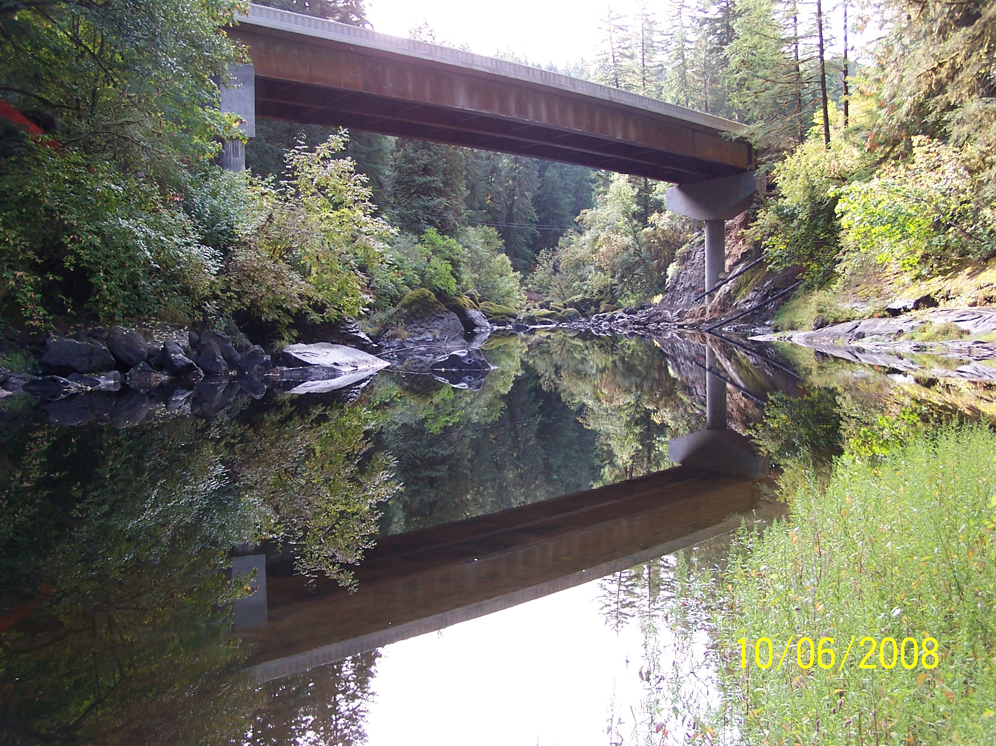

OTIA III Bundle 401
OR38: Elk Creek to Hardscrabble Creek
Contract 13266
January 30, 2009

Introduction

In 2007 the Oregon Department of Transportation applied to the Federal Highway Administration for a $1 million grant to assist in the replacement of
five substandard bridges on OR 38 (Umpqua River Highway, State Highway 45) between Drain, Oregon and Elkton, Oregon in Douglas County.

OR 38 is a major regional route for the movement of people and goods between Interstate 5 (I-5), a national high priority corridor and US 101, Oregon’s only coastal highway and a component of the National Highway System and National Scenic Byway. OR 38, also a component of the National Highway System, is the only route connecting I-5 to US 101 between Coos Bay and Florence that can accommodate commercial vehicle legal loads.

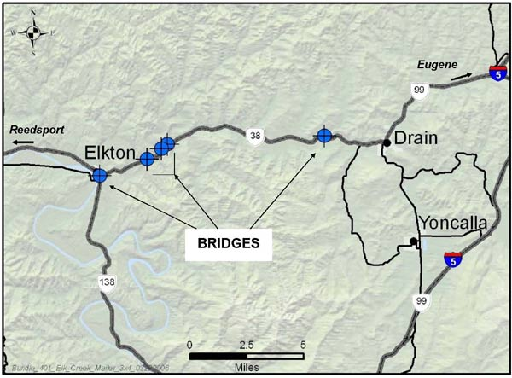
This report is to document the program requirements as defined in the Highways for Life Grant Application, January 24, 2007. As of January 30, 2009, the project is substantially completed and nearing Final Acceptance by the Agency.

Project Summary

This project had several unique characteristics that the contractor had to deal with in relation to the issue of traffic mobility and difficult topographic and environmental conditions and constraints. The bridges to be replaced were built in the late 1920s and early 1930s and were near the end of their useful life. The bridges were selected for replacement under the Oregon Transportation Investment Act (OTIA III) State Bridge Program for a variety of reasons, including: (1) structural and functional deficiencies resulting in repair costs that exceed one-half of the replacement cost; (2) substandard bridge width; and (3) load ratings insufficient to carry permit vehicle loads.

OR 38 is a curvilinear two-lane route with large elevation changes that passes across Oregon’s coastal range. Although all of the bridges identified for replacement had challenging site conditions, two of them stood out for their exceptionally difficult topographic and environmental conditions. Elk Creek Crossings #3 and #4, located at mileposts 39.64 and 39.97 respectively, are situated at each end of the Elk Creek Tunnel located within the Elk Creek Tunnel State Park.

At each tunnel portal, there was only either a 30 foot or 200 foot separation between the tunnel portal and an adjacent bridge abutment. Therefore, the transitions from the tunnel to the temporary roadway during construction represented an extreme challenge. To add to the site complexity, the tunnel width is only 25 feet, thereby restricting traffic shifts to accommodate tall or wide loads; this route is routinely used by logging trucks and other commercial vehicles. Finally, these two bridges fall within Northern Spotted Owl nesting and roosting habitat. As a result, replacement of these bridges requires the use of construction activities that will not violate established noise standards between March 1 and July 7 of each year.

The project’s overall construction zone extends approximately 11.5 miles along OR 38 from MP 36.39 (the 1st crossing of Elk Creek adjacent to the town of Elkton) to MP 48.00 (Hardscrabble Creek). This stretch of OR 38 is posted between 35 and 55 MPH (depending on location). In 2004 average daily traffic (ADT) for the route ranged from of 3,200 to 4,400 vehicles, with a projected ADT increase of 20 percent by 2020. The current percentage of truck traffic is estimated at 23 percent of the total daily traffic

Safety

One of the key goals of the FHWA Highways for Life Program is safety.
On the OTIA III Program, safety is more than a performance goal, it is a requirement. Over the course of the last 10 years, a total of 28 crashes and 5 fatalities have occurred on or near project bridges. Though crashes in work zones are not uncommon, a key component of the project design philosophy was that crashes must be avoided at all costs during construction of the replacement bridges and completion of related roadway improvements.

The ability to safely construct replacement bridges at each of the 5 bridge sites was also an overarching project requirement. The foremost solution to achieving work zone safety for this project was to minimize traffic disruption and interaction with construction workers. Towards this end, the approach adopted for replacing bridges was to minimize the number of vehicle and pedestrian traffic shifts and to maintain two lanes of uninterrupted traffic throughout the duration of construction at all sites except for one.

Results

In the three years prior to the beginning of construction (2004-2006) the crash data showed a crash rate that was slightly higher than the statewide crash rate for a rural principal arterial (.69 crashes per million vehicle miles vs. .67 crashes per million vehicle miles statewide) – See Attached

During construction the contractors took extraordinary steps to assure that accidents were kept to a minimum during construction. The many safeguards that were put in place to prevent accidents during construction were effective.

The crash data for OR38 during the first 16 months of the project (most recent data available) shows a slightly elevated crash rate at 0.80 crashes per million vehicle miles. While this is higher that the average crash rate for similar Oregon routes, and slightly higher than the 2004-2006 historic number, a review of the individual crash incidents shows that only three crashes occurred in the vicinity of the project’s bridge sites. Of these crashes, the report does not indicate that they are as a result of the construction activity. – See Attached

Included as an addendum to this report is the Slayden Construction Group’s OSHA 300 incident rate for the work zone – See Attached.

Construction Expediency

One of the elements that the Oregon Department of Transportation focused on in the delivery of this particular project was the use of the design-build method of procurement as opposed to the more traditional design-bid-build approach.

While design-build is not unique to many states, in Oregon it was not used very much until the start of the OTIA III Program. There are several reasons for this, but the driving reason was that many of ODOT’s historic projects were not large enough to employ the method and obtain the desired cost and time savings.

Simply put, design-build is a method of project delivery in which the design and construction phases of a project are combined into one contract, usually awarded on either a low bid or best-value basis.” (1) The overall goal is to reduce project costs, shorten overall project schedule and construct a quality project. Bundle 401 OR38: Elk Creek to Hardscrabble Creek was developed with the idea of making use of the Design Build process to maximize the project results. As the project nears completion, the Agency believes this goal has been met.

Traditional Design-Bid-Build project timeline

Design--Build project timeline

In addition to the design-build approach, there was a significant focus on constructing the bundle using a “Context Sensitive and Sustainable Solutions” or “CS³” approach as well. CS³ emphasizes minimizing environmental impacts and led to the development of a programmatic permitting process for replacing bridges that streamlines the permit process while improving environmental outcomes.

A key component of CS³ is innovative mobility planning and coordination, which helped reduce the impact of construction on the movement of people and goods. ODOT’s mobility planning has focused on communicating and coordinating both between various parts of the department and also with stakeholders in the private sector, particularly the trucking industry.

Below are summary reports of how each of the crossings in the bundle were delivered and how the contractor worked to meet the CS3 goals of the Program.

Traffic Impacts

Crossing #1, Traditional Phasing: The Design Builder chose to change the alignment of OR38 such that the first phase of the new bridge was constructed off line while traffic remained on the original alignment to keep traffic flowing freely. After the first phase of the bridge was constructed, the contractor demolished the existing bridge and the second phase was constructed. This phasing approach preserved the alignment of OR38 as it enters the town of Elkton. No additional right-of-way was need, no homes or families were displaced, and no disruptions to the permanent configuration of the local community occurred. The alignment at the east end of the bridge, at the junction of OR38 and OR138, shifted slightly to the north. The contractor utilized drilled shafts for the interior bents, eliminating the use of spread footings. Spread footings require cofferdams, which would have added cost to the project and created more negative environmental impact.

Crossing #2, Traditional Phasing: The contractor chose to change the alignment of OR38 such that the entire bridge was constructed off line. As a result, there weren’t any significant savings over and above what would be expected with this approach. However, there was a significant benefit to traffic which was able to flow freely during construction with only minor delays occurring during the changeover from the old bridge to the new one. There were not any significant businesses or residential concerns that prevented a minor realignment of OR38 at this site.

Crossing #3 and Crossing #4, Rapid Reconstruction: Crossings #3 and #4 featured the most innovative work the contractor could have performed on the project. Rapid reconstruction is a seldom used method because of the risk associated with the complete elimination of a route. If rapid reconstruction is employed and an unexpected event happens during the time when the rapid reconstruction is underway, the availability of the route to traffic is eliminated. As such this type of construction carries some inherent risk and in the cases of crossings #3 and #4 this risk was exacerbated by the relative proximity of a tunnel to both bridge abutments.

On crossings #3 and #4, the contractor chose to use rapid reconstruction for these primarily because of the proximity of the tunnel. Crossing #3 is approximately 250 feet from the tunnel and Crossing #4 is less than 50 feet from the tunnel. From a constructability perspective, the Design Builder used rapid reconstruction to preserve the existing highway alignment, and to maintain free flow of traffic as much as possible.

With a 45 MPH design speed, it would have been very difficult to construct a detour bridge or a portion of a bridge so near the tunnel. This alternative to rapid reconstruction would have required either temporary signals or 24/7 flagging. Both traffic control measures are disruptive to the flow of traffic, and given the duration needed to complete the project, would have created less than desirable mobility impacts to the corridor.

The contractor has estimated that building a detour structure for both crossing #3 and #4, would have added at least six months more to the project duration and would have added an additional $500,000 to the cost of each bridge. The Oregon Bridge Delivery Partners mobility staff estimates that flagging traffic is about 10% more efficient than temporary signals. In addition, OBDP has discovered on recent projects utilizing temporary signals; this “inefficiency” in operations is perceived as being far worse than 10% by the traveling public and can result in significant complaints. Simply put, under flagging, when the queue in one direction is gone, the other direction can move. The flaggers can quickly determine when the last vehicle passes and ready for the next direction can move. Human beings are much more efficient that the signal’s computer and the traveling public understand this.

However, because the contractor chose to use a rapid reconstruction, flagging on the site was limited to 40 hours per week with free flow of traffic the rest of the time. The route was closed for just 57 hours while the reconstruction took place.

Crossing #5, One Lane Detour: The approach taken by the contractor at this one span bridge site utilized a one lane detour (16’ wide) for six weeks. Six weeks was the time required to demolish the existing bridge, construct the substructure, pave the superstructure and install the bridge rail in order to make it operational for traffic.

The Design Builder priced 24/7 flagging for 6-7 weeks as being the break-even price point when compared to a temporary signal configuration. This bridge site also had the complication of a T-intersection just off the west end of the bridge. Utilizing a temporary signal at this location, while possible, would have been problematic. Flagging operations were easier to implement and more efficient as each direction of traffic could reasonably see the other legs of the intersection and there was very little real or perceived inefficiency in the traffic control operation.

User Satisfaction:

This task was completed by the Design Builder, January 6, 2009

Innovative Features of this Project (Return on Investment)

Cost Savings due to Traffic Improvements

In the section above we discussed the time savings associated with some of the mobility measures employed by the Contractor on Bundle 401. In this section we use StratBENCOST to estimate the monetary value of those time savings.

StratBENCOST is an economic model widely used for analyzing large-scale transportation projects. This model was developed in association with the National Cooperative Highway Research Program (NCHRP) and Federal Highway Administration (FHWA) with HDR Decision Economics. The model utilizes input data on several variables to determine the economic costs of a transportation project, as well as to determine where economic savings from employing certain mobility and transportation strategies can be created. The variables considered in the analysis are average peak-period travel in the work zone in miles per hour; peak-period vehicle-to-crash ratio in the work zone; extra travel time costs; extra accident costs; extra vehicle operating costs; and extra environmental costs. In the case of the Program, the word “extra” refers to additional economic costs imposed as a result of performing the construction activities, versus the costs of standard free-flowing traffic in a normal situation.

Estimates are based on historical data of annual average daily traffic (AADT) for the structure. For Bridge 01614 (Crossing 1) the traffic delay benefit model estimates that over the 3 month period $68,650 in economic benefit were generated in the form of savings of extra travel time costs, extra accident costs, extra vehicle operating costs, and extra environmental costs. Of these costs $52,174 are savings in extra travel time costs, $8,925 are savings in extra accident costs, $4,119 are savings in extra vehicle operating costs, and $3,432 are savings in the form of extra environmental costs.

Crossing 2

Because the Contractor did nothing unusual on the second crossing in Bundle 401 there were no associated savings with this bridge.

Crossings 3&4

In reviewing the costs for crossings 3 and 4 (bridges 01465 and 01406) it was found that the usage of temporary signals versus the usage of flaggers 24 hours a day, seven days a week was pretty much a wash in costs. The temporary signals are roughly between $65K -$100K in cost, while the flagging is estimated to have cost approximately $70K-80K. However, the benefits of the flagging helped to reduce work zone congestion and allowed for better management of traffic flow. Estimates of this savings are based on historical data of annual average daily traffic (AADT) for the structure. The economic benefits of this have been estimated for both bridges 01465 and 01406. For Bridges 01465 and 01406 the traffic delay benefit model estimates that over the total duration of flagging (roughly 6 months) $76,600 in economic benefit was generated in the form of savings of extra travel time costs, extra accident costs, extra vehicle operating costs, and extra environmental costs. Of these costs $58,216 are savings in extra travel time costs, $9,958 are savings in extra accident costs, $4,596 are savings in extra vehicle operating costs, and $3,830 are savings in the form of extra environmental costs.

Crossing 5

On crossing 5 (Bridge 01424) an accelerated six week construction schedule was way shorter than traditional 4 months work schedule – so reduction of traffic delays by 2.5 months.

The use of an accelerated schedule through rapid reconstruction was estimated to have reduced traffic delays and work zone congestion periods by 2.5 months. The estimates are based on historical data of annual average daily traffic (AADT) for the structure. The economic benefits of this have been estimated for bridge 01424 in the same fashion as all of the previous bridges. For bridge 01424 the traffic delay benefit model estimates that the reduction in construction duration garnered $63,840 in economic benefit generated in the form of savings of extra travel time costs, extra accident costs, extra vehicle operating costs, and extra environmental costs. Of these costs $48,518 are savings in extra travel time costs, $8,299 are savings in extra accident costs, $3,830 are savings in extra vehicle operating costs, and $3,192 are savings in the form of extra environmental costs.

Bundle-wide

Larry Gescher, the project manager for the Design-Build contractor, indicated that the overall bundle was completed a year ahead of what a Design-Bid-Build would have been due to the aggressive nature which they approached the work. In addition – because they were aggressive in resolving permitting issues with SHPO on some artifact issues they were able to avoid a schedule delay of up to a year that a traditional D-B-B wouldn’t have been able to deal with.

Collectively, across all five structures in the bundle, the time savings generated from the avoidance of permitting issues and delivery of the bundle quicker than in a traditional D-B-B project created additional mobility savings, as well as direct savings in overall construction costs.

The savings in construction cost are estimated based on what an additional 12 months of duration would have required in terms of a cost premium to account for rising costs of materials and labor beyond normal inflation (escalation). The estimated cash flows of the project were drawn out an additional year and loaded to match an extended schedule. The cash flows were then adjusted with the new midpoint of construction to calculate the savings based on the historical escalation incurred during the time horizon of construction in relative year of expenditure dollars. Using this method it is estimated that the project had potential cost savings of approximately $1.596 million (or 3.3% of construction value).

The additional mobility benefits were also estimated across each of the bridges based on the AADT (or traffic flow). For the entire bundle the additional traffic benefits (beyond what have already been quantified) are estimated to be $102,140.

For the total bundle this generates a total construction cost savings estimated at $1.596 million and total mobility economic benefits of $311,230. This yields an estimated net economic benefit of $1.91 million.

Cost-Savings - General

In addition to the mobility and escalation avoidance cost savings, several of the methods of implementation employed by the contractor saved additional money on the project.

For example, on crossing 1 the contractor saved $40,000 in additional mobilization costs by performing the installation of the interior bents all in one in-water season.

The use of rapid reconstruction on crossings 3 & 4 produced a combined savings of $1 million because there was no need to build temporary detour bridges and an additional $250,000 was saved on crossing 5 by building a smaller detour which resulted in an additional $15,000 in savings because additional right-of-way did not have to be purchased.

In summary, with the previous economic benefits with the estimated hard cost savings of $1.29 million, the project generated an estimated total savings of $3.2 million. In total this represents an estimated cost savings in construction value to the total project of roughly 6.3%.

