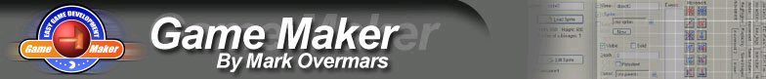

GameMaker Design Document

Game Title_____________________ Programmer_________________________

Game Flow- Describe the Storyline of the Game and How a Player Achieves Goal
Storyline/Goals | Description-Storyline. How does player attempt to reach goals, score points, or conquer enemy?

Controls (Mouse clicks, Keypresses)
Control Type | Describe Control and How it Affects Game Play

Levels (if any)
Level | Description
(Add more rows if necessary)

Game Objects
Object Name | Describe Appearance (Sprites) & Purpose in Game
(Add more rows if needed)

Game Sounds
Sound | Describe Sound & Purpose in Game

