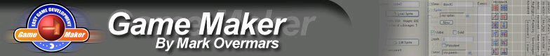
GameMaker Grade Form

Game Title_____________________ Programmer_________________________

Reviews ( 2 Required)
Reviewers | Positive Comments | Suggested Improvements
Reviewer #1:
Reviewer #2:

Scoring Guide
Game Flow
(4) | Game meets Requirements of this Assignment:
(3) | All controls work as they should – (no bugs):
(3) | Progressive and appropriate levels of difficulty
(2) | Creativity and Interest – sprites, sounds, title etc.

Programming Skills | Attention to documentation, Naming, and User friendliness
(4) | Documentation –  Game Info Screen:  Internal comments throughout:
(4) | Descriptive Component Names
TOTAL  (20) | General Comments

