

GOSEP: Georeferenced Oregon Soil Engineering Properties

USER MANUAL

Release v 1.0

May 20, 2020

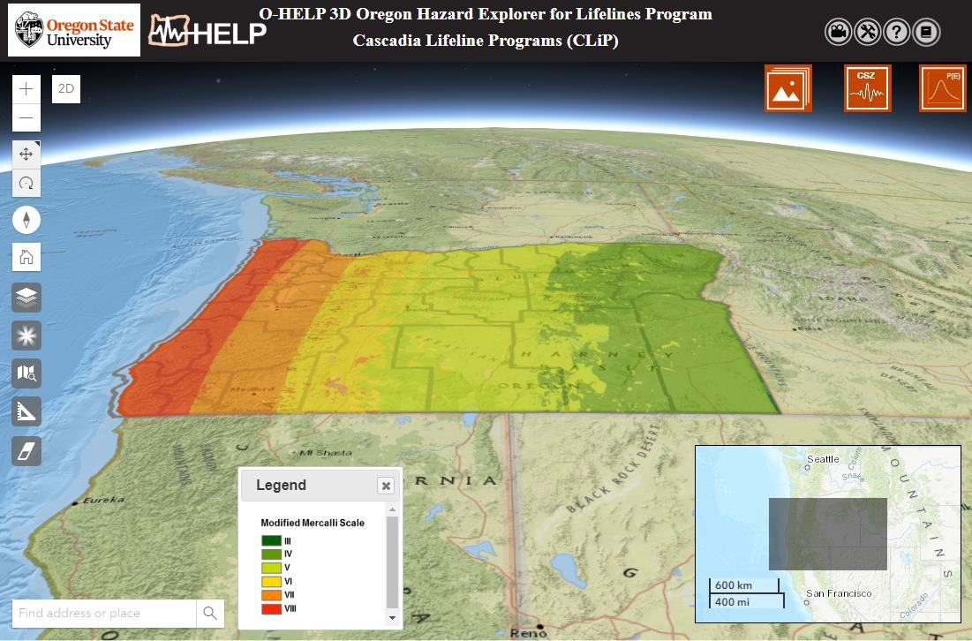

## Funding provided by the Cascadia Lifelines Program (https://cascadia.oregonstate.edu/)

Development Team:

Victoria Dutille, Jaehoon Jung, Michael J. Olsen, T. Matt Evans

School of Civil and Construction Engineering, College of Engineering

Table of Contents

[Introduction 4](#_bookmark0)

[Background 4](#_bookmark1)

[Intended Audience 4](#_bookmark2)

[Participants in the Project 4](#_bookmark3)

[Disclaimer 5](#_bookmark4)

[Platform 5](#_bookmark5)

[Tool Features 6](#_bookmark6)

1. [Overview Map 6](#_bookmark8)
2. [Get layer value 6](#_bookmark9)
3. [Switch view from 3D to 2D 6](#_bookmark10)
4. [Navigation widgets 7](#_bookmark11)
5. [Address Locator 7](#_bookmark12)



1. [Base Layer Selection 7](#_bookmark14)



1. [Opacity Tool 8](#_bookmark15)



1. [Reports Tool 8](#_bookmark16)
2. [Measure Tool 12](#_bookmark21)



1. [Eraser Tool 13](#_bookmark23)



1. [User Help 13](#_bookmark24)

[Layer Control Option 13](#_bookmark25)

[1. General Site Info Tab ............................................................................................................ 13](#_bookmark26)G:\CODE\O-HELP2\images\General.png

[2. CSZ Hazards Tab .................................................................................................................. 16](#_bookmark27)G:\CODE\O-HELP2\images\CSZ90.png

[3. Probabilistic Hazards Tab ..................................................................................................... 20](#_bookmark28)G:\CODE\O-HELP2\images\PE.png

## [Mobile Device support 21](#_bookmark29)

## [Future work 21](#_bookmark30)

## [References 22](#_bookmark31)

## [Appendix 23](#_bookmark32)

[Access to the data 23](#_bookmark33)

[Troubleshooting and FAQs 25](#_bookmark35)

# INTRODUCTION:

This is a user manual for the GOSEP (Georeferenced Oregon Soil Engineering Properties) 3D website, which is a user-friendly, web-based 3D geographic information system (GIS) tool to assess Oregon soil engineering properties and geotechnical site investigations, developed with support from the Cascadia Lifelines Program (CLiP, https://cascadia.oregonstate.edu/). The website contains previous boreholes, in situ and laboratory tests of Oregon soils in a powerful 3D web-based interface, which does not require the user to have extensive knowledge of GIS.

# BACKGROUND:

Unfortunately, the Cascadia Subduction Zone (CSZ) is capable of generating a M9.0 earthquake that could greatly damage the built environment in Oregon. Such a powerful and long-lasting earthquake can generate severe ground shaking, landslides, liquefaction-induced ground deformations, fault rupture vertical displacement, tsunamis, etc. These seismic deformations will likely be considerably damaging to foundations, bridges, roadways, pipelines, and other lifelines.

Many of Oregon’s lifeline providers, such as public and private entities responsible for transportation, electric and gas utilities, water and wastewater, fuel, airports, and harbors face an aging infrastructure that was built prior to a full understanding of this extreme seismic risk. Generally, available methods to assess and mitigate seismic risk to these vital lifelines have been developed for much shorter duration, crustal earthquakes, typical of those experienced in California. However, such methods may not be appropriate for mitigating subduction zone earthquakes, which can last up to three- to five-minutes, as recently experienced in Chile and Japan, and expected in Oregon. As such, the purpose of the O-HELP 3D website is to provide easy access to the latest and best available hazard information over the web, including work completed in the recent Oregon Resilience Plan (ORP) (OSSPAC, 2013) and other work completed by the Department of Geology and Mineral Industries (DOGAMI) and the United States Geological Survey (USGS).

# INTENDED AUDIENCE:

This tool is designed for engineers, planners, geologists, and others who need this information to help make appropriate decisions. It is assumed that the users have enough knowledge about earthquake engineering and geologic hazards to understand what the data means and how to use it appropriately. Minimal knowledge of GIS will be needed to work with this web-GIS tool.

# Participants in the Project:

Participating organizations in CLiP include: the Oregon Department of Transportation (ODOT), Portland General Electric (PGE), Northwest Natural Gas (NWN), Portland Water Bureau (PWB), Port of Portland (PDX), Eugene Water and Electric Board (EWEB), Bonneville Power Administration (BPA) and Tualatin Valley Water District (TVWD).

The Geomatics research group in the School of Civil and Construction Engineering at Oregon State University manages this website under the direction of CLiP. Specifically the following persons from OSU (unless directed otherwise) have worked directly on this project since its inception:

* + **Project management**: Michael Olsen, Daniel Gillins, Ben Leshchinksy.
  + **WebGIS Version 3.0** (current) development and maintenance: Jaehoon Jung and Michael Olsen
  + **Previous WebGIS** (versions 1.0 & 2.0) development and maintenance: Rubini Narayanan, Farid Javadnejad, Mahyar Sharifi-Mood, Daniel Gillins, and Michael Olsen
  + **Server support**, maintenance, and administration: Paul Montagne

## Creation of data layers specifically available through O-HELP:

* + - The **CSZ scenario modeling** were created by Mahyar Sharifi-Mood, Michael Olsen, and Daniel Gillins with support by Ian Madin (DOGAMI)
    - **Borehole Database of Oregon (BODO)**: May Shin Lyan, Nicholas Matthews, Ben Leshchinsky, and Michael Olsen.
    - **Bridge damage assessment**: Pat Burns, Andre Barbosa, Michael Olsen, & Haizhong Wang.
    - **Fully probabilistic landslide mapping**: Mahyar Sharifi-Mood, Michael Olsen, Daniel Gillins
    - **Probabilistic landslide susceptibility mapping**: Danny Hess, Nick Matthews, Ben Leshchinsky, & Michael Olsen
    - **Transportation flow modeling**: Haizhong Wang

The Department of Oregon Geology and Mineral Industries (DOGAMI) developed and contributed several of the datasets that have been included in the website such as the OLC lidar hillshade, the SLIDO v4 database, and preliminary layers from the Oregon Resilience Plan. They have also contributed ideas to the design of the website. Their important role in hazard mapping is recognized and appreciated.

# DISCLAIMER:

The Cascadia Lifelines Program (CLiP) and the Geomatics research group in School of Civil and Construction Engineering at the Oregon State University works to ensure that the information provided on this website is accurate, timely, and useful. The information provided herein is for reference only and is **not suitable** for incorporation in engineering design or site-specific analysis; instead, it provides a starting point to identify and understand hazards of primary concern. For more generalized information regarding earthquake and other types of hazards in Oregon meant for the general public, please visit the web page of Oregon HazVu: Statewide Geohazards Viewer at: [http://www.oregongeology.org/hazvu/.](http://www.oregongeology.org/hazvu/)

CLiP and the Geomatics research group are not responsible for errors or omissions in information provided on this website. ***Any use of this website or the information available at this website is at your own risk and we will not be responsible for the consequences of your decision to utilize the information.***

Visitors are encouraged to confirm the information contained on this website with other reliable sources and agencies. Use and access to this website or any of the links contained within this website do not create an engineering consultant-client relationship. The linked websites are not under Geomatics research group’s control and the research group does not assume any responsibility or liability for any communication or materials available at such linked websites.

Corrections, additions, and updates to this website will be made when necessary or as time permits.

# PLATFORM

The web-GIS framework for O-HELP 3D has been designed in ESRI’s ArcGIS for Server (i.e., ArcServer) platform. ArcServer enables the use of several of ESRI’s base layers, including aerial

imagery, topographic maps, and road networks. While the primary interface is the O-HELP webGIS, the data layers may be streamed directly in GIS software. The Appendix contains instructions on how to access the layers.

# TOOL FEATURES

Several features and tools in O-HELP 3D (numbered in [Figure 1](#_bookmark7)) are defined individually below. O-HELP can simply be accessed via a web browser. (Although please note that some compatibility versions will occur with different browsers. Chrome is currently the preferred browser).

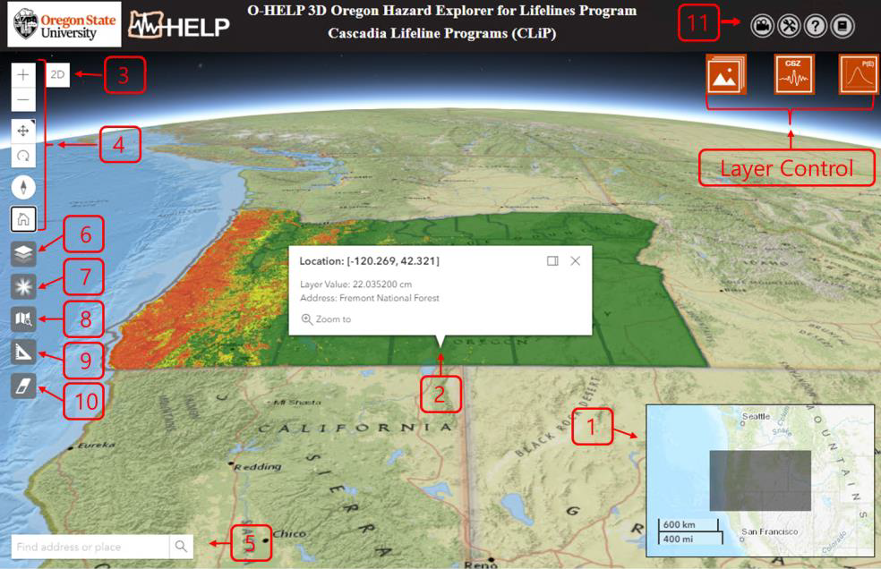

## Figure 1. Outline view of the O-HELP 3D website with various feature tools and their screen location.

1. **Overview Map**

Located in the lower right corner of the website, an overview map shows the user where the main display is concentrated. It includes an interactive scalebar that provides map scale both in kilometers and miles.

## Get layer value

After a layer is selected and displayed on the map (see “Layer Control Option”), the user can click on a desired point on the layer and a pop-up window will appear like the one shown in Figure 1. This will allow the user to view the latitude/longitude, layer value, as well as address of the point. Note that this tool is available only for layers in the raster format.

## Switch view from 3D to 2D

Click the 2D button  in the top-left corner of the view to switch the view from 3D to 2D and vice versa. **Note that the MultiPoint Report tool (see “7. Reports Tool”) is available only in 2D view. The user needs to switch the view from 3D to 2D before using the tool**.

## Navigation widgets



The user can zoom in and out with the buttons or by using the mouse wheel.

The default navigation mode is always pan . The alternate navigation mode to toggle to is rotate .



This allows the user to rotate the view with a mouse drag and pan the view with a right-click and drag gesture.

The Compass widget indicates where north is in relation to the current view rotation or camera



heading. Clicking the Compass widget rotates the view to face north (heading = 0).

The Home Widget Quickly return to the map's default starting viewpoint using the Home button



widget.The initial default view is the entire State of Oregon.

## Address Locator



This tool enables the user to search for a specific location by entering either geographic coordinates in longitude, latitude format, or by entering the address for a location of interest. Once the user inputs the search information, the locator will show the place by dropping a black point on the map. A window will then pop up in the map with the latitude and longitude information for that site (see Figure 2). Within the same pop-up window, there is a link that can be selected for generating a report for that location. Similar report can be generated using single point report (See “Single Point Report” in section “7. Report Tools” for more details).

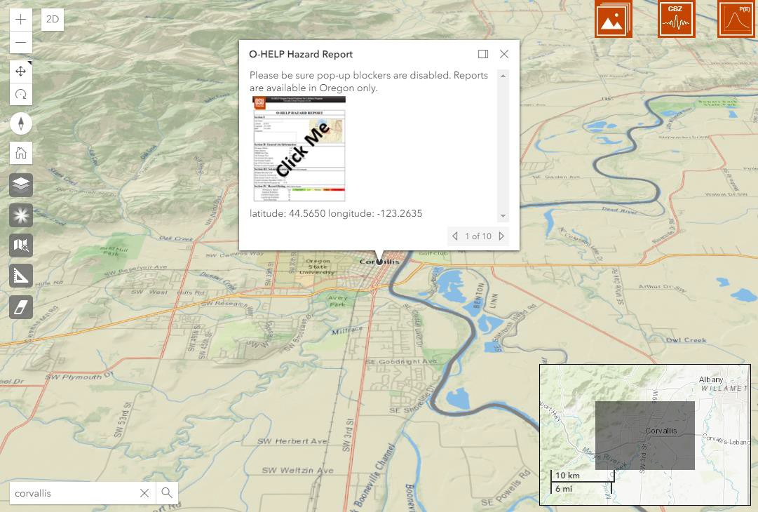

## Figure 2: Pop up window representing spatial information of the selected address or latitude, longitude on the interactive map.

1. **Base Layer Selection**



After selecting this icon, a new box will open which gives the user three options for a base map layer (Figure 3). Current available base map layers are ESRI Streets, ESRI Imagery and ESRI Topography. Once the selection is done, the user can click on the same icon to have the box removed from the window.

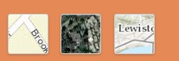

## Figure 3: ESRI street, imagery and topography basemaps in O-HELP 3D (Left to Right).

1. **Opacity Tool**



The opacity tool enables the user to change the opacity of the current selected layer. Note that only one layer can be visible and selected at a time. The default initialized value for opacity is 60%. By clicking on the icon, a box will pop up (Figure 4) wherein the user can adjust the opacity value by moving a slider.

By increasing the opacity value, the layer will become less opaque and more visible. By decreasing the value, the layer will become more transparent and the underlying base map will become more visible.



## Figure 4: Window with a slider for adjusting the opacity value of the current selected layer.

1. **Reports Tool**



By clicking on the measurement tool button, a box will be shown (see [Figure](#_bookmark17) 5) which gives the user ability to select a single point report, multipoint report, CSV multipoint report, or screenshot.



## Figure 5: Window with single point report, multipoint report, CSV multipoint report, and screenshot (Left to Right)

*Single Point Report*

After clicking on the single point report button, the user can click on a desired point on the map and a pop-up window will appear like the one shown in [Figure 2](#_bookmark13)2. This will allow the user to view the latitude/longitude of the point as well as a screenshot of the final report linked to a detail report on the pinned point. Similar report can be obtained by using any of the following options:

* + Using the address locator in the search box (see “4. Address Locator”)
  + Using the single point report button

Both of above methods will add a point to the map at the desired location and a pop up window will be shown (Figure 2). Inside the window, the report thumbnail will link to an O-HELP hazard report in a new window for that specified location. An example O-HELP hazard report is shown in [Figure 6](#_bookmark18)6.

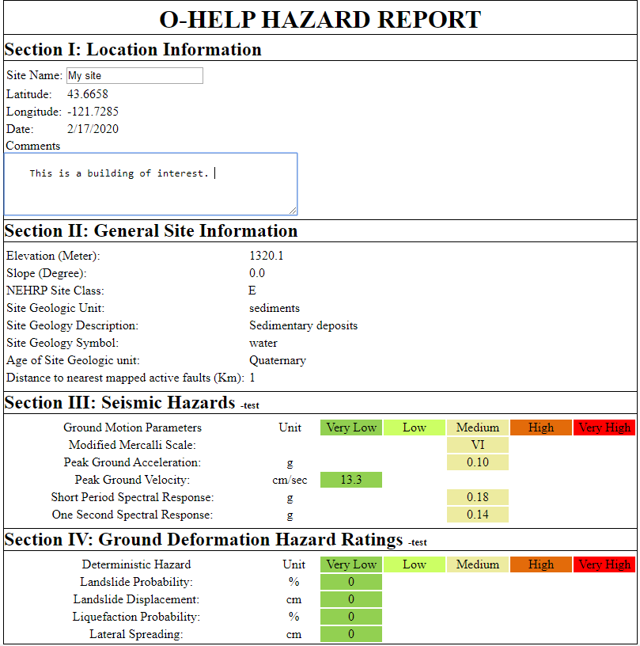

## Figure 6: Example O-HELP hazard report, generated by clicking on the “Print Report Tool”.

Each generated report for a specific location has 4 sections. Data shown in this report are taken from the data layers referenced later in this manual. In the first section of the report, a user can type a site name and any relevant comments. This section also includes the latitude and longitude of the site, and the date.

The second section gives the user the details of general site information, including elevation, slope, NEHRP site class, general and detailed site geology information, the corresponding geologic symbol, geologic age, and distance to nearest mapped active fault.

The third section summarizes details about estimated seismic parameters in that location given a CSZ earthquake scenario of M8.1, M8.4, M8.7, and M9.0. Such parameters are the modified Mercalli scale earthquake intensity, peak ground acceleration (PGA), peak ground velocity (PGV), coastal coseismic subsidence (only available for M9.0), and one-second spectral response.

Within the fourth section of the report, various hazards associated with a Cascadia Subduction Zone earthquake scenarios are given in a graphical representation. The landslide probability, estimated landslide displacement, liquefaction triggering probability, and estimated lateral spreading displacement values are categorized into 5 different hazard classes: very low, low, medium, high and very high. Note that these are generalized categorizations and would vary depending on the structure or object of interest.

Table 1 defines the thresholds used to categorize these hazards.

## Table 1: Various classes of hazards and their corresponding thresholds.

|  |  |  |  |  |  |  |
| --- | --- | --- | --- | --- | --- | --- |
| **Layer** | **Units** | **Very**  **Low** | **Low** | **Medium** | **High** | **Very**  **High** |
| Landslide Probability | % | 0-5 | 5-10 | 10-15 | 15-20 | >20 |
| Landslide Displacement | cm | 0-3 | 3-10 | 10-30 | 30-100 | >100 |
| Liquefaction Probability | % | 0-5 | 5-10 | 10-15 | 15-20 | >20 |
| Lateral Spreading | cm | 0-3 | 3-10 | 10-30 | 30-100 | >100 |

*MultiPoint Report *

The MultiPoint Report allows the user to iterate report generation on more than one point. Performing the MultiPoint tool, user can click on desired multiple points on the map to extract hazard related information. To add the last point of the multiple points, user needs to double-click on the map. The final report can be downloaded as a CSV file from a pop up window. The CSV download link appears after completion of the report generation ([Figure](#_bookmark19)7). The report includes the following fields on each pinned point: PID, Latitude, Longitude, Elevation(m), Slope(deg), NEHRP Site Class, Geologic Unit, Geology Description, Geology Symbol, Age of Geologic Unit, Modified Mercalli Scale, PGA(g), PGV(cm/s), Short Period Spectral Response(g), One Second Spectral Response(g), Landslide Probability(%), Landslide Displacement(cm), Liquefaction Probability(%), Lateral Spreading(cm). **Note that the MultiPoint Report tool is currently available only in 2D view, so the user needs to switch the view from 3D to 2D before using this tool (see “2. Switch view from 3D to 2D”).**

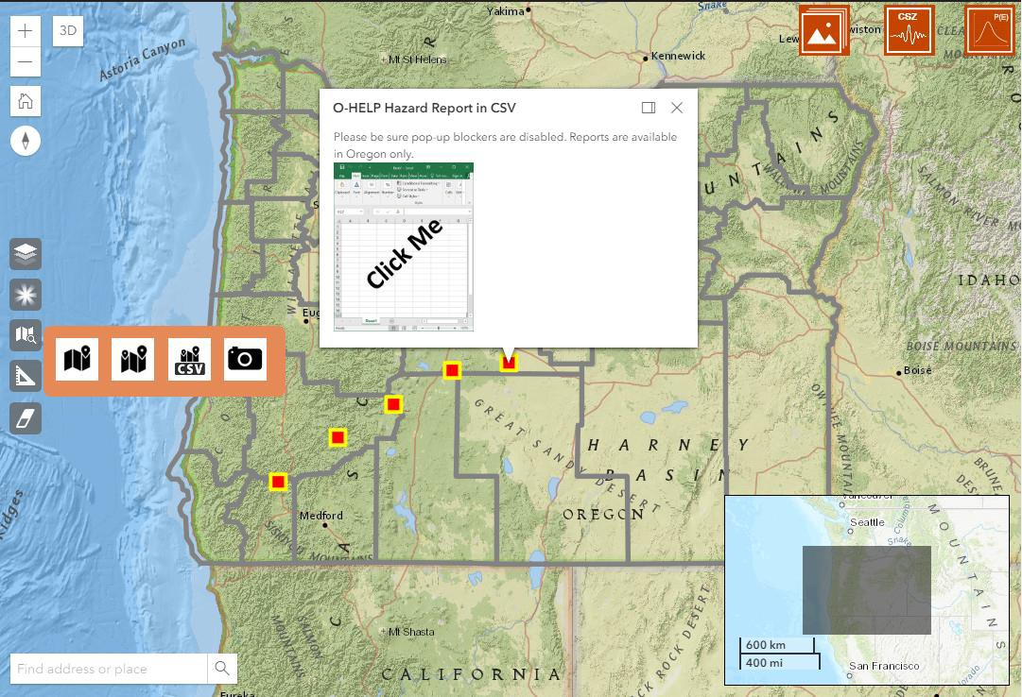

## Figure 7: Example of O-HELP MultiPoint report and final CSV download links

*CSV MultiPoint Report *

User can also get MultiPoint Report by submitting a CSV file ([Figure 8](#_bookmark20)8) of point information that lists the PID, latitude, and longitude of the points. The acceptable file is a comma-delaminated format with the required fields is aforementioned order. After receiving the CSV file, O-HELP will sparse the coordinate

values and will extract hazard parameters for each of point and return a new CSV file with hazard information. Similar to MultiPoint Tool, the final report can be downloaded as a CSV file from a pop-up window. The CSV download link appears after completion of the report generation (Figure 7). The report generation time varies based on the number points that report is requested for.

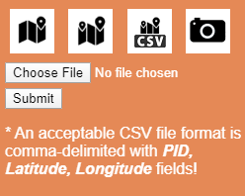

## Figure 8: CSV file submission for generating O-HELP MultiPoint report

*Screenshot F:\e_drive\2019_OHELP\3D OHELP\images\measure_screenshot_icon.png*

The screenshot button allows the user to export a screenshot of a map to enable sharing as an image. Pan and zoom to find an interesting location, then drag and drop the left mouse button to take a screenshot. The screenshot will be displayed. Note that there may be a small delay if the map is still rendering when you push the button. The user can enter a text to be displayed on the image. Then, the user can click on  to download the image or  to return to webscene (see Figure 9).

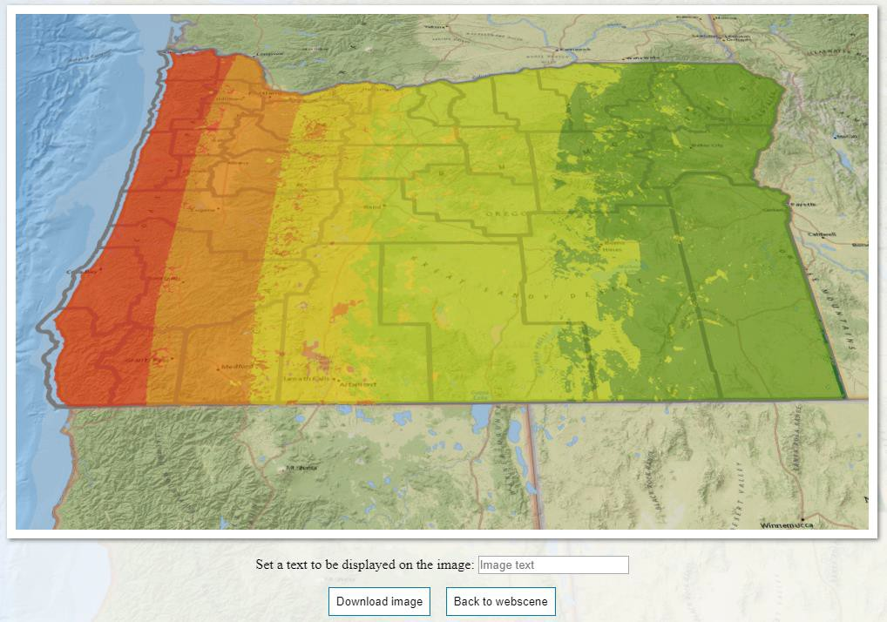

## Figure 9: Example custom map generated by clicking on the screenshot button.

1. **Measure Tool**



By clicking on the measurement tool button, a box will be shown (see [Figure](#_bookmark22)0) which gives the user ability to select a line or polygon for measurement.



## Figure 10: Measurement tool box and dimensions of the current selection.

*Line Segment*



The first option inside the measure tool is the line segment button. It will display a new measurement tool

button.  (Figure 11). By clicking on this button, the user has the ability to left click on various points on the map in 2D or 3D and draw a series of line segments. A double left click will stop drawing the lines. The cumulative length of the line segments is shown in various desired units (e.g., feet, meters, and miles).

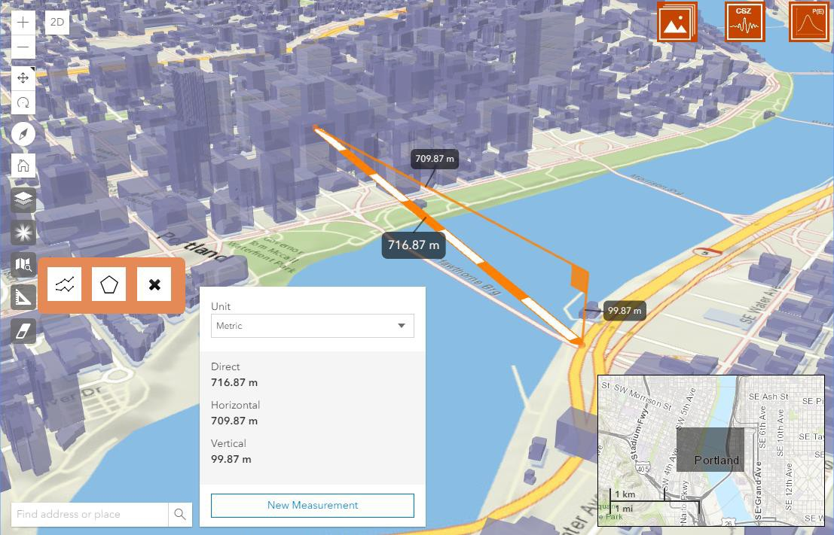

## Figure 11. Line measurement tool

*Polygon*



Similar to the line segment, it will display a new measurement tool button

(Figure 12). This button will calculate the area inside a defined polygon, which is drawn by the user by clicking on various points on the map in 2D or 3D. The same procedure is applied to select the points on the map (left click for choosing corner points and double left click for closing the polygon). The area of the polygon is shown in various desired units (e.g., feet, meters, and miles).

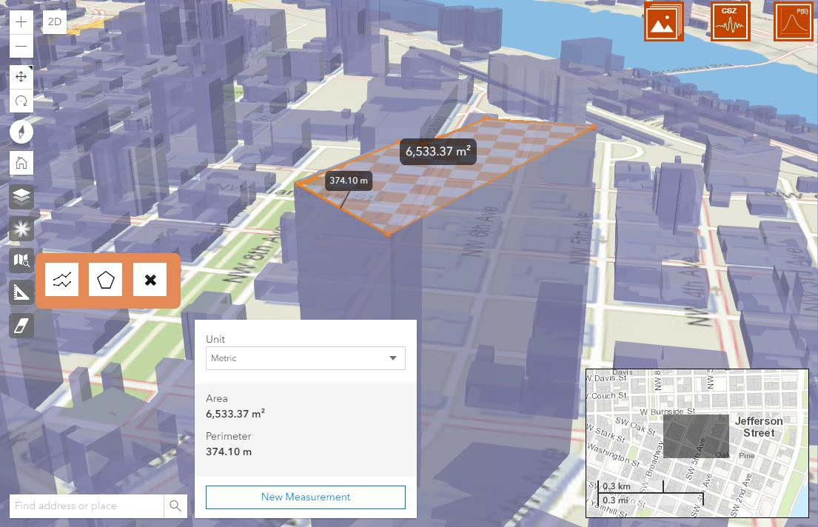

## Figure 12. Area measurement tool

*Clear button*



This button will clear the lines or polygons which were previously drawn on the map.

## Eraser Tool



This button will clear all added layers, points, lines, polygons, or popup windows previously loaded or drawn on the map.

## User Help

Clicking on F:\e_drive\2019_OHELP\3D OHELP\images\movie-icon-01.png provides a link to the O-HELP 3D video tutorial. Clicking on F:\e_drive\2019_OHELP\3D OHELP\images\tool_rep-icon-01.png provides a link to the O-HELP 3D tool repository.

Clicking on F:\e_drive\2019_OHELP\3D OHELP\images\help-icon5.png provides a link to the O-HELP 3D user manual document.

Clicking on  provides a link to the Sharifi-Mood (2017) which describes how many of the layers in O- HELP were created.

# LAYER CONTROL OPTION

Three icons which control the various data layers are presented in the upper right portion of the O-HELP 3D website. Each selectable icon is discussed below.

## General Site Info Tab G:\CODE\O-HELP2\images\General.png

Selecting this icon creates a box of headers that allow the user to access several data layers of general site information. The headers are: Elevation Model, Geology, Site Class, data streamed from the SLIDO database (version 3.2), Transportation, Drillhole Database, Bridges and Highways, Hillshade, and 3D

Portland. Selecting a header will then allow the user to select and view various data layers, as defined below, by clicking on a radio or checkbox button.

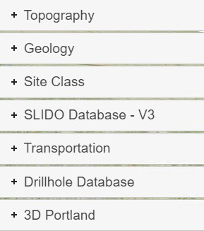

*Topography*

* + ***Elevation Model (30m):*** a raster hybrid digital elevation model (DEM) which combines 1 meter lidar data from the Oregon Lidar Consortium where available with 10 meter resolution USGS National Elevation Dataset (NED) data elsewhere. The data were then resampled using bilinear interpolation to a 30 m cell size to balance file size with level of detail. The NED data was obtained from at the USGS at [http://ned.usgs.gov/.](http://ned.usgs.gov/) More information about the lidar data can be found at: [http://www.oregongeology.org/sub/projects/olc/.](http://www.oregongeology.org/sub/projects/olc/)
  + ***OLC Hillshade:*** a raster hillshade derived from a lidar DEM provided by the Oregon Lidar Consortium.

*Geology*

* + ***Site Geology:*** a vector polygon feature layer depicting general site geology in Oregon, compiled by DOGAMI and made available through the Oregon Geologic Data Compilation (OGDC) v5.0. This file was downloaded at <http://www.oregongeology.org/sub/ogdc/>on March 22, 2014.
  + ***Quaternary Fault:*** a vector polyline feature layer depicting mapped quaternary (i.e. active) faults of the last 1,600,000 years (USGS, 2006). This file was downloaded from the USGS at<http://earthquakes.usgs.gov/regional/qfaults/>on March 4, 2014.

*Site Class*

* + ***NEHRP:*** a vector polygon feature depicting soil site class, as defined by the National Earthquake Hazard Reduction Program (NEHRP). These data were produced by DOGAMI and published as part of the Oregon Resilience Plan (OSSPAC, 2013). Table 2 gives the profile type for each soil site class according to the average shear wave velocity in the upper 30 meters of the site profile.

## Table 2: NEHRP Site classification definitions (BSSC, 2001).

|  |  |  |
| --- | --- | --- |
| **Site Class** | **Profile Type** | **Rock/Soil Shear wave Velocity**  **(m/s)** |
| **A** | Hard rock | >1500 |
| **B** | Rock | 760 - 1500 |
| **C** | Very dense soil/soft rock | 360 - 760 |
| **D** | Stiff soil | 180 - 360 |
| **E** | Soft soil | <180 |
| **F** | Special soils requiring site- specific evaluation |  |

*SLIDO Database - Version 4.0*

DOGAMI provides the Statewide Landslide Information Database for Oregon (SLIDO), which contains a compilation of landslides that have been identified on published maps (Burns et al., 2011). O-HELP streams these data directly from the SLIDO database server (Version 4), accessed directly at <https://www.oregongeology.org/slido/data.htm>

* ***Landslide Polygons:*** a vector polygon feature representing the landslide deposits and scarps along with scarp flanks. DOGAMI is rapidly advancing this layer by utilizing lidar technology.
* ***Landslide Points:*** the location of historic landslides, which occurred in Oregon, compiled as a point feature dataset.

*Transportation*

* ***Bridges:*** this is a complete database of all bridges in the state of Oregon provided by ODOT and made available by the Oregon Geospatial Data Enterprise Spatial Data library.
* ***Highway:*** this is a compilation of the entire ODOT highway network, provided by ODOT.
* ***PDX Base Condition:*** this accessibility map presents the estimated travel time from each zone to Portland International Airport when the network is intact. The afternoon peak traffic condition (4pm-5pm) is adopted for simulation in VISUM.
* ***PDX Bridge Failure Condition:*** this accessibility map presents the travel time from each zone to Portland International Airport when the network is disrupted, specifically, the eight bridges over the Willamette Rive near Portland downtown are set to be failed. The afternoon peak traffic condition (4pm-5pm) is adopted for simulation in VISUM.

*Drillhole Databases*

* ***BODO:*** This is the Borehole Database of Oregon, which contains basic information about boreholes that has been autonomously extracted from logs via machine learning. Links to pdfs of the logs themselves are provided.
* ***PDX Boreholes:*** This feature class provided by DOGAMI contains actual and "pseudo" drillholes used to create 3D geologic and geophysical models for the 2013 Portland NEHRP project.

Drillhole points were digitized from maps or coordinates in drilling reports for geotechnical or other purposes (e.g. water wells, hydrocarbon exploration, etc). The drillhole feature class participates in two one-to-many relationship classes with tables of downhole geologic interpretations (PDX\_NEHRP\_interpretations) and shear-wave velocity measurements (PDX\_NEHRP\_Vs) using the key field "LOG\_ID\_concatenated". It is provided by department of Oregon geology and mineral industry (DOGAMI). Specific sublayers can be individually turned on or off via the checkboxes:

* + ***CPT:*** locations of Cone penetrometer testing.
  + ***SPT:*** location of standard penetration testing.
  + ***Shearwave Tests:*** locations where shear wave velocity tests have been completed and compiled.

*3D Portland*

The layer is a 3D model depicting buildings and rails in Portland, Oregon. This layer is only available in 3D view (See “2. Switch view from 3D to 2D” in Tool Features). These layers are streamed directly from ArcGIS online.

* ***Buildings:*** this is a 3D mesh model of the buildings in Portland.
* ***Rails:*** this is a 3D line model of the rails in Portland.

## CSZ Hazards Tab G:\CODE\O-HELP2\images\CSZ90.png

Selecting this icon creates a box of headers that allow the user to access several hazard layers associated with scenarios M9.0, M8.7, M8.4, and M8.1 CSZ earthquake. The tectonic activities of the Cascadia Subduction Zone are capable of triggering great seismic events; hence, numerous layers of raster and vector data depicting such hazards associated with a M8.1, M8.4, M8.7, and M9.0 Cascadia Subduction Zone (CSZ) earthquake have been collected and uploaded to this platform. Initial versions of these data layers for the M9.0 scenario were published in the Oregon Resilience Plan (OSSPAC, 2013; Madin and Burns, 2013). However, Sharifi-Mood (2017) describes how the current versions of these layers were created for the different scenarios, which automated the approach of Madin and Burns (2013) based on input PGA rasters provided by the USGS as custom shakemap scenarios..

*Earthquake Scenario Slider*

User can select between four Cascadia Subduction Zone (CSZ) earthquake scenarios of M8.1, M8.4, M8.7, and M9.0. The default values is magnitude 9.0 scenario, which changing the slider to any of the earthquake magnitude scenarios will make earthquake hazard map of that scenario available for user in the data layers of CSZ hazard tab.

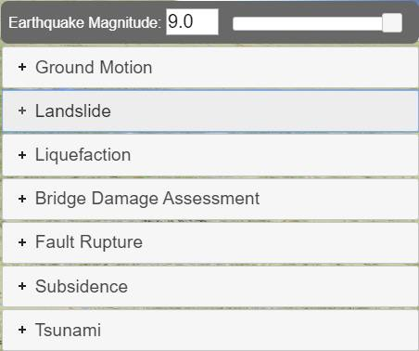

The headers are: Ground Motion, Landslide, Liquefaction, Bridge Damage Assessment, Fault Rupture, Subsidence, and Tsunami. Selecting a header will then allow the user to select and view various data layers, as defined below, by clicking on a radio button.

*Ground Motion*

* ***Modified Mercalli scale:*** a raster showing the intensity of the earthquake at the surface according to the Modified Mercalli Intensity Scale. The raster was computed using mapped PGA values provided by the USGS and a regression relationship developed in Wald et al. (1999). The Modified Mercalli Intensity Scale refers to the expected effects experienced at a place during the earthquake. Lower numbers of the scale generally deal with how the earthquake is felt by people; higher numbers are based on observations of structural damage (see Table 3). For more details see: Sharifi-Mood (2017) and Madin and Burns (2013).
* ***Peak ground acceleration (PGA):*** a raster of PGA values at the ground surface during any of the

CSZ earthquake scenarios. This raster was created based on modeling data provided for by the USGS for each scenario. Briefly, the raster was computed using bedrock PGA values from a USGS Shakemap for a scenario M9.0 CSZ earthquake, a polygon feature of NEHRP site classes described above, and soil amplification relationships in Boore and Atkinson (2008). The M9.0 Shakemap is available at: <http://earthquake.usgs.gov/earthquakes/shakemap/global/shake/Casc9.0_expanded_se/#download> For more details see: Sharifi-Mood (2017) and Madin and Burns (2013).

* ***Peak ground Velocity:*** a raster of PGV values at the ground surface during the CSZ earthquake scenarios. The raster was computed using bedrock one-second spectral acceleration (SA01) values from the same USGS Shakemap as the one used for computing the PGA raster. Then, based on the polygon feature of NEHRP site classes described above, SA01 values at the ground surface were computed using soil amplification relationships in Boore and Atkinson (2008). Finally, the SA01 values were converted into PGV values by using the relationship described in Newmark and Hall (1982). For more details see: Sharifi-Mood (2017) and Madin and Burns (2013).

**Table 3: Abbreviated description of the 12 levels of Modified Mercalli Intensity (from** [**http://earthquake.usgs.gov/learn/topics/mercalli.php,**](http://earthquake.usgs.gov/learn/topics/mercalli.php) **accessed July 2014).**

|  |  |
| --- | --- |
| **No.** | **Description** |
| **I** | Not felt except by a very few under especially favorable conditions. |
| **II** | Felt only by a few persons at rest, especially on upper floors of buildings. |
| **III** | Felt quite noticeably by persons indoors, especially on upper floors of buildings. Many people do not recognize it as an earthquake. Standing motor cars may rock slightly.  Vibrations similar to the passing of a truck. Duration estimated. |
| **IV** | Felt indoors by many, outdoors by few during the day. At night, some awakened. Dishes, windows, doors disturbed; walls make cracking sound. Sensation like heavy truck striking building. Standing motor cars rocked noticeably. |
| **V** | Felt by nearly everyone; many awakened. Some dishes, windows broken. Unstable objects overturned. Pendulum clocks may stop. |
| **VI** | Felt by all, many frightened. Some heavy furniture moved; a few instances of fallen plaster. Damage slight. |
| **VII** | Damage negligible in buildings of good design and construction; slight to moderate in well-built ordinary structures; considerable damage in poorly built or badly designed structures; some chimneys broken. |
| **VIII** | Damage slight in specially designed structures; considerable damage in ordinary substantial buildings with partial collapse. Damage great in poorly built structures. Fall of chimneys, factory stacks, columns, monuments, walls. Heavy furniture overturned. |
| **IX** | Damage considerable in specially designed structures; well-designed frame structures thrown out of plumb. Damage great in substantial buildings, with partial collapse.  Buildings shifted off foundations. |
| **X** | Some well-built wooden structures destroyed; most masonry and frame structures destroyed with foundations. Rails bent. |
| **XI** | Few, if any (masonry) structures remain standing. Bridges destroyed. Rails bent greatly. |
| **XII** | Damage total. Lines of sight and level are distorted. Objects thrown into the air. |

* ***Short period spectral response:*** This layer provide raster of surficial 0.3-second spectral acceleration values for the selected CSZ earthquake scenario from the scenario slider. This raster was computed using bedrock 0.3 second spectral acceleration values from the same USGS Shakemap as the one used for computing the PGA raster depicted in O-HELP. Then, based on the polygon feature of NEHRP site classes described above, SA0p3 values at the ground surface were computed using soil amplification relationships in Boore and Atkinson (2008). For more details see: Sharifi-Mood (2017) and Madin and Burns (2013).
* ***One second spectral response:*** a raster of one-second spectral acceleration values at the ground

surface during the CSZ earthquake scenarios. This raster was computed using bedrock one- second spectral acceleration (SA01) values from the same USGS Shakemap as the one used for computing the PGA raster depicted in O-HELP. Then, based on the polygon feature of NEHRP site classes described above, SA01 values at the ground surface were computed using soil amplification relationships in Boore and Atkinson (2008). For more details see: Sharifi-Mood (2017) and Madin and Burns (2013).

*Landslides*

* ***Landslide triggering probability:*** a raster depicting landslide triggering probabilities given a CSZ earthquake scenario of M8.1, M8.4, M8.7 and M9.0. Briefly, the raster was computed using the model described in section 4.2.2.2 of HAZUS-MH MR4 software (FEMA, 2011). A custom landslide susceptibility map developed by DOGAMI and the PGA raster depicted in O-HELP were used in this model. Then, following HAZUS (FEMA, 2011) recommendations, the probabilities of landslide triggering were scaled to a maximum of 30%. For more details see: Sharifi-Mood (2017).
* ***Landslide displacement:*** a raster depicting landslide displacement given a CSZ earthquake

scenario of M8.1, M8.4, M8.7 and M9.0. Briefly, the raster was computed using the model described in section 4.2.2.2 of HAZUS-MH MR4 software (FEMA, 2011). A custom landslide susceptibility map developed by DOGAMI and the PGA raster depicted in O-HELP were used in this model. Then, following HAZUS (FEMA, 2011) equation 4-25, the permanent ground displacement of peak ground displacement was computed. For more details see: Sharifi-Mood (2017) and Madin and Burns (2013).

*Liquefaction*

* ***Liquefaction triggering probability:*** a raster depicting liquefaction triggering probabilities given a CSZ earthquake scenario of M8.1, M8.4, M8.7 and M9.0. Briefly, the raster was computed using the model described in section 4.2.2.1 of HAZUS-MH MR4 software (FEMA, 2011). A custom liquefaction susceptibility map developed by DOGAMI and the PGA raster depicted in O-HELP were used in this model. Then, following HAZUS (FEMA, 2011) recommendations, the probabilities of liquefaction triggering were scaled to a maximum of 30%. For more details see: Sharifi-Mood (2017) and Madin and Burns (2013).
* ***Lateral spreading:*** a raster depicting lateral spreading given a CSZ earthquake scenario of M8.1,

M8.4, M8.7 and M9.0. Briefly, the raster was computed using the model described in section

4.2.2.1 of HAZUS-MH MR4 software (FEMA, 2011). A custom liquefaction susceptibility map developed by DOGAMI and the PGA raster depicted in O-HELP were used in this model. Then, following HAZUS (FEMA, 2011) equation 4-23, the liquefaction-induced lateral spreading was computed. For more details see: Sharifi-Mood (2017) and Madin and Burns (2013).

*Bridge Damage Assessment*

These layers show the results of a bridge damage assessment completed by Burns (2015). This study compared the vulnerabilities of bridges combining effects of earthquake-induced ground shaking, ground failure (e.g., landslides and lateral spreading), and tsunami inundation. Two of the scenarios are provided:

* ***Using HAZUS-MH Fragility Functions:*** a bridge damage map for the selected Cascadia subduction zone earthquake scenario using HAZUS-MH fragility functions.
* ***Using EQ+LS+LQ Fragility Functions:*** a bridge damage map for the selected Cascadia subduction zone earthquake scenario using earthquake ground shaking + landslide + liquefaction fragility functions.

*Fault Rupture*

* ***Extent:*** this is the extent of fault rupture corresponding to selected Cascadia earthquake scenario that were used to generate the custom shakemaps provided by the USGS.

*Subsidence*

* ***Coastal co-seismic subsidence:*** this layer is only available for M9.0 CSZ earthquake. The layer is a raster depicting subsidence given a M9.0 CSZ earthquake. This is a parameter which depicts the land level change in a Cascadia subduction earthquake event along the coast. DOGAMI input the elastic dislocation models by Witter et al (2011) in order to compute this map.

*Tsunami*

* ***Anticipated inundation area:*** this layer is only available for M9.0 CSZ earthquake. The dataset is shapefile representing the areas which will be inundated in a Large (L1) tsunami scenario for Oregon coast. The methods and data used to make this map are described in detail in Priest et al (2013).

## Probabilistic Hazards Tab G:\CODE\O-HELP2\images\PE.png

Selecting this icon creates a box of headers that allow the user to access a probabilistic version of hazards rather than a scenario based maps. The headers area: Ground Motion, Landslide Hazard Map, and Landslide Susceptibility Map. Selecting a header will then allow the user to select and view various data layers, as defined below, by clicking on a radio button.

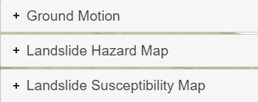

*Ground Motion*

* ***2% in 50 Years PGA:*** probabilistic PGA from the USGS 2014 US National Seismic Hazard Model.
* ***10% in 50 Years PGA:*** probabilistic PGA from the USGS 2014 US National Seismic Hazard Model.

*Landslide Hazard Map*

Subsets of the seismic landslide hazard analysis completed by Sharifi-Mood et al. (2017) are provided for the following recurrence intervals:

* ***2% in 50 Landslide Disp.:*** landslide displacement value corresponding to a probability of 2% of being exceeded in a 50 year timeframe.
* ***10% in 50 Landslide Disp.:*** landslide displacement value corresponding to a probability of 10% of being exceeded in a 50 year timeframe.

*Landslide Susceptibility Map*

Analysis results completed by Hess et al (2017) of a simplified 3D shallow landslide susceptibility framework considering topography and seismicity.

* ***1\_ek00\_m025\_cr0:*** susceptibility map for the Gales Creek watershed showing a probability of failure corresponding to a kh=0, m=0.25 and cr=0 scenario.
* ***2\_ek00\_m025\_cr8:*** susceptibility map for the Gales Creek watershed showing a probability of failure corresponding to a kh=0, m=0.25 and cr=8.
* ***3\_ek01\_m025\_cr8:*** susceptibility map for the Gales Creek watershed showing a probability of failure corresponding to a kh=0.1, m=0.25 and cr=8.
* ***4\_ek03\_m025\_cr8:*** susceptibility map for the Gales Creek watershed showing a probability of failure corresponding to a kh=0.3, m=0.25 and cr=8.

# MOBILE DEVICE SUPPORT

O-HELP 3D is available in mobile devices (Figure 13). Note that some features (title, overview map, sponsor list.) are not available in a mobile phone due to the limited display space available, so the experience will ordinarily be better in a web browser on a desktop.

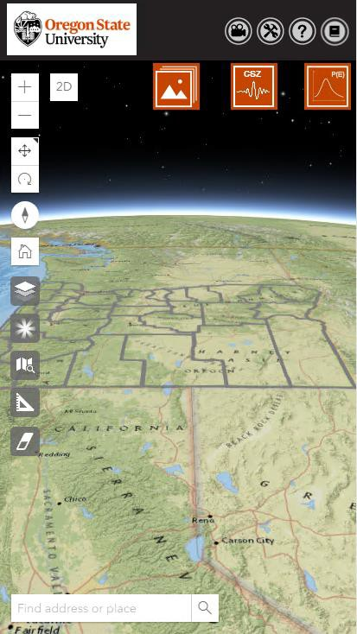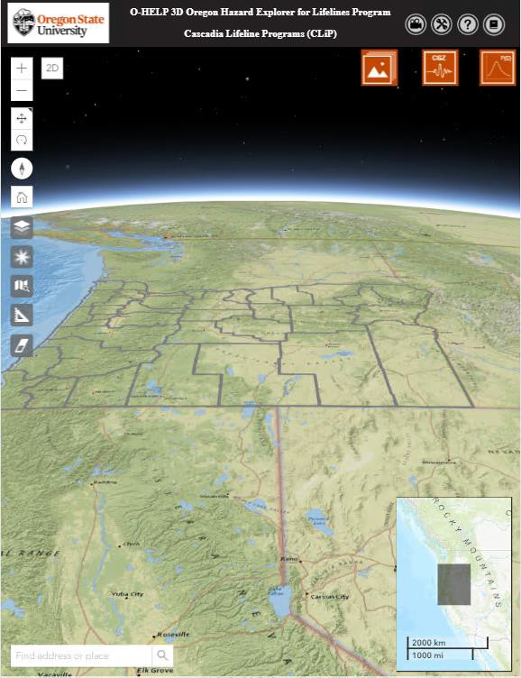

## Figure 13. The starting screen of O-HELP 3D in mobile phone (left) and tablet device (right)

**FUTURE WORK**

As previously discussed, a placeholder is set for probabilistic maps, which are very useful for engineering analysis and risk management. Currently, building codes generally require engineers to use probabilistic seismic hazard analyses for their designs. Future plans are to create python functions to allow the user to do an analysis on the layers within O-HELP.

# REFERENCES:

Boore, D.M., and G.M. Atkinson. "Ground-motion prediction equations for the average horizontal component of PGA, PGV, and 5%-damped PSA at spectral periods between 0.01 s and 10.0 s." Earthquake Spectra, Vol. 24, No. 1, 2008, pp. 99-138.

Building Seismic Safety Council (BSSC). 2000 Edition, NEHRP Recommended Provisions for Seismic Regulations for New Buildings and Other Structures, FEMA-368, Part1 (Provisions): developed for the Federal Emergency Management Agency, Washington, D.C, 2001.Burns, W.J., R.J. Watzig, "SLIDO-3.0, Statewide Landslide Information Database for Oregon (SLIDO), Release 3." [http://www.oregongeology.org/sub/slido/data.htm#interim,](http://www.oregongeology.org/sub/slido/data.htm#interim) Oregon Department of Geology and Mineral Industries. Portland, OR, 2014.

Burns, P. O. "Multi-hazard damage and loss assessment of bridge networks." Master thesis, Oregon State University, 2015, 116p.

FEMA, MRl, HAZUS-MH. "Multi-Hazard Loss Estimation Methodology: Earthquake Model." Department of Homeland Security, FEMA, Washington, DC. Web[: http://www.fema.gov/media-](http://www.fema.gov/media-) library-data/20130726-1716-25045-6422/hazus\_mr4\_earthquake\_tech\_manual.pdf , 2003.

FEMA (Federal Emergency Management Administration), HAZUS®-MH 2.0, Multi-Hazard Loss Estimation Methodology, software and technical manual documentation. Web: [http://www.fema.gov/plan/prevent/hazus;](http://www.fema.gov/plan/prevent/hazus%3B) Earthquake model technical manual: [http://www.fema.gov/library/viewRecord.do?id=4713,](http://www.fema.gov/library/viewRecord.do?id=4713) 2011.

Gesch, D.B., The National Elevation Dataset, in Maune, D., ed., Digital Elevation Model Technologies and Applications: The DEM User’s Manual, 2nd Edition: Bethesda, Maryland, American Society for Photogrammetry and Remote Sensing, 2007, pp. 99-118.

Hess, Daniel M., et al. "A simplified three-dimensional shallow landslide susceptibility framework considering topography and seismicity." Landslides Vol. 14, No. 5, 2017, pp. 1677-1697.

Madin, I.P. and Burns, William J. DOGAMI Open-File Report O-13-06, Ground motion, ground deformation, tsunami inundation, coseismic subsidence, and damage potential maps for the 2012 Oregon Resilience Plan for Cascadia Subduction Zone Earthquakes. Oregon Department of Geology and Mineral Industries. Portland, OR, 2013.

Madin, I.P., W.J. Burns, G. R. Priest, J. C. Allan, and J. Roberts. "Using high-resolution lidar data to evaluate natural hazards and risk in Oregon." In AGU Fall Meeting Abstracts, Vol. 1, 2013, p. 04.

Newmark, N. M., and W. J. Hall. Earthquake spectra and design, Engineering Monographs on Earthquake Criteria, Structural Design, and Strong Motion Records, Vol. 3: Berkeley, Calif., University of California, Earthquake Engineering Research Institute, 1982, 103 p.

Oregon Seismic Safety Policy Advisory Commission (OSSPAC). The Oregon Resilience Plan: Reducing Risk and Improving Recovery for the Next Cascadia Earthquake and Tsunami. [http://www.oregon.gov/OMD/OEM/osspac/docs/Oregon\_Resilience\_Plan\_draft\_Executive\_Summar](http://www.oregon.gov/OMD/OEM/osspac/docs/Oregon_Resilience_Plan_draft_Executive_Summary.pdf%20%2C2013) [y.pdf ,2013](http://www.oregon.gov/OMD/OEM/osspac/docs/Oregon_Resilience_Plan_draft_Executive_Summary.pdf%20%2C2013).

Sharifi-Mood, M., Olsen, M.J., Gillins, D.T. and Mahalingam, R., "Performance-based, seismically- induced landslide hazard mapping of Western Oregon." Soil Dynamics and Earthquake Engineering, Vol. 103, 2017 pp. 38-54.

U.S. Geological Survey. Quaternary fault and fold database for the United States, accessed on July 2014, from USGS web site: [http://earthquakes.usgs.gov/regional/qfaults/,](http://earthquakes.usgs.gov/regional/qfaults/) 2006.

Wald, David J., Vincent Quitoriano, Thomas H. Heaton, and Hiroo Kanamori. "Relationships between peak ground acceleration, peak ground velocity, and modified Mercalli intensity in California." Earthquake spectra, Vol. 15, No. 3, 1999, pp. 557-564.

Witter, R. C., Zhang, Y., Wang, K., Priest, G. R., Goldfinger, C., Stimely, L. L., English, J. T., and Ferro,

P. A., Simulating tsunami inundation at Bandon, Coos County, Oregon, using hypothetical Cascadia and Alaska earthquake scenarios: Oregon Department of Geology and Mineral Industries, Special Paper 43, 2011, 57 p, plates, GIS and data files, animations.

Priest, George R., Witter, Robert C., Zhang, Y. Joseph., Wang, Kelin., Goldfinger, Chris., Stimely, Laura L., English, John T., Pickner, Sean G., Hughes, Kaleena L.B., Wille, Taylore E. and Smith, Rachel L. DOGAMI Open-File Report O-13-19 Tsunami Inundation Scenarios for Oregon. Oregon Department of Geology and Mineral Industries, Portland, OR (2013).

# APPENDIX:

## Access to the data:

The data in O-HELP is available for research purposes through the College of Engineering at Oregon State University’s ArcGIS web server. To access the mapping data in ESRI’s ArcGIS products, follow the steps below to setup the server and to connect to the data:

1. Go to “Arc Catalog”.
2. Double-click on “Add ArcGIS Server”.
3. In the check box choose “Use GIS services” (Figure 14).

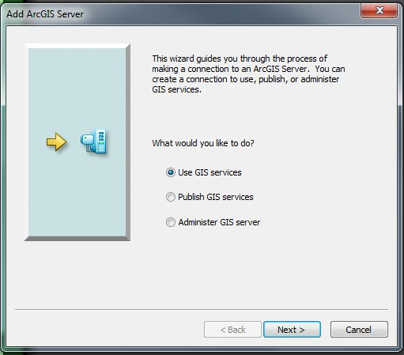

## Figure 14: setting up of server step 3

1. Enter the following URL in the server URL box ([Figure](#_bookmark34) 15): (https://arcweld.engineering.oregonstate.edu:6443/arcgis/rest/)

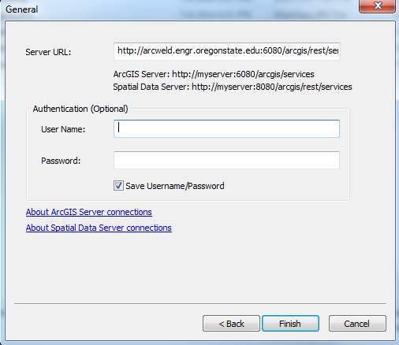

## Figure 15: Setting up of server Step 4

1. No authentication credentials are necessary at this time.
2. Once the server setup is completed, the data becomes visible on the catalog window. Data can be added to ArcMap from Arc Catalog by dragging and dropping the files to the table of contents.

## Troubleshooting and FAQs:

Please make sure that once you have selected the pin tool on the location of interest, wait for the pop-up window to come up.

Q: The Print Report Tool is not working. What should I do?

A: The preferred browser for O-HELP is GOOGLE CHROME. Try opening the website with the chrome browser and refresh the page. Also, let the page allow pop-ups.

Q: Feature layers like NEHRP and Site Geology are not rendering on the website. Why is that?

A: Usually, it takes more time to read feature class files from the server in comparison to rasters. Please wait for the server to bring the data on the screen.

Q: The home button on the left side of the screen is vanished and features are not working properly. What should I do?

A: Go to the Settings for the CHROME browser and try clearing your “Cookies and Cached images and files”.