**Bridges**

**OBJECTIVE:**

Test the strength of various bridges.

**TERMS TO GO OVER:**

Terms

**LAB MATERIALS:**

* Roll of pennies
* Small cup
* 2x4 plywood
* 11x17 paper
* Scissors
* Drill
* Screwdriver
* Screws
* Skill saw

**GROUP LEADER/VOLUNTEER/TLC ROLE**

Assist students

**SETUP PROCEDURE**

1. Create the bridge base:
   1. Cut the 2x4 plywood into two 8in pieces and one 10in piece
   2. Lay the 10in piece flat on the table (4in side on the table)
   3. Stand the 8in pieces on their ends on the table so they are standing erect on either side of the 10in piece like so: 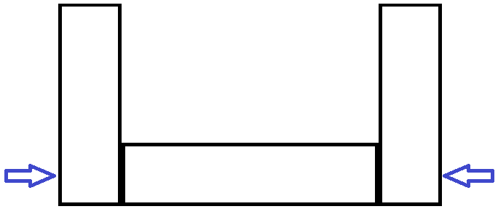
   4. Using 2 screws on each side, where the blue arrows indicate.
2. Create the bridges:
   1. Cut 11x17in paper into 4 equal pieces – each 2.75x17in in size – and are the “beams”
   2. For 3 of the pieces, fold up the edges on the lengthwise side so there is a “railing” approximately 1cm high
   3. Cut another 11x17in paper in half lengthwise and fold the pieces into a fan approximately .5in high – this will be the corrugated bridge.

**LAB PROCEDURE**

1. Place one beam onto the bridge frame
2. Put the cup in the middle of the bridge and gently place pennies into the cup until the beam gives way.
3. Place two beams onto the bridge frame and repeat step two.
4. Continue this with three beams, one beam and the corrugated beam, and one beam with the unfolded 2.75x17in piece acting as an arc beneath it.
5. Record the data and compare the results as a class discussion