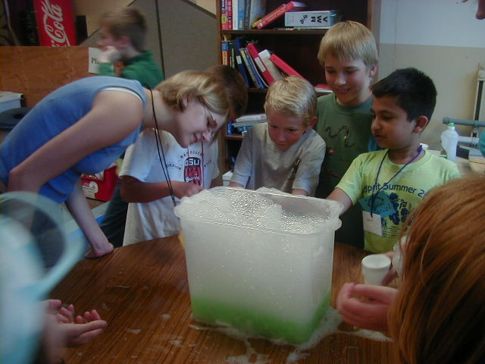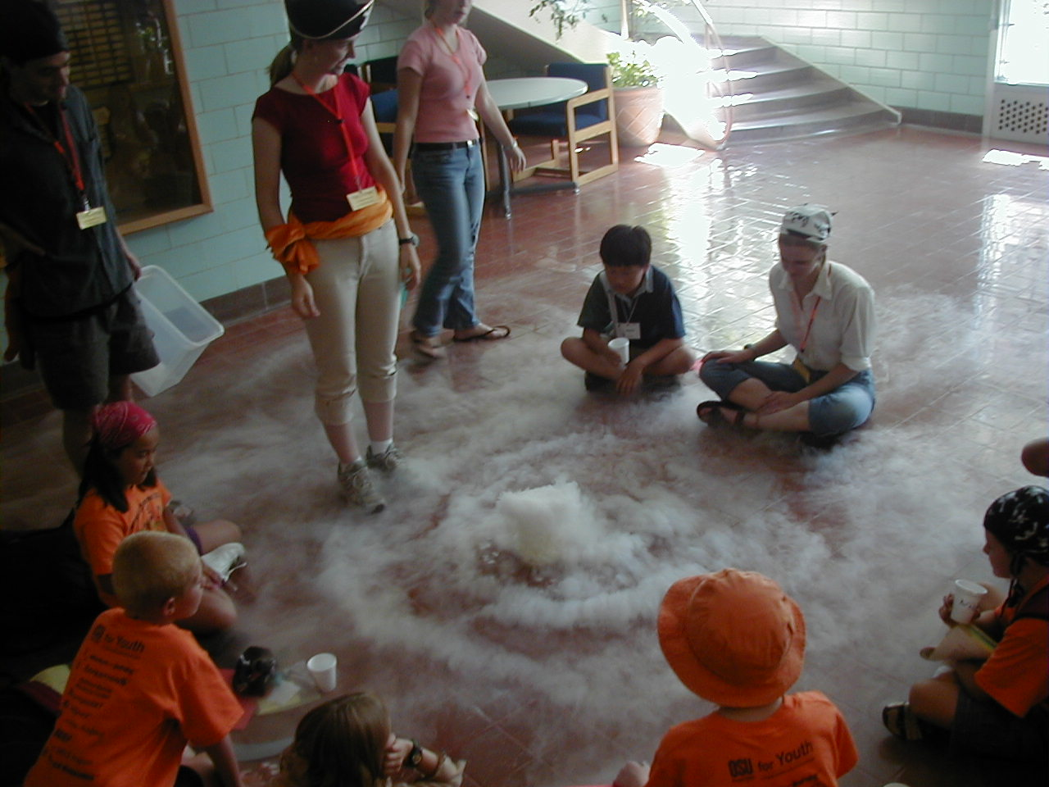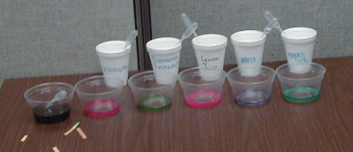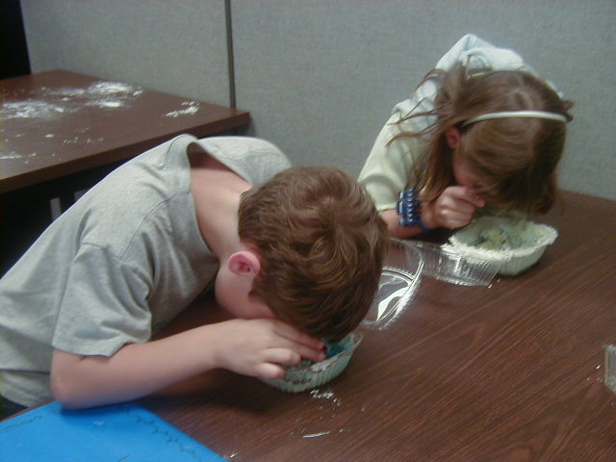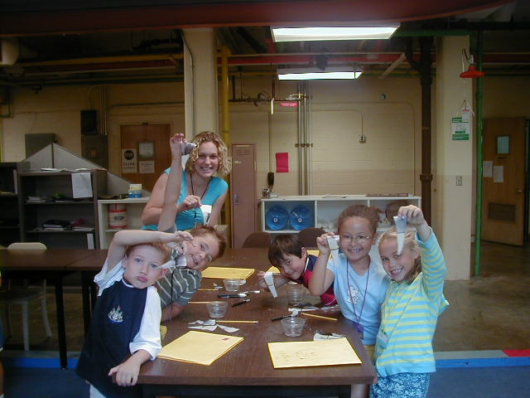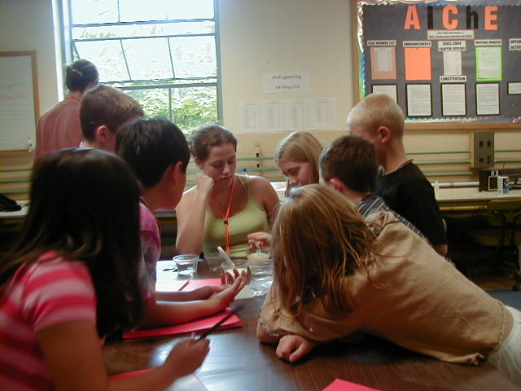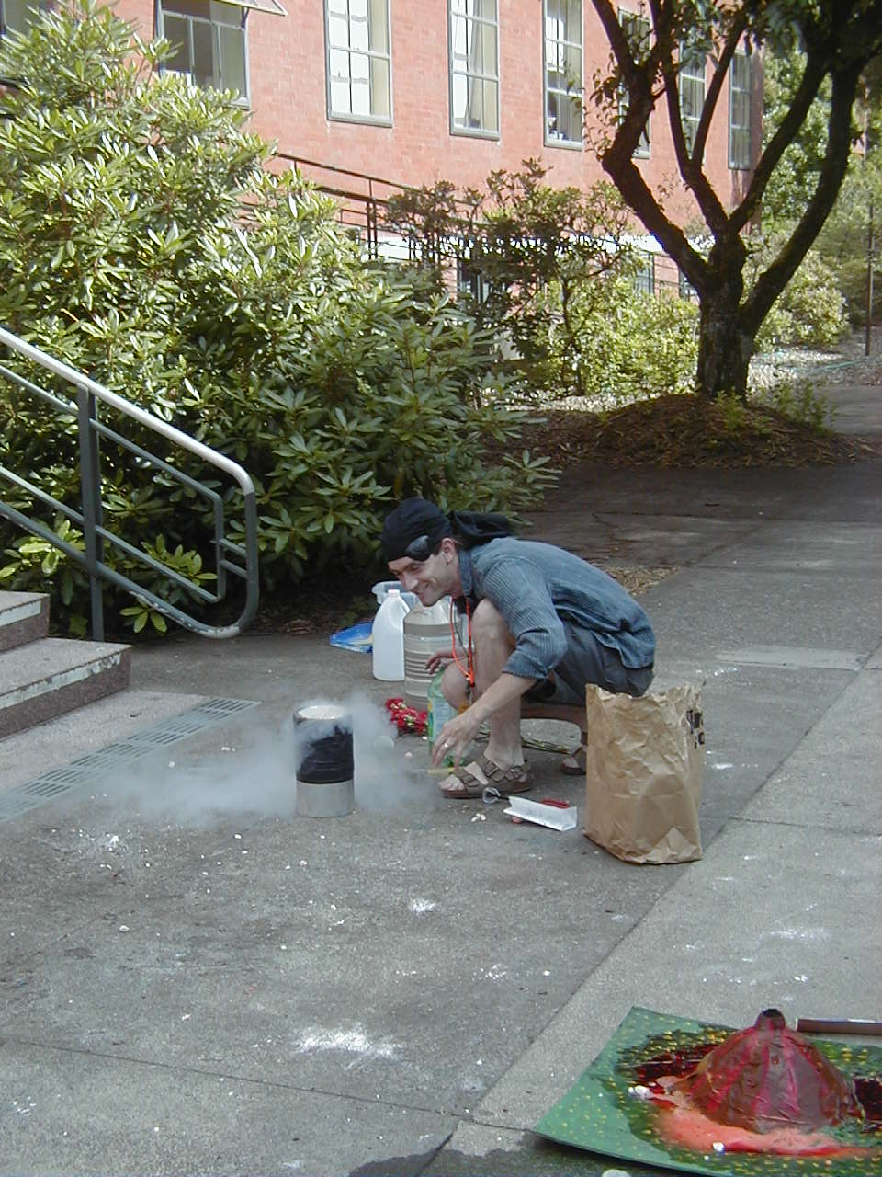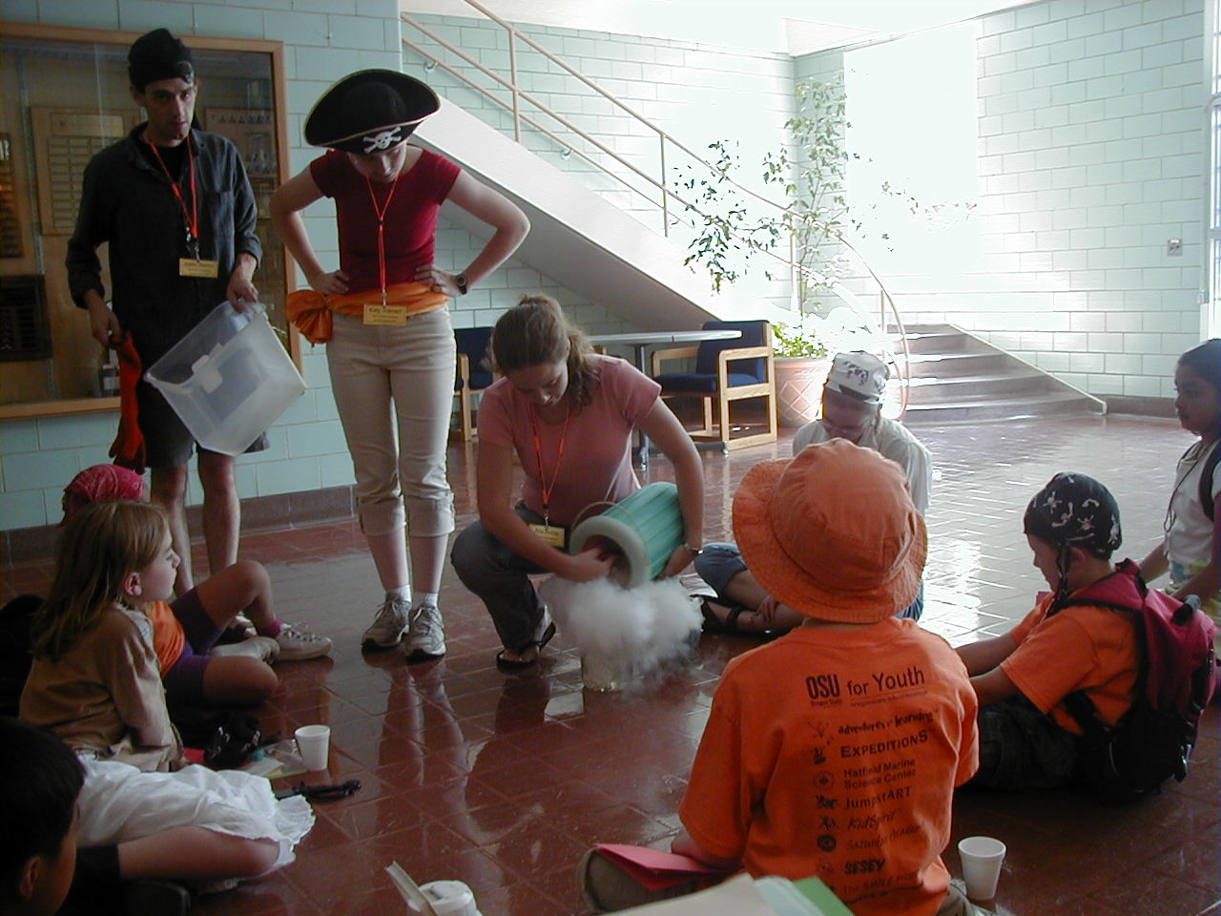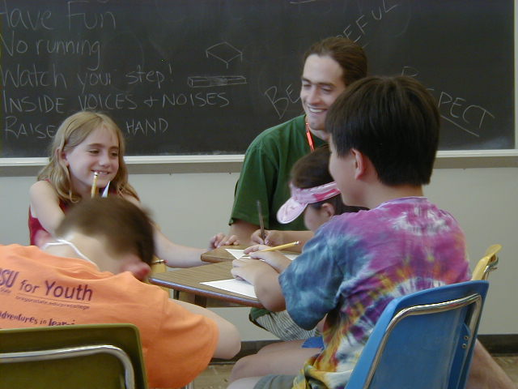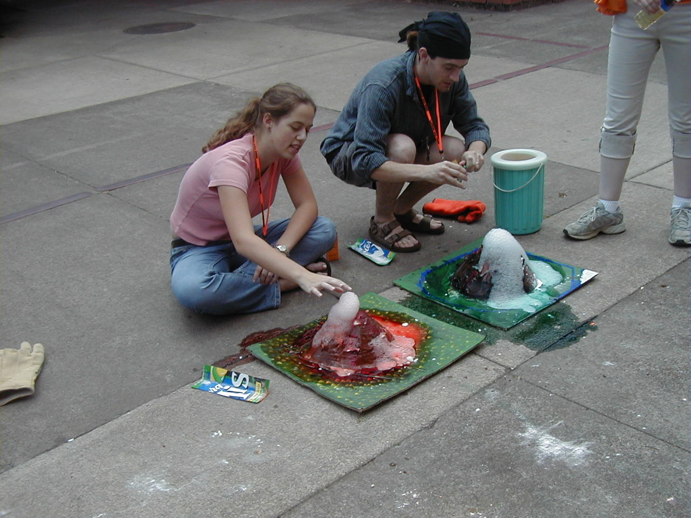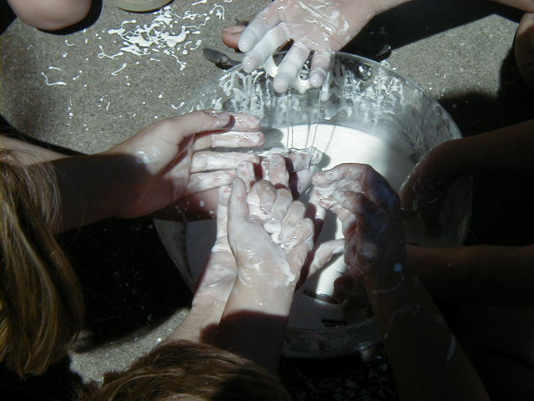
Chemistry
Chemistry
Introduction

Objective:
The goal of the chemistry unit is to teach students how to identify when a chemical reaction has occurred. The students should be able to watch a process and determine if a chemical reaction has occurred. They will see (and usually perform) reactions demonstrating every type of chemical change.

Background:
Chemistry is the study of chemical reactions as a result of molecular interaction. There are four ways to determine if a chemical reaction has occurred.

Heat is transferred:
The chemicals will change temperature when a reaction occurs. If the chemicals feel warmer then the reaction is exothermic, heat is going out of the system. If the chemicals feel colder then the reaction is endothermic, heat is going into the system. Most spontaneous reactions are exothermic, but the reaction between Epsom salts and water is a simple endothermic reaction. Combustion is an exothermic reaction that usually requires some activation energy, such as lighting it with a match.

A gas is released:
These are usually visible reactions because they will start to bubble. A safe and simple example of this is the reaction between baking soda and vinegar. These two chemicals (sodium bicarbonate and acetic acid) react and release carbon dioxide.

A color change occurs:
Combining chemicals can change the pigmentation that gives the chemicals color. A change in the pigments will cause the light to reflect differently and a color change to occur. Testing for pH is an example of a color changing reaction. The pH of the solution will change the pigment on the litmus paper or in the indicator. Acids and bases change the pigments in different ways, which causes the indicator to change different colors depending on the pH.

A precipitate is formed:
A chemical reaction has occurred if two liquids are poured together and a solid (called a precipitate) is formed. This happens when the two chemicals react to form something that is not soluble in water. A common example of this is curdling milk. Adding vinegar to milk causes it to curdle and form a precipitate.

Chemistry
State Standards and Benchmarks
Oregon Standards for 3rd and 5th grade

Science – Scientific Inquiry
Oregon Common Curriculum Goals:
- Understand chemical and physical changes.
- Formulate and express scientific questions or hypotheses to be investigated

Benchmarks:
- (Grade 3) Describe changes that occur in matter.
(Grade 5) Describe the ability of matter to change state by heating and cooling.
- (Grade 3) Make observations. Based on these observations, ask questions or form hypotheses, which can be explored through simple investigations.
(Grade 5) Make observations. Ask questions or form hypotheses based on those observations, which can be explored through scientific investigations.

Science- Physical Science
Oregon Common Curriculum Goals:
1. Understand structure and properties of matter.

Benchmarks:
1. Grade 3: Describe objects according to their physical properties.
Grade 5: Identify substances, as they exist in different states of matter.

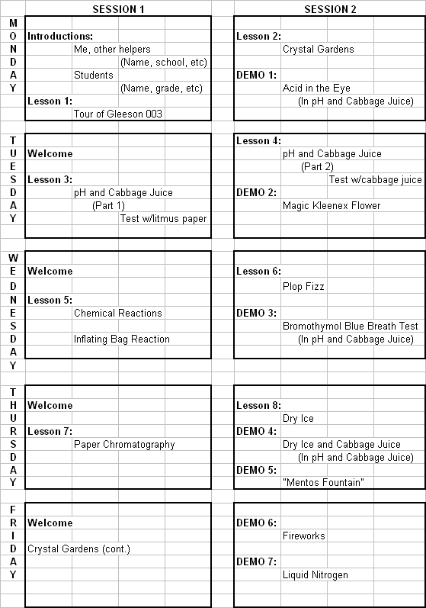
Chemistry
Vocabulary

- Acetic acid
- Acetic Acid
- Acidic (Acid)
- Alkaline (Base)
- Ammonia
- Calcium Chloride
- Capillary action
- Celsius
- Chemical Reaction
- Chromatography
- CO₂ –Carbon Dioxide
- Color change
- Combustible
- Control
- Copper Sulfate
- Crystal
- Dissolve
- Effervescent
- Endothermic
- Evaporate
- Exothermic
- Fahrenheit
- Gas
- Hypothesis
- Incandescence
- Iron hexacyanoferrate
- Laundry Bluing
- Liquid
- Liquid Nitrogen
- Lithium Chloride
- Magnesium Sulfate
- Molecules
- Neutralization
- Nucleation Site
- pH scale
- Pigment
- Precipitate
- Prediction
- Reaction
- Reaction Rate
- Sodium Bicarbonate
- Sodium Borate (Borax)
- Sodium Chloride
- Solubility
- Solution
- Solvent
- Strontium Chloride
- Sublimate
- Substrate
- Surface Area
- Surface Tension
- Temperature

Chemistry
Lesson Index

Lesson:

Chemical Reactions

Crystal Gardens

Dry Ice

Fireworks Demonstration

Liquid Nitrogen Demonstration

Mentos Fountain Demonstration

Paper Chromatography

pH and Cabbage Juice

Plop Fizz

Page:

6

9

13

17

19

22

24

27

30

Chemistry
Chemical Reactions

Grades K-5 (with variations)

Overview:
Students work with normal household products to make endothermic, exothermic, and precipitate-producing reactions.

Time: 45 minutes

Materials:
- Milk
- Tide Laundry Detergent
- Epsom Salts
- Water
- Baking Soda
- Vinegar
- Small cups
- Spoons
- Small resalable plastic bags
- Chemical Reactions activity sheet (1 per student)

Setup:
For each group pour one cup of each of the following: water, Tide, baking soda, milk, and Epsom salts. Pour two cups of vinegar. Have a spoon for each of the following cups: water, Tide, baking soda, and milk. Prepare enough sets of chemicals for each group to have one set. There is a Chemical Reaction Worksheet that goes along with this activity.

Background:
There are four ways to tell that a chemical reaction has taken place. If there is a color change, if heat is absorbed or released (endothermic or exothermic reaction), if a precipitate (insoluble solid) forms, or if a gas is released, then a chemical reaction has occurred. This activity demonstrates three of these indicating factors. It will not demonstrate a color changing reaction.

The reaction between Tide laundry detergent and water is exothermic. When the two are mixed together the reaction creates heat. The reaction between Epsom salts and water is endothermic. It begins to feel cold when the two are mixed. These are both examples of a heat transfer.
Combining milk and vinegar is an example of a reaction that forms a precipitate. Pouring the two together creates a white solid. This is also known as curdling milk.

Baking soda and vinegar react together and release a gas. The scientific name of baking soda is sodium bicarbonate, and vinegar is acetic acid. The chemical reaction is:
CH₃COOH (acetic acid) + NaC₃H₂O₂ (sodium bicarbonate) → NaC₂H₃O₂ (sodium acetate) + H₂O (water) + CO₂ (carbon dioxide gas)
The carbon dioxide being released causes the reaction to bubble.

Activities/procedure:
This is mostly a demonstration activity. Have a leader perform the reactions while the students watch.

Tide and water:
Put two teaspoons of Tide into a plastic bag for each of the students. Add one or two teaspoons of water to each bag so it makes a paste. Have the students mix the chemicals by carefully squeezing the bag. They should be able to feel the bag get warmer.

Epsom salts and water:
Put two teaspoons of Epsom salts into a plastic bag for each student. Add two teaspoons of water to each bag. Have the students mix the chemicals. The bag should begin to feel cold. This change can be more difficult to notice, and it doesn’t last long, so it might be helpful to put just water in one plastic bag and have the students compare the temperatures of the two.

Milk and vinegar:
Pour one of the cups of vinegar into the cup of milk. The reaction will occur instantly. The precipitate may be difficult to see so straining some of it out with a spoon to show the students may be helpful.

Baking soda and vinegar:
Add spoonfuls of baking soda to the remaining cup of vinegar. The reaction will be obvious as the mixture begins to bubble and flow out of the cup. Continue to add baking soda until the vinegar is used up and the reaction stops.

Discussion:
- Talk about the different ways to determine that a chemical reaction has occurred
- What happened to the Tide and water? (Became warm)
- What was the difference between that and the Epsom salts? (Became cold)
- Which one was endothermic and which was exothermic? (Tide, exo; Epsom: endo)
- What happened to the milk when the vinegar was added? (Curdled)
- What is that solid called? (A precipitate)
- What did the baking soda and vinegar do? (Created gas)
- What gas was released? (Carbon Dioxide)

Vocabulary:
- Acetic acid
- Chemical reaction
- Color change
- Endothermic
- Exothermic
- Gas
- Precipitate
- Sodium bicarbonate

References:
http://www.newton.dep.anl.gov/askasci/chem99/chem99183.htm
http://www.newton.dep.anl.gov/askasci/chem00/chem00303.htm

Chemistry
Crystal Garden

Grades K-5 (with variations)

Overview:
Make delicate, colorful crystals! This is a great, classic crystal-growing project. By using porous materials and a mixture of ammonia, salt, laundry bluing, and water you can grow a crystal garden. The crystals are very delicate and break very easily. There are some components of that garden that are toxic if ingested!

Time:
30 min to an hour to assemble
At least 2 days for crystals to grow (crystals will begin to form within hours. 4-5 days will produce large gardens)
About 15 minutes per day to observe and discuss

Materials:
For each student:
- Porous substrates- (i.e., Charcoal, Sponge, Brick, Terra Cotta) each substrate should be in small pieces, about 1-inch in diameter
- Ammonia- 2 teaspoons per student
- Laundry bluing- 2 teaspoons per student (available in the laundry aisle or online)
- Water- 4 teaspoons per student
- Uniodized Salt- 2 teaspoons per student (seems to work better than iodized)
- Food Coloring
- Non-metal container- glass or plastic bowls work well
- Disposable plastic spoons
- Small cups/containers- One for each student (if you choose to mix first) and one for each material in mixture (Salt, Ammonia, Water, Bluing)
- Copy of take home instructions
- Crystal Garden activity sheet

Setup:
Label small containers of bluing, water, ammonia, and salt for each table. Include the number of spoonfuls required on the label. Have substrates broken into 1 inch chunks.

Laundry bluing is found with laundry detergent at many different stores in the laundry aisle. Mrs. Stewart’s Bluing is a company that produces one product- bluing. It is available online at http://www.mrsstewart.com/

Background:
Crystals form on the porous materials and grow by drawing up the solution using capillary action. Water evaporates on the surface, depositing solid/forming crystals, and pulling more solution up from the base of the non-metal container. Small amounts of ammonia (NH3) are added to speed up the evaporation process and to help the salt dissolve.

The bluing contains particles of iron hexacyanoferrate (KFe2(CN)6), ammonia (NH6), and salt (sodium chloride (NaCl). As the water in the solution evaporates, two things happen. The iron hexacyanoferrate particles can no longer be supported and the excess salt cannot stay in solution. This provides starting points for the salt crystallization process, which will take place around the iron particles as nuclei. This works in much the same way as silver iodide cloud seeding accelerates the formation of rain drops. Both the KFe2 crystals and the salt crystals sprinkled over the substrates act as seed crystals and allow for a place for the dissolved salt to form crystals. The crystals grow in the same shapes as the crystals, each crystal growing on top of others, creating very delicate patterns.

Mrs. Stewart’s Bluing works by replenishing the blue hue in white fabrics. There are over 300 shades of white and the most intense whites have a blue tint in them, so by adding a slight blue hue to white fabric makes it look brighter.

Activities/procedure:
- Place chunks of substrate in the non-metal container; try not to have substrates touching each other. Use about 6 pieces of substrate per student.
- Spoon Ammonia, bluing, water and salt over the substrate
- Add a drop of food coloring to substrate if desired, areas with no food coloring will grow white crystals. Be careful not to get too much food coloring, there should only be 1-4 drops for the whole garden. Too much food coloring will slow the growth of crystals and they will not form as well. Red seems to slow down growth. Yellow does not color the crystals. Blue and green seem to work the best.
- Set garden in a safe place where it will not be disturbed, make sure the garden is not enclosed- it needs air to grow.
- Each day add more salt.
- On the third day add all of the ingredients again
- Then repeat this cycle *Once the crystals are formed they will last indefinitely if undisturbed. However, remember these crystals are very fragile and will break if touched.

EXTENSIONS: Make a tree out of pipe cleaners or filter paper and set it on a piece of substrate, or in the bottom of the dish. Crystals will form on the branches of the tree.

Copper Sulfate Geodes Extension:
While the second activity makes gorgeous geodes and not a garden, it still is a fun way to explore solutions, evaporation, and crystal growth. The supplies for this activity are more difficult to obtain. Copper sulfate is not sold in grocery stores and most likely needs to be ordered or purchased from a chemical supply company. However, the directions and ingredients are very simple:

Activity Materials:
1 half egg shell – used as the shell for the geode
Supersaturated Copper Sulfate solution

Procedure:
Begin by making a supersaturated copper sulfate solution. Heat water and add as much copper sulfate as you can when the temperature is elevated. Allow the solution to cool until you can safely handle it and pour a small amount into each half egg shell. Over night, the blue liquid will evaporate and leave translucent blue crystals that resemble the insides of a geode. The crystals are safe to touch and investigate.

Crystal Stars Extension:

Activity Materials:
For each crystal structure
500mL water
+15mL Borax
1-2 Pipe Cleaners
String
Microwaveable container
Container to soak stars/shapes in overnight
Pencil(s)

Procedure:
Heat the water in the microwaveable container in a microwave oven until boiling. Pour the water into the canning jar. Add 15mL of borax and stir it in until dissolved. Continue to add borax until no more will dissolve. Give the students the opportunity to form stars or other shapes out of pipe cleaners. Tie one end of the string to the pipe cleaner star/shape. Tie the other end of the string around a pencil. Place the pipe cleaner star/shape in the solution. Leave the star/shape in the solution, completely covered, overnight. The next morning, lift the star out of the solution and examine the crystals formed.

Discussion:
- Talk about the different types of crystals that formed
- Discuss the process of evaporation that causes the calcium deposits to form crystals. (Drawing pictures of the molecular structure of crystals on the board may be helpful. Salt is a relatively small crystal (NaCl) compared to the sugar crystal (C₆H₁₂O₆).)
- What did their crystals look like? (Answers will vary)
- Why did some crystals look different? (Different substrates)
- What made some crystals grow better than others? (Different substrates, amount of food coloring)
- Can you see any repeating shapes? (Yes)
- Where did the crystals come from? (They grew from a dissolved solution)
- Did certain substrates grow crystals better than others? (Yes)

Vocabulary:
- Ammonia
- Crystal
- Evaporate
- Iron hexacyanoferrate
- Laundry bluing
- Liquid
- Sodium chloride
- Solution
- Substrate

References:
Experiencing Chemistry: Museum Manual Part 1. Portland, Oregon: Oregon Museum of Science and Industry, 1997. Pgs U1.59-U1.62.

http://chemistry.about.com/cs/growingcrystals/ht/charcoalgarden.htm
http://www.mrsstewart.com/
Chemistry
Dry Ice

Grades K-5 (with variations)

Overview:
These demonstrations familiarize students with dry ice and its properties, and help to teach them about different states of matter. They allow students to make connections with the use of dry ice in the real world. Dry ice is a potentially dangerous substance so precautions should be taken.

Time: 45-60 minutes

Materials:
For the exploration:
- Cup of water
For Screaming Metal:
- Metal spoon
- water
For Fire Extinguisher
- Candle
- Matches
- Cup of water
For Balloon Magic
- Balloon
- Hot water
For Soap Experiment:
- Soap*
- Hot water
- Plastic container
*Note: this can be made with a homemade bubble solution (dish soap + water + glycerin or mineral oil) being substituted for the soap and hot water.
For Bubbles:
- Bubbles and wand
- Hot water
- Plastic container
For the class:
- Heavy Duty gloves
- Hammer (if ice doesn’t come in pellets)
- Tongs for handling the ice
- Food coloring
Demo:
- Cabbage juice
- Graduate cylinder (large)
- Ammonia

Setup:
This is easy to set up in table groups, with each group having the materials for all the experiments except the bubble and soap experiments. Remember to start heating hot water before the exploration time and have the soap already in the container when you go to do the demonstration.

Inform students of the dangers of dry ice! Make sure to tell them that regular H₂O steam will burn badly. Even though this looks like steam, it is not. It is safe to touch CO₂ gas.

Background:
Humans exhale gaseous carbon dioxide (CO₂), but what does carbon dioxide look like as a solid? It is dry ice. Just like water, carbon dioxide must be frozen to become a solid. It freezes at -109ºF or -80ºC, which is much colder than the 0ºC at which water freezes, so it can be very dangerous. Dry ice undergoes sublimation, a direct change from a solid to a gaseous state without becoming a liquid. Dry ice burns in the same way that boiling water will burn the skin and can cause frostbite, ice crystals form under the skin and cause tissue damage just like a burn, when touched for long periods of time. Be very careful with the ice and carefully observe the students’ exploration of the ice to ensure safety.

Carbon dioxide is a chemical compound composed of one carbon and two oxygen atoms. It is often referred to by its formula CO2. It is present in the Earth's atmosphere at a low concentration and acts as a greenhouse gas. In its solid state, it is called dry ice. It is a major component of the carbon cycle.

Atmospheric carbon dioxide derives from multiple natural sources including volcanic outgassing, the combustion of organic matter, and the respiration processes of living aerobic organisms; man-made sources of carbon dioxide come mainly from the burning of various fossil fuels for power generation and transport use. It is also produced by various microorganisms from fermentation and cellular respiration. Plants utilize carbon dioxide during photosynthesis, using both the carbon and the oxygen to construct carbohydrates. In addition, plants also release oxygen to the atmosphere, which is subsequently used for respiration by heterotrophic organisms, forming a cycle.

Exploration: The dry ice bubbles when placed in the water because it is sublimating and releasing little pockets of gas into the water, the same idea as when we blow bubbles in the swimming pool or using a straw with our drinks. The fog then rises when the ice is placed in hot water because the water molecules cool off and clump together, after mixing with the carbon dioxide.

Screaming Metal: Begin by asking the students if they know why the metal makes so much noise, or if maybe the metal is trying to warn them of the dangers of dry ice. The metal screams when it comes into contact with the ice because the heat from the metal melts a bit of the ice into a gas. This gas then pushes the spoon off the ice, but the spoon quickly falls back down and the process continues causing the screech.
The water in the spoon freezes because the ice is so much colder than the temperature at which water freezes.

Fire Extinguisher: The steam from the dry ice sublimating in the hot water is made up of CO₂ rather than vaporous H₂O. The fire burns because it is surrounded by oxygen, so when it is put in an oxygen-starved environment, the fire goes out.

Balloon Magic: When dry ice gets hot, it sublimates meaning that it skips the liquid phase and goes straight to the gas phase. As the ice sits in the balloon in hot water, it sublimates even quicker, then if it was by itself and fills the balloon with CO₂ gas which causes the balloon to expand. This because gas takes the shape of its container, so the same amount of gas is a lot larger than a solid of the same substance.

Soap Experiment: As the hot water melts the dry ice, pockets of gaseous CO₂ are released. The soap then locks in the carbon dioxide and the bubbles are full of fog.

Bubbles: As the dry ice sublimates, it causes the vapor that was explained in the exploration. The bubbles float above the carbon dioxide gas because the carbon dioxide gas is heavier than air.

Cabbage Juice Demo: Put some cabbage juice in a large graduated cylinder. Put a little dry ice in the bottom. As the ice reacts with the water and the carbon dioxide is disolved, it Carbonic acid. The juice will turn pink. Add some ammonia – it will turn green and then back to blue and purple as it forms acid. This is a fun and colorful way to explain the chemistry of the reaction between dry ice and water. It is also a good review of pH.

Carbonic acid (ancient name acid of air or aerial acid) has the formula H2CO3. It is also a name sometimes given to solutions of carbon dioxide in water, which contain small amounts of H2CO3. The salts of carbonic acids are called bicarbonates (or hydrogencarbonates) and carbonates.

Carbon dioxide is a colorless gas which, when inhaled at high concentrations (a dangerous activity because of the associated asphyxiation risk), produces a sour taste in the mouth and a stinging sensation in the nose and throat. These effects result from the gas dissolving in the mucous membranes and saliva, forming a weak solution of carbonic acid. You may notice this sensation if you attempt to stifle a burp after drinking a carbonated beverage.

Activities/procedure:
For exploration:
- set ice on the table
- watch piece disappear
- put ice in cup of water
- watch ice disappear and the liquid bubble
- then put a piece of dry ice in a cup of warm/hot water
- watch the ice disappear and the fog form
For Screaming Metal:
- put some dry ice on the table
- press a spoon to the dry ice
- be very quiet
- listen to the noise that is produced
- you can also put water in the spoon
- observe freezing of the water
For Fire Extinguisher:
- light a candle
- put dry ice in a cup of hot water
- set candle near the cup or pour the fog coming from the cup over the candle
- watch the flame die
For Balloon Magic:
- put a piece or 2 of dry ice in balloon
- add some hot water to the balloon or put balloon in the water
- tie or pinch off balloon
- watch balloon expand
- if the balloon was tied set it away from students in case it pops
For Soap Experiment:
- Put soap in plastic container
- Add hot water
- Add dry ice
- Watch the solution ooze up and even over the container sometimes
For Bubbles:
- place a cup of hot water into a large plastic container
- add dry ice to cup of hot water
- observe fog coming off of hot water and dry ice cup
- blow bubbles into container
- watch the bubbles float

Discussion:
- After each demonstration try to lead the students to explanations of how each experiment works by reminding them of the special properties of dry ice.

Vocabulary:
- CO₂- Carbon Dioxide
- Sublimate- during phase change the solid form skips the liquid phase and goes straight to the gaseous phase

References:
http://www.rockitscience.com/dryice1.html
http://www.dryiceinfo.com/science.htm
http://www.cooldictionary.com/words/Dry-ice.wikipedia

Chemistry
Fireworks Demonstration

Grades K-5 (with variations)

Overview:
Burning small amounts of different powdered metal compounds results in different colored flames. This shows children how fireworks are made and they are amazed at the multicolored flames. This lesson is entirely demonstration.

Time:
10 min to explain
20 min to demonstrate (more or less depending on amount of powdered chemicals)

Materials:
- Bunsen Burner (or small butane torch)
- Gas for Bunsen Burner
- Scoopula or wire loops, one for each chemical
- Safety goggles
- Aluminum sheet (or other fire resistant material) to put under burner to protect the table
- Glass beaker to cool and rinse wire loops between tests
- Fire extinguisher
- Powdered Chemicals
Strontium Chloride- produces red flames
Calcium Chloride- produces blue flames
Magnesium Sulfate (Epson Salts) - produces white flames
Baron salts (Borax) - produces yellowish-green flames
Copper Sulfate (Blue Vitrol) - produces green flames
Sodium Chloride (Table Salt) - produces yellow flames
Lithium Chloride- produces magenta flames

Setup:
Make sure this demonstration is done outside or in a well ventilated area. A dark classroom allows for the colors to be seen the best. This lesson is all about fire and colors so be careful and make sure there is enough room for everyone to safely see.

Background:
Incandescence is light produced from heat. Heat causes a substance to become hot and glow, initially emitting infrared, then red, orange, yellow, and white light as it becomes increasingly hotter. When the temperature of a firework is controlled, the glow of components, such as charcoal, can be manipulated to be the desired color (temperature) at the proper time. Metals, such as aluminum, magnesium, and titanium, burn very brightly and are useful for increasing the temperature of the firework.

Sometimes the salts needed to produce the desired color are unstable. Barium chloride (green) is unstable at room temperatures, so barium must be combined with a more stable compound (e.g., chlorinated rubber). In this case, the chlorine is released in the heat of the burning of the pyrotechnic composition, to then form barium chloride and produce the green color. Copper chloride (blue), on the other hand, is unstable at high temperatures, so the firework cannot get too hot, yet must be bright enough to be seen.

Activities/procedure:
- Set Bunsen burner up
- Adjust flame till it is at the hottest setting, it should be a blue flame
- Put powder on scoopula or wire loop
- Put scoopula or wire loop in flame
- Watch the flame change colors
- Clean scoopula well between chemicals

Discussion:
  - Talk about how scientists use flame tests like this to test for the presence of certain metals
    - If the flame burns blue they can tell there is calcium present
    - This knowledge of chemistry is also used when making fireworks
  - Ask the class about the sorts of fireworks they have seen
    - Theorize what kinds of chemicals might have been in them.

Vocabulary:
- Calcium chloride
- Combustible
- Copper sulfate
- Incandescence
- Lithium chloride
- Magnesium sulfate
- Sodium borate (borax)
- Sodium chloride
- Strontium chloride

References:
http://chemistry.about.com/library/weekly/aa062701a.htm
http://www.members.tripod.com/Howtuz/flames.html

Chemistry
Liquid Nitrogen Demonstration

Grades K-5 (with variations)

Overview:
This is a demonstration lesson where students get to watch what a very cold liquid can do.

Time: 30 minutes to 1.5 hours

Materials:
Teaching/demo materials:
- Liquid nitrogen
- Open container insulated to hold liquid nitrogen (dewar)
- Hammer
- Tongs
- Safety goggles
- Thick gloves for handling extreme temperatures
Suggested materials:
- Hot dogs
- Silly putty
- Tennis ball
- Carnations
- Bananas
- Inflated balloon
- Anything else that will smash when frozen in liquid nitrogen

Setup:
Liquid nitrogen can be purchased from Chem. Stores. It can be kept in a closed, insolated container for a few hours, so it must be purchased the day of the activity. A full dewar (4 liters) of liquid nitrogen should be enough for this activity, and still have some left over.

In class, give the students a safety lecture on liquid nitrogen. Any contact with skin can result in frostbite. It is important that the class behave around the liquid nitrogen and stay back during the activity. Set strict rules involving this activity.

Background:
Liquid nitrogen (N₂) is a coolant that exists at -196 degrees Celsius, or -321 degrees Fahrenheit (-77 Kelvin). It is much colder than dry ice (CO_{2,} which freezes at -78.5 degrees Celsius or -109.3 degrees Fahrenheit) which is capable of “burning” tissue due to its extreme cold. As a result, liquid nitrogen is even more dangerous.

Since liquids transfer heat efficiently, they make good coolants. Placing an object in liquid nitrogen will freeze it within seconds. Since most substances we use (especially food and plants) contain water, they freeze and become brittle. When items are frozen, their molecules do not move as much. This allows objects that would normally stretch, tear, or bend to shatter when sharp pressure (such as a hit from a hammer) is applied. When molecules can not move, energy is not returned as well. This is why frozen rubber balls will not bounce as well.

Another property of extreme temperature is that gases expand or contract. In heat gasses expand, but in extreme cold they contract. A balloon will shrink to about 1/10 its size when liquid nitrogen is poured over it. Moments later it will expand to its normal size as the air expands again.

Activities/procedure:
This is entirely a demonstration activity. The students should not be allowed to touch the liquid nitrogen. It is important that they stay back while things are being smashed, since flying pieces could be enough to cause burns. Stress that they are not to touch the broken pieces! They can burn.

Using thick gloves pour some of the liquid nitrogen into the open container for demonstrations. The fog will make it difficult to see when the container is full, so pour until the liquid nitrogen begins to overflow. At first it may be necessary to continue to add more liquid nitrogen because it will boil off as the container cools down.

With tongs, put objects into the liquid nitrogen. Take them out and smash them with a hammer. Some things may take longer to freeze than others. Show the difference in the consistency before and after being in the liquid nitrogen. Demonstrate how most objects will return to their original state after they have heated up again (with exception of the carnations, which will wilt).

Pour some liquid nitrogen over an inflated balloon. Talk about how gas expands and contracts depending on the temperature. Watch while the balloon re-inflates as it gets warmer. It is fun to drop in a long balloon, and then watch it shrink to almost nothing, and then re-inflate as it warms up. For added fun, we used screamer balloons. After the balloon re-inflated, we let it go and the kids went nuts! Anything add some showmanship!

When a rubber ball is dropped into the liquid, it gets very hard and sounds like a pool ball when bounced. When first frozen, it may bounce pretty well since it is so solid. After a few seconds, it will almost lose its bounce. It will hit the ground and die. After a few minutes, the ball will bounce again.

At the end, the remaining liquid nitrogen can be poured on the floor, or down the stairs or on the ramp. Be VERY careful to poor away from people, as the droplets travel a long ways on clouds of vapor. It is especially interesting on a tile or linoleum floor, since it will lift the oil and dirt off and the balls of oil will slide around until all the nitrogen has evaporated. It makes a great “spooky fog” effect. Very mad scientist.

Discussion:
- Discuss the difference between the Fahrenheit and Celsius (possible also Kelvin) temperature scales
- Discuss changes in molecules with heat
  - When the object is cold, the molecules do not move as much
  - Things become more brittle
  - Rubber loses its bounce
  - When gasses get cold, they get closer together

Vocabulary:
- Celsius
- Fahrenheit
- Liquid nitrogen
- Molecules

References:
http://www.ilpi.com/genchem/demo/liquidnitrogen/
http://www.howstuffworks.com/question264.htm
Chemistry
Mentos Fountain Demonstration

Grades K-5 (with variations)

Overview:
This is a cool soda fountain that the kids really enjoy. When Mentos candy is dropped into a 2-liter bottle of soda, it produces a soda eruption. The spray tastes delicious and it is not too sticky if you use diet soda.

Time: 15 min for set up and 5 minutes for actual demonstration

Materials:
For each demo:
- Pushpin or large needle
- Thread
- 2 liter bottle of pop (diet cola is less sticky, but after repeated trials, we found that room temperature non-diet cola seems to work the best… for whatever reason)
- Mint or strawberry Mentos (works best)—at least 7 per fountain

Setup:
With the pushpin, make holes in each Mentos to thread onto a string/thread. Thread the candies onto the string, tie off, and leave a tail on at least one end. Right before the experiment, punch a hole in the lid of the soda and pour out as much soda as needed, so that when the tail is threaded through the hole of the lid and the Mentos are in the bottle with the lid on, they are not touching the soda (don’t even let it touch the soda for a second). The less soda you remove, the better. You may string the Mentos in a loop so both top and bottom strings are threaded through the hole in the lid. This makes it so you do not have to pour out as much soda.

Diagram:
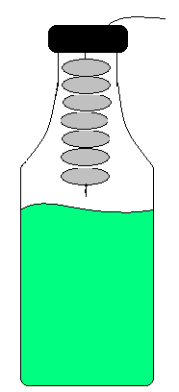

Background:
Mentos contain gum arabic which gives them the chewy property. Soda on the other hand, contains carbon dioxide gas (in bubbles) surrounded by water molecules which are super-attracted to each other. The clumping together of the water molecules causes surface tension, which is a measure of how hard it is to separate the water molecules. We can break the surface tension even more easily by adding the gum arabic to the soda. The Mentos then begin to dissolve leaving little pits on the surface, which are called nucleation sites-places where more carbon dioxide gas bubbles can form. This causes the contents of the soda bottle to explode, out the hold and into a fountain.

Activities/procedure:
- thread Mentos string through lid
- put in bottle and screw lid onto bottle
- drop Mentos into soda*
- run away as fast as possible
*If doing this later, tape the string to the bottle and then cut the string when you wish to start the reaction.

Discussion:
- Talk about surface tension
  - Water (the main ingredient in soda) has a certain amount of surface tension
  - If the surface tension in the soda is broken it allows the carbon dioxide to be released
  - If the gas all breaks the surface tension at the same time an explosion occurs.

Vocabulary:
- CO₂ – Carbon dioxide
- Nucleation site
- Surface tension

References:
Steve Spangler Science Experiment Mentos Fountain
Chemistry
Paper Chromatography

Grades K-5 (with variations)

Overview:
Using common household supplies, the students will discover the different types of ink that are used in black pens. This experiment can also be done using colored pens and then figuring out which colors are primary colors (the ones whose ink was made up of one pigment).

Time: 30 min for activity, 15 min for discussion

Materials:
For the class:
- Coffee filters
- Different brands of permanent black pens and markers (each brand is given a #)
- Water cups
- Optional: “ransom note”
For each student:
- Cup of water
- Coffee filters for each pen- the filters can be cut into quarters
- A collection of pens for each table group- should include one of every numbered pen
Teaching/demo materials:
- Water cup
- Coffee filter
- Marker
Extension:
- Coffee filters
- Colorful markers
- Water droppers

Setup:
Find four different black markers that have unique chromatography spectrums. Label the markers with numbers. Make enough sets for each group. Be sure that each type of marker has the same number in each group.

Using one of the four different markers, write a ransom note on a piece of filter paper. For example: tell the students that one of the leaders has the key to the classroom, and they need to find out who has it. On the bottom of it write symbols or drawings (question marks are good) that can be cut off and given to each group to test. Or, you can simply cut the note into strips. Have one of the helpers run into class with the note.
Background:
Chromatography is used to separate chemical complexes into their original/individual components. Knowing that all elements have unique chemical properties, they react differently with a common solvent. As the ink is immersed in the common solvent (water), it dissolves and separates into the colors/ pigments used to make up the ink. Separation of the underlying pigments occurs because of each individual’s affinity to water. The more soluble pigments travel farther up the paper. The water travels up the coffee filter by capillary action.

Activities/procedure:
Often times it is easy to engage the students in this lesson if they are asked to solve a mystery. Given a ransom note (written on filter paper), the students are asked to discover which pen was used for the ransom note. Of course there can also be suspects associated with each pen.
- Draw a thick line about ¼ from the bottom of the filter and label filter with pen # used
- Place filter in water cup and watch the ink dissolve as the water creeps up the filter
- Repeat steps 1 and 2 for each pen
- Test the ransom note using step 2

Extension:
For more fun with paper chromatography, let the students color on coffee filters with washable markers. Either place part of the filter in water and watch the colors spread as the water soaks up using capillary action, or drop water on the filters using the water droppers. This makes a good art project for the class.

Discussion:
- What kind of applications does chromatography have for the real world? (criminal investigations, understanding the formation of certain chemical complexes, art work, etc.)
- If using colored pens too, there can be discussions about primary and secondary colors, and the mixtures needed to form secondary colors.
- Talk about solubility. (Markers must be soluble in water in order for chromatography to work.)

Vocabulary:
- Capillary action
- Chromatography
- Dissolve
- Pigment
- Solubility
- Solvent

References:
National Chemistry Week - Experiments - Paper Chromatography
Chromatography - Chemical Separation of Colors

Chemistry
pH and Cabbage Juice

Grades K-5 (with variations)

Overview:
We are going to use the juice from a cooked red cabbage to test the pH of many household items.
The more acidic the solution, the more red/pink it will turn when the cabbage juice is added. If it is neutral it will be purple and if it is alkaline then it will be green/blue. Colors are very brilliant and the kids love to try testing and mixing different solutions.

Time:
30-45 min

Materials:
For the groups:
- Cabbage Juice
- Test Solutions- Lemon Juice, Ammonia, Baking Soda mixed with water, Vinegar, Seltzer Water, Laundry Detergent mixed with water, Borax mixed with water, Plain Water, clear soda
- Small Containers for test solutions
- Droppers (in cabbage juice)
- Litmus Papers
- Crayons for observation notes
- pH Testing worksheet for each student

Demo materials:
“Acid in the Eye”
- HCl - hydrochloric acid
- Petri dish
- Egg
“Bromothymol Blue Breath Test
- Bromothymol Blue pH indicator solution
- Rubber stopper
- Straw
- Small test tube
- Safety glasses
- Dry ice nuggets (optional)

“Dry Ice and Cabbage Juice”
- Cabbage Juice
- Large (100mL) graduated cylinder
- Cup of dry ice nuggets

“Magic Kleenex Flower”
- Kleenex
- Pipe cleaners
- Phenolphthalein (pH indicator)
- Spray bottle
- Windex

Setup:
- Shred the cabbage and add enough water to cover it. Boil for 20-30 min- long enough for the water to turn dark purple. Strain the cabbage, collect the juice, and allow it to cool. (Or shred and add equal amount of hot water to a blender. Then blend and strain.)
- One head of cabbage makes about 1 gal of juice, which starts to stink after a couple of days. The cabbage keeps better than the juice, so if you want to spread this out over a couple of weeks, you may want to make a couple of batches. Keep juice refrigerated or it will spoil.
- You can make the solution the night before, or you can have the kids help you shred the cabbage and make the solution.
- Pour test solutions in small containers
- Label the small containers
- Set out one set of test solutions for each group

Background:
Acids and bases are related to the number of hydrogen ions present in a solution based on the Brønsted-Lowry definition. Acids increase the concentration of hydrogen ions and bases decrease the concentration by accepting the ions.

Sören Sörensen came up with the pH scale, which measures the acidity on a scale from
1-14.

1- Most acidic like HCl (hydrochloric acid)
7- Neutral like Pure water
14-Most alkaline like NaOH (Sodium Hydroxide)

|---------------------------------------------|----------------------------------------------|
1 Acid (Acidic) 7 Base (alkaline) 14
Neutral

To test an acid or base you can use an indicator like litmus paper, which generally turns pink when dipped into an acid and blue when dipped into a base.

Red cabbage juice is another indicator. Red cabbage contains pigments call anthocyanins. The pigments give it the red/purplish color. Anthocyanins belong to group of chemical compounds called flavonoids.

For most pH indicators, the compound acquires a proton at low pH (lots of H+) but loses it at higher pH. This seemingly minor alteration is sufficient to alter the wavelengths of light reflected by the compound, thus creating the color change with respect to pH. Anthocyanins behave somewhat inversely in that the pigments "gain" an -OH at basic pH, but loose it at acidic pH.

Activities/procedure:
- First test each solution with litmus paper and record the pH on the worksheets
- With the droppers, add cabbage juice to each test solution until the solution changes color. Record this data on the worksheets. Kids can try to mix crayon colors to try and match the color of the cabbage juice.
- Organize the solutions from most Acidic (pink) to most Basic (green)
- Compare findings with other groups
- When done, invite the students to mix the solutions slowly and see what happens to the color! They will get some bubbles (gas release) as another sign that a chemical reaction is occurring. Challenge them to “neutralize” the solutions by trying to get them as close to the original color purple as possible.

Demos:
“Acid in the Eye”
This demo must be done in a proper lab under a hood and splash shield. It is a good opportunity to allow the kids to put on protective eye wear and to model lab safety.

The proteins found in the white of an egg are very similar to the proteins found in the human eye. First separate the white of an egg and put it in a Petri dish and place it under the hood. With the hood down, and safety glasses on all of the children, add a few drops of strong hydrochloric acid (HCl) one drop at a time to the egg white. When it comes in contact with the egg white, the proteins become cloudy and “denatured” which is an irreversible condition and will cause great damage in the human eye.

“Bromothymol blue Breath Test”

Bromothymol blue is a pH indicator that is blue in a neutral or basic solution. It turns greenish and then yellow as it is acidified.

In a small test tube, place a small amount of Bromothymol blue. If prepared in advance, it should be sealed with a rubber stopper to prevent the solution from reacting with the CO2 in the air. With safety glasses on, slowly blow bubbles through the straw into the solution. After a few seconds, it will turn greenish and then yellow.

Discuss with the students how CO2 from your breath creates a weak acid in the solution and changes the pH, altering the color. Since it was respiration that created the CO2 in the students breath, photosynthesis by a plant should reverse the color change.

Extension: If not over-carbonated, you can put a water plant in it and put it in the sun for about 20 minutes and it should turn back to blue.

Photosynthesis in water plants can be observed by acidifying the bromothymol blue with carbon dioxide from breath through a straw to change the solution to yellow. Placing a plant in the solution will remove the CO2 from the water, changing it back to blue. Sunlight works best as a light source and can make the color change in about 20 minutes.
If artificial light is used it will take at least 30 minutes if not more, depending on the strength of the bulb.

It is important that the bromothymol blue solution is not too heavily acidified by the students’ breath. If too much CO2 is added, it will be difficult for the plant to remove it in a timely fashion. You can create a “standard” color by acidifying a test tube with bromothymol solution and placing a stopper on it. The CO2 will diffuse out of the solution without the stopper. Students can use this solution as a standard to make their own from.

“Dry Ice and Cabbage Juice”
Poor some cabbage juice into a large graduated cylinder. Put a little dry ice in the bottom. As the carbon dioxide dissolves in water, it creates carbonic acid. (see dry ice for more background) The juice will turn pink. Add some ammonia – it will turn green and then back to blue and purple as it forms acid. This is a fun and colorful way to explain the chemistry of the reaction between dry ice and water. It is also a good review of pH.

“Magic Kleenex Flower”
Make a flower out of Kleenex and spray it with a phenolphthalein mixture. When sprayed with a base (Windex or ammonia work great) the flower will turn pink. When it dries, it goes back to white. You can to this over and over!

Discussion:
- Talk about the pH scale (pH is a measure of the hydrogen concentration.)
- Which substances were acidic? (lemon juice, soda, seltzer water, vinegar)
- Which were basic? (ammonia, seltzer, detergent)
- Which was the most acidic/basic? (in order: lemon juice, vinegar, soda, seltzer, detergent, ammonia. Borax turns it brown)
- Why did the Borax turn brown (We don’t know!?)
- Was there a chemical reaction between the cabbage juice and the substance? (Yes. See background)
- How do we know that a chemical reaction has happened? (Color change is one indicator of a chemical reaction. Some kids may also mention that they observed bubbles when they mixed solutions, showing that gas was released.)
- Review the four ways to identify that a chemical reaction has occurred. (heat change, gas released, color change, solid is formed)
- Which one of these is this reaction? (This is a color changing reaction.)

Vocabulary:
- Acidic (Acid)
- Alkaline (Base)
- Chemical reaction
- Neutralization
- pH scale

References:
http://www.visionlearning.com/library/module_viewer.php?mid=58

http://chemistry.about.com/library/weekly/aa012803a.htm

http://www.madsci.org/experiments/archive/859332497.Ch.html

http://www.slc.k12.ut.us/staff/larmad/science/Link%20Files/Biology_Details/Lessons/stand2obj2WatchingPhotosynthesis.pdf
Chemistry
Plop Fizz

Grades K-5 (with variations)

Overview:
This activity teaches students how rate of reaction changes at higher temperatures and greater surface areas of the reactants. Students experiment with antacid tablets and time them as they dissolve in water. Signs of a chemical reaction for this experiment are: release of a gas and a change in pH.

Time: 20 minutes

Materials:
For the class:
- Styrofoam cups
- Hot and cold water
- Effervescent antacid tablets (at least one for each student)
- Stopwatch or clock with second hand
- Plop Fizz worksheet

Setup:
Break some of the antacid tablets. Most of them come in sets of two, so smash one and leave the other whole. Heat water and pour a cup for each group. Give each group a cup of cold water, too.

Background:
Surface area and temperature are both important factors that will influence the rate at which a solid dissolves. A solid will dissolve much more quickly at high temperatures than at low temperatures. Also, if the solid has a larger surface area to volume ratio, it will dissolve much faster. Breaking a solid into small pieces will create more surface area.

Activities/procedure:
Divide the class into groups and send each group with a leader. Give each group a cup of hot water, a cup of cold water, four antacid tablets (two broken, two whole), and a stopwatch. Each student should have a Plop Fizz Worksheet.

In groups, tell the students that they will dissolve for tablets: a solid tablet in cold water, and one in hot water, and a crushed tablet in cold water, and one in hot water. Ask the students to predict which will dissolve faster.

Dissolve each of the tablets individually. Time how long it takes from the moment the tablet is dropped until when the bubbling stops. The crushed tablet in hot water should dissolve the fastest.

Discussion:
- Which did you predict would be the fastest? (answers will vary)
- Which was actually the fastest? (crushed/hot)
- Talk about the effect that temperature and surface area have on the rate at which something dissolves. (The higher the temperature or surface area, the faster it dissolves)
- Was there a chemical reaction between the tablet and the water? (Yes)
- How can we tell? (Gas was released)
- What gas was released? (CO₂)

Vocabulary:
- Chemical reaction
- Control
- Dissolve
- Effervescent
- Hypothesis
- Prediction
- Reaction
- Reaction rate
- Surface area
- Temperature

Chemistry
Worksheet Index

Worksheet:

Chemical Reactions

Crystal Gardens

pH Testing

Plop Fizz

Page:

33

34

36

37

SKIES
Chemistry

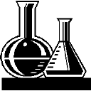
Chemical Reactions
Draw a picture of the milk. | Add vinegar. Now draw the picture.
1. A solid is formed: Curdled Milk –
Take the pH, then add the vinegar Take the pH again
Milk pH _____________ Milk + vinegar pH____________
2. A temperature change occurs: Epsom salts and Tide –
Add 1tsp. water to one baggy of each Tide and Epsom salts (2 tsps each)
- What happens to the Epsom salt?

- What happens to the Tide?

3. A gas is released: Vinegar and Baking Soda –
Add a small amount of vinegar to the baking soda in your cup
What happens?

Vinegar pH ___________ Baking soda + Water pH________________

Vinegar + Baking soda pH ________________

New words: Chemical reaction, gas, chemical change, pH, ions, exothermic, endothermic,
SKIES
Chemistry
Crystal Observation Sheet

Day 1:

Charcoal Sponge Terra Cotta

Day 2:

Charcoal Sponge Terra Cotta

Day 3:

Charcoal Sponge Terra Cotta

Day 4:

Charcoal Sponge Terra Cotta

Day 5:

Charcoal Sponge Terra Cotta
SKIES
Chemistry
pH Testing

Item #1:  pH:  Observations: | Item #2:  pH:  Observations: | Item #3:  pH:  Observations: | Item #4:  pH:  Observations: | Item #5:  pH:  Observations:
Item #6:  pH:  Observations: | Item #7:  pH:  Observations: | Item #8:  pH:  Observations: | Item #9:  pH:  Observations: | Item #10:  pH:  Observations:

|---------------------------------------------|----------------------------------------------|
1 Acid (Acidic) 7 Base (alkaline) 14
Neutral
SKIES
Chemistry
Plop Fizz – Oh what a reaction it is!

The Professor has a problem. He ate three pizzas, two ham sandwiches and one gallon of ice cream for lunch. Now he’s sick to his stomach and needs some medicine. He wants to take an effervescent, like Alka-Seltzer, but he wants to know a way to make it react fastest! Can you help him?

What’s an Effervescent? An effervescent is when something becomes bubbly. Alka-Seltzer is an effervescent when mixed with water.

There are two things that we can do to try and make the reaction faster: crush the tablets or add hot water. Let’s try both! We will time the reactions from the moment we drop the tablet in until there are no more bubbles.

Tablet | Water | Prediction | Time (sec)
Whole Tablet (control) | Cold
Whole Tablet | Hot
Crushed | Cold
Crushed | Hot

Which was the fastest reaction?

Which was the slowest?

What was the pH? Do you think there is anything different we could do?

New words: reaction, prediction, effervescent, reaction rate, hypothesis, control

