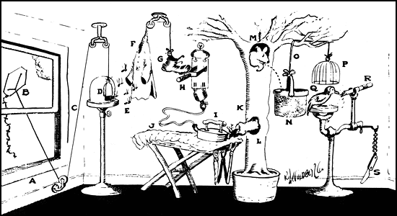
Open window (A) and fly kite (B). String (C) lifts small door (D) allowing moths (E) to escape and eat red flannel shirt (F). As weight of shirt becomes less, shoe (G) steps on switch (H) which heats electric iron (I) and burns hole in pants (J). Smoke (K) enters hole in tree (L), smoking out opossum (M) which jumps into basket (N), pulling rope (O) and lifting cage (P), allowing woodpecker (Q) to chew wood from pencil (R), exposing lead. Emergency knife (S) is always handy in case opossum or the woodpecker gets sick and can't work.

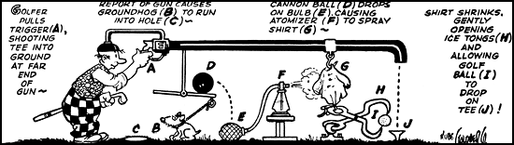
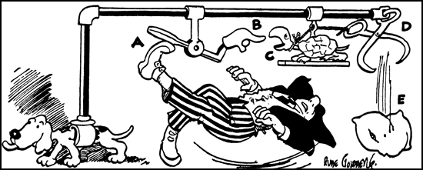
When you slip on ice, your foot kicks paddle (A), lowering finger (B), snapping turtle (C) extends neck to bite finger, opening ice tongs (D) and dropping pillow (E), thus allowing you to fall on something soft.

