VM Installation

In order to use a VM, you'll need to install a VM system. OSU College of Engineering students have access to VMware Workstation via TEACH. Click the "VMware Academic Site Login" link in the bottom right under "External Sites" and select the latest version of VMware Workstation if using Windows, and VMware Fusion if using a Mac. You may have to use the search bar to find it. Download and install it prior to moving on to the next step.

Configuration

We will be using Ubuntu. The choice of desktop is ultimately yours. Do make sure you select the 64-bit version of whichever environment you prefer. Once you have the ISO file downloaded, move on to the next step. Windows is immediately below, Mac is on page 3.

Windows:

Open Workstation, and create a new VM. Select the Typical option in the screen below, and click Next.
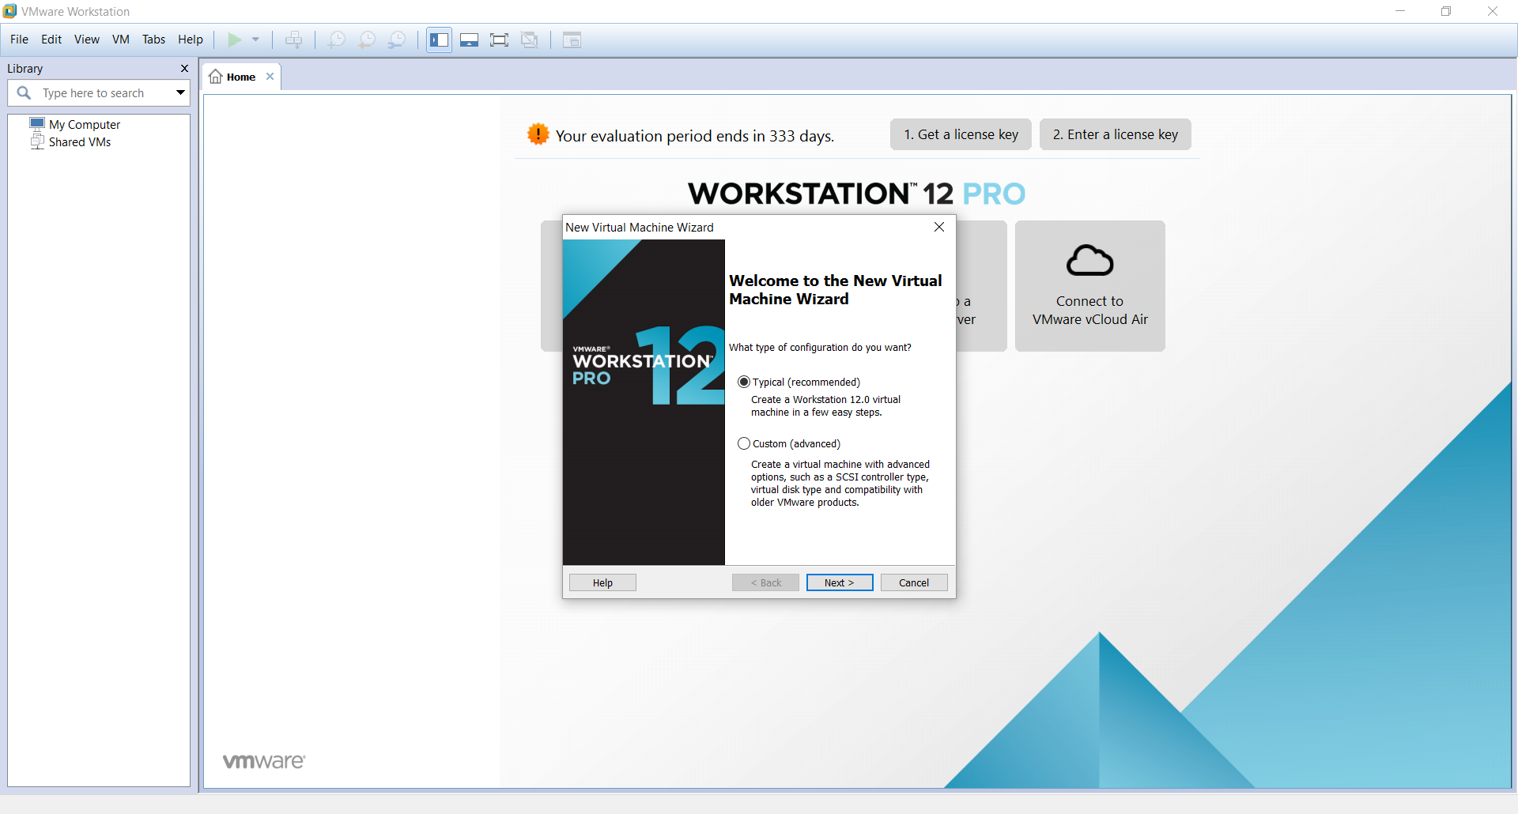

Select “Installer disc image file (iso):” and specify the ISO file you downloaded as the installation medium. It should auto-recognize the OS you are trying to install, and give you some options to “Personalize Linux”. Fill in your full name, preferred user name, and your password, then click next.

Provide a name and location for your VM, and click Next.

Set your disk capacity to at least 60GB, and tell it to Split the virtual disk into multiple files. Click next. You should now be at the below screen. Click Customize Hardware.

Some options you will want to make sure to set:

- RAM: Minimum 2GB, preferably 4+GB if you have the spare memory
- Processors: At least 2 cores on a single processor.
- Display: Check “Accelerate 3D graphics”, 768MB of graphics memory (or more, if available)

You should see the following:

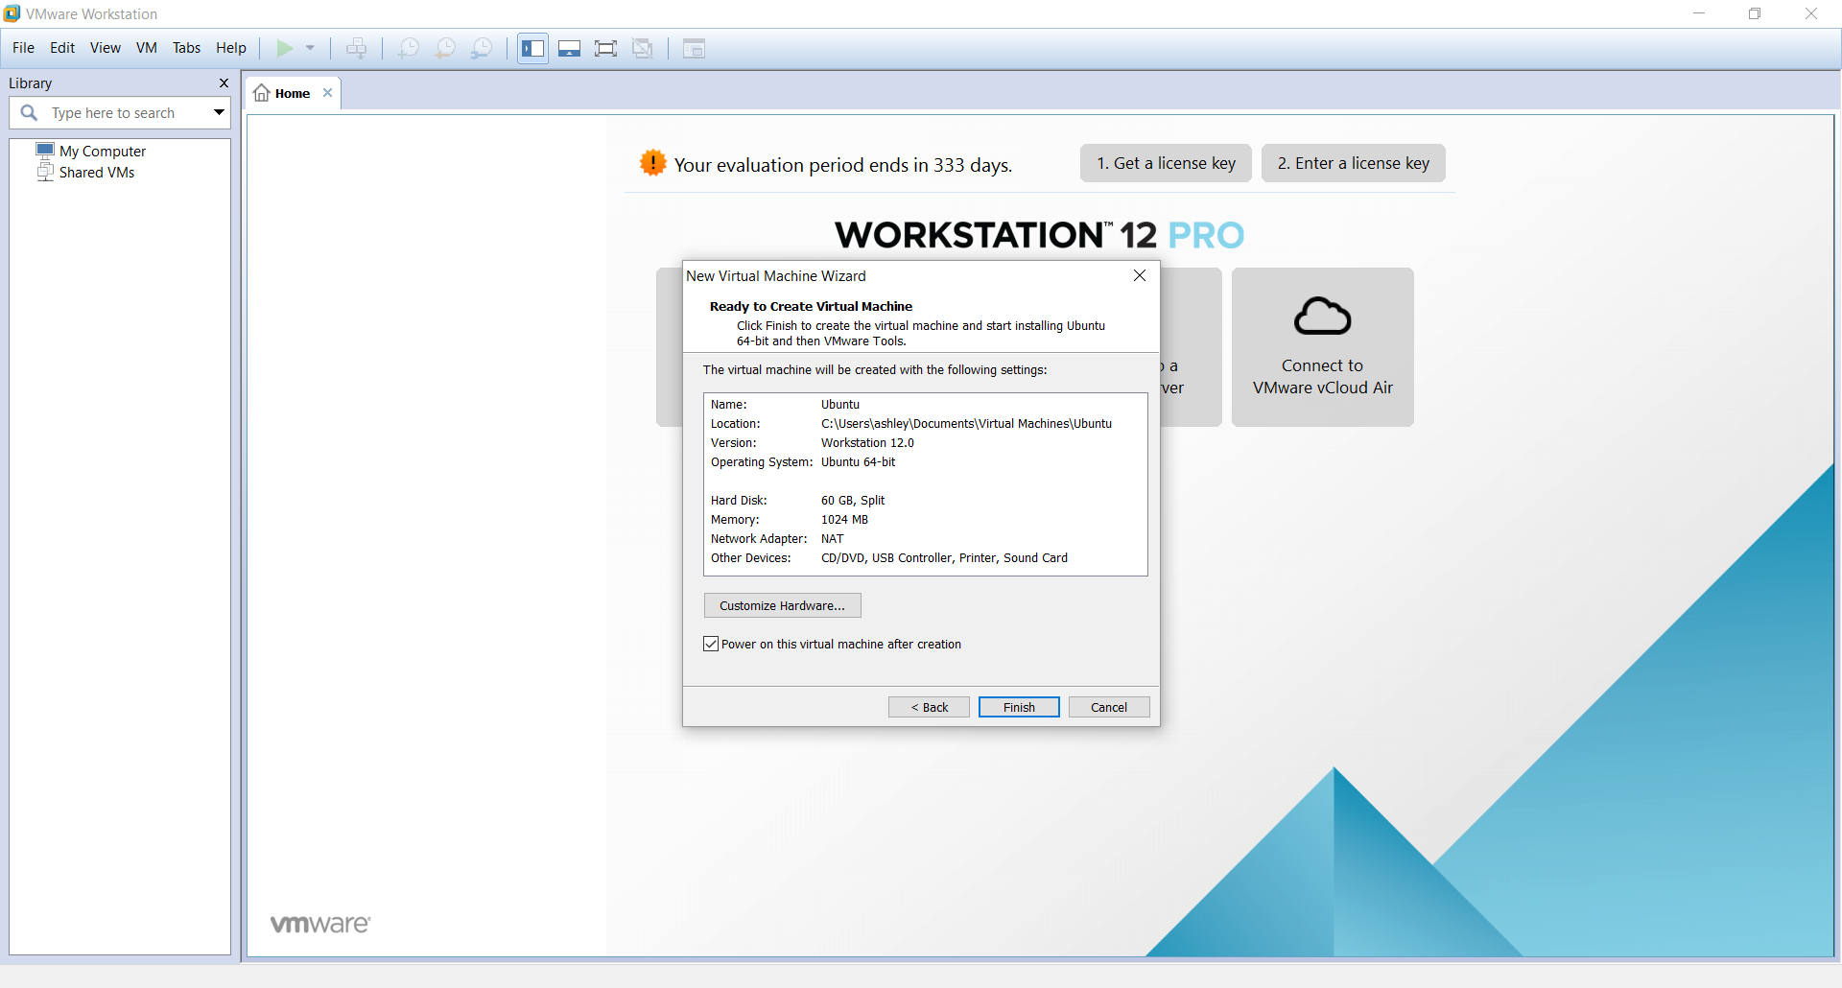

Click Finish, and launch your VM. Linux should install automagically for you.

Mac:

Open VMware Fusion, and you’ll see the below screen.

Click the Add dropdown, and select New. You’ll see the screen below.

You want to create a custom virtual machine. Click continue, select Linux in the left pane, then Ubuntu 64-bit in the right pane.

Click continue. Select “Create a new virtual disk” and click continue. You will customize it in the next step. At this point, you should be here:

You may notice, all the settings are completely wrong! Let’s fix that by clicking Customize Settings. You’ll need to name and save your VM before progressing. Give it a name, pick a home, and click save, and you’ll be ready to move on.

After saving, you’ll be presented with 2 windows:

The window on the right is the settings window, and we’ll be entering several of the choices.

Let’s begin with the Processors & Memory tab. I would recommend assigning at least 2 processor cores, and at least 2GB of RAM. I usually give it 4 Cores and 4GB of RAM, but be reasonable based on your machine. Once you’ve made your selections, click the Show All button in the upper left of the window.

Next, click on Hard Disk (SCSI), and increase the size to at least 60GB. Hit Apply, and then show all again. That was the last setting we need to modify, so now you’re ready to do the installation. Close out the settings.

In order to launch from the Ubuntu image you downloaded, click on the Virtual Machine menu option, then CD/DVD (SATA), then Choose Disc or Disc Image. Find your Ubuntu image, and select it. Now click on the Virtual Machine menu option, then CD/DVD (SATA), and choose Connect CD/DVD.

Now you are ready to launch your VM and install Linux, so just click the big play icon on the screen. Unfortunately, you’ll need to install Linux yourself rather than have it automagically install like the Windows users.

